Sl.  No. | Tournament/Competition | Held at | Date | No. of Students | Inter National /National/State/  University /Zonal | Achievement
1 | Badminton (M&W) | SJBIT , Bangalore | 8th & 9th Sept 2025 | 10 | VTU Bangalore South Division | Participated
2 | Table tennis (M&W) | DSATM Bangalore | 15th & 16th Sept 2025 | 10 | VTU Bangalore South Division | Our College Team (M & W) Qualified For Semi Finalist
3 | Chess (M&W) | Sairam CE Anekal | 25th & 26th Sept 2025 | 09 | VTU Bangalore Division | Participated
4 | Swimming (M&W) | MSRIT , Bangalore | 24th & 25th Sept 2025 | 02 | VTU State Level | Participated
5 | Cross Country (M&W) | SJMIT,  Chitradurga, | 16th & 17th October 2025 | 08 | VTU State Level | Participated
6 | Wrestling & Judo | MIT MYSuru | 18th & 19th October 2025 | 01 | VTU State Level | Prathik Kundar 1st sem ME Secured Bronze Medal in above 83Kg Category
7 | Weight Lifting & Best Physique (M) | GAT,Bangalore, | 27th & 28th Oct 2025 | 04 | VTU State Level | Participated
8 | Karate | RVITM Bengaluru | 31st Oct 2025 | 01 | VTU State Level | Participated
9 | Basket Ball (Men) | JSSATE Bangalore, | 3rd & 4th Nove 2025 | 12 | VTU Bangalore South Division | Participated
10 | Power lifting (M&W) | RVITM Bangalore | 6th & 7th Nove 2025 | 02 | VTU State Level | Participated
11 | Cricket (M) | DBIT, Bangalore | 24th & 25th Nove 2025 | 04 | VTU Team Cricket (M) Selections | Vivek M S 7th sem ECE, Vikram S 7th sem CSE & Aryan A Singh 3rd ECE got Selected for State level Cricket team selection which is going to be held at PESCE Mandya.11th & 12th December 2025.
12 | Throw Ball(Women) | Jyothi IT, Bangalore, | 1st & 2nd Dece 2025 | 12 | VTU Bangalore South Division | Participated
13 | The South Zone Inter University VTU Table Tennis | GITAM University Visakhapatnam (AP) | 4th to 11th December 2025 | 01 | The South Zone Inter University Tournament | Anuka S V 3rd Sem ECE Represented VTU
14 | Cricket (M) | PESCE Mandya | 11th & 12th Dece 2025 | 03 | VTU Team Cricket (M) Selections | Participated
15 | 70th Senior Women National Championship | Kamothe Raygad  (Maharashtra) | 26th to 29th December 25 | 01 | National Championship | 70th senior women national championship winners Karnataka
16 | The South Zone Inter University VTU Ball Badminton ( Women ) | Anna University Chennai (TN) | 11th to 15th February 2026 | 01 | The South Zone Inter University Tournament | Vshnu Priya G S 6th Sem CCE Represented VTU

Sl.  No. | Tournament/Competition | Held at | Date | No. of Students | Inter National /National/State/  University /Zonal | Achievement
17 | Cricket (M) | R V University , Bangalore | 2nd & 3rd March 2026 | 16 | Inter College | Participated
18 | Ball Badminton ( W ) | RLJIT Doddaballapura | 9th & 10th March 2026 | 01 | VTU Team Ball  Badminton (W) Selections | Participated
19 | Athletic Meet (M&W) | KIT Tiptur | 25th to 29th March 2026 | 10 | VTU State Level | Participated
20 | Football (M) | ACSCE, Bangalore | 16th & 17th April 2026 | 16 | VTU Bangalore South Division | Participated
21 | Cricket (M) | RRCE, Bangalore | 22nd to 30th April 2026 | 16 | VTU Bangalore South Division | Participated
22 | Volleyball (M) | JIT, Bangalore | 4th & 5th May 2026 | 12 | VTU Bangalore South Division | Participated

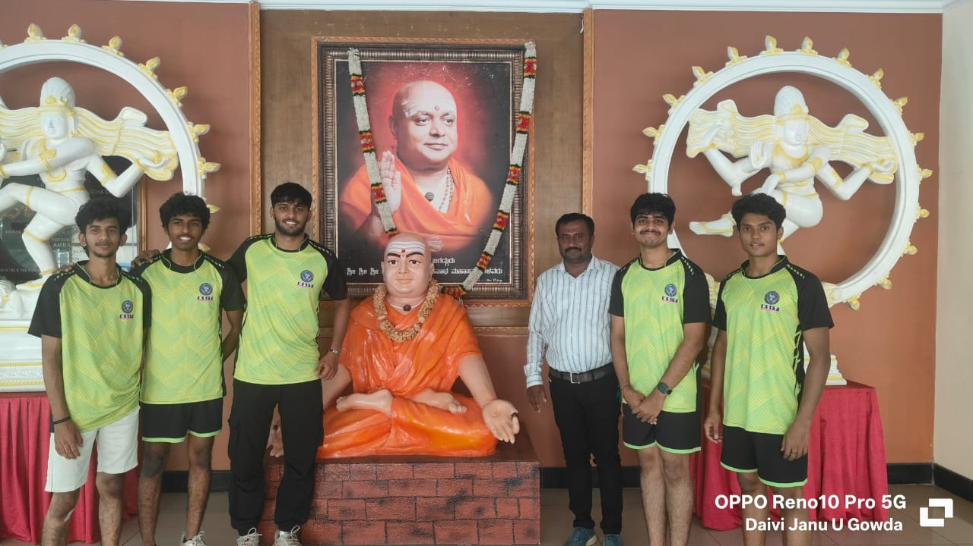
Participated in VTU Bangalore South Division Badminton (M &W) Tournament 2025-26 which was held at SJBIT, Bangalore on 8th & 9th September 2025.
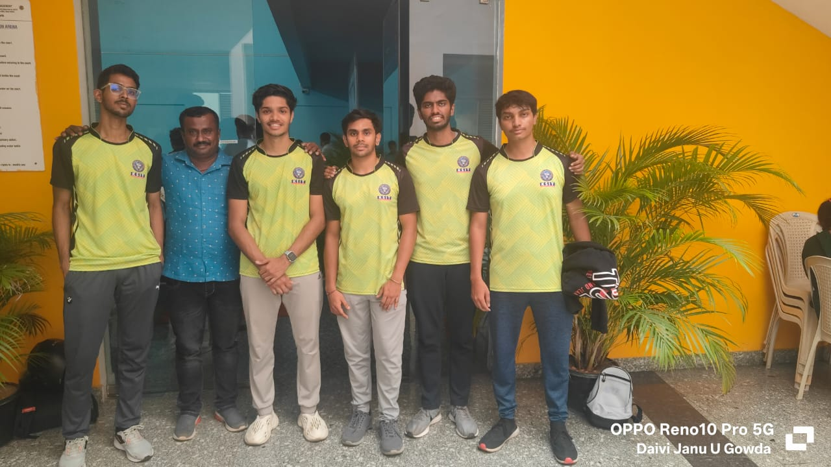
Participated in VTU Bangalore South Division Table Tennis (M &W) Tournament 2025-26 which was held at DSATM, Bangalore on 15th & 16th September 2025.
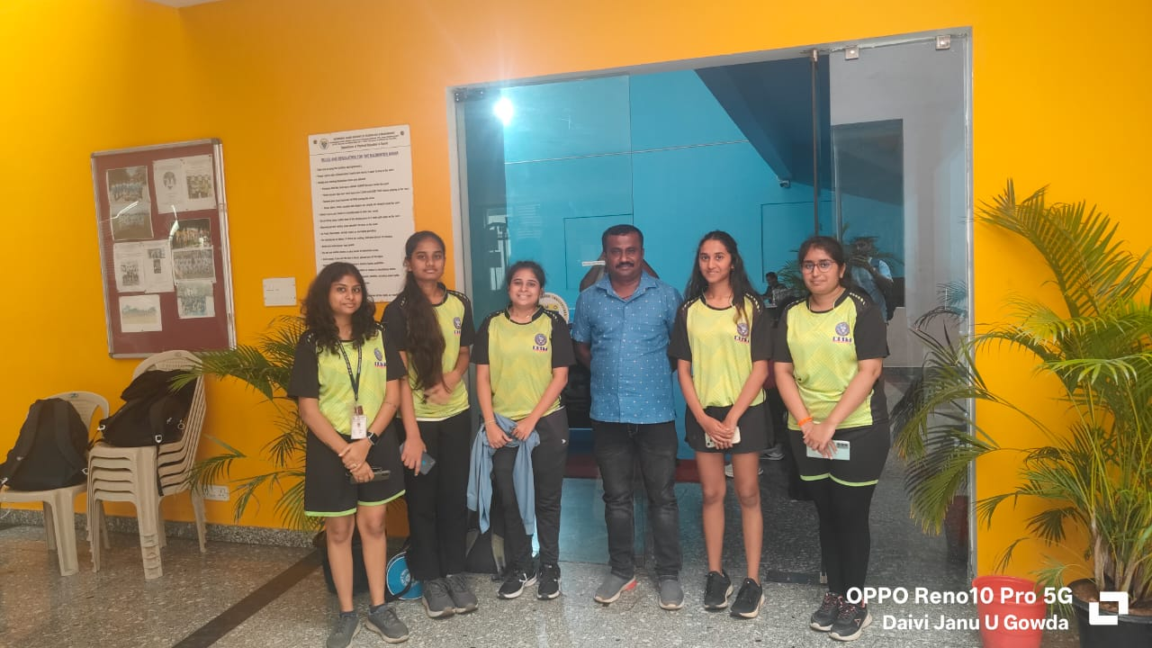
Participated in VTU Bangalore South Division Table Tennis (M &W) Tournament 2025-26 which was held at DSATM, Bangalore on 15th & 16th September 2025
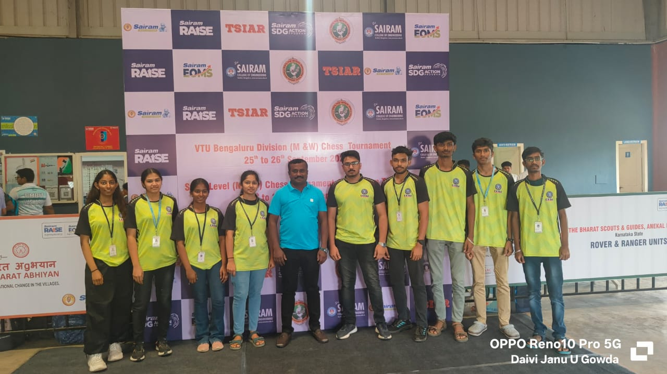
Participated in VTU Bengaluru Division Inter collegiate Chess (M&W) tournament 2025-26 which was held at Sairam CE Anekal on 25th & 26th September 2025.
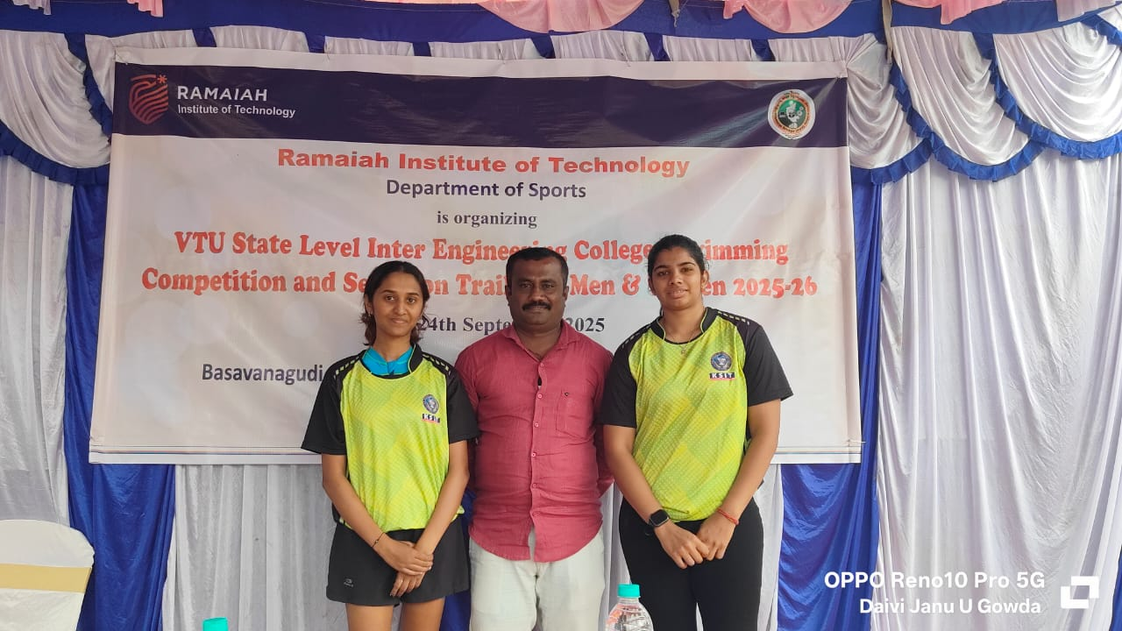
Participated in VTU State Level Inter Collegiate Swimming (M&W) Competition 2025-26 at which was held at MSRIT Bengaluru. on 24th & 25th September 2025.
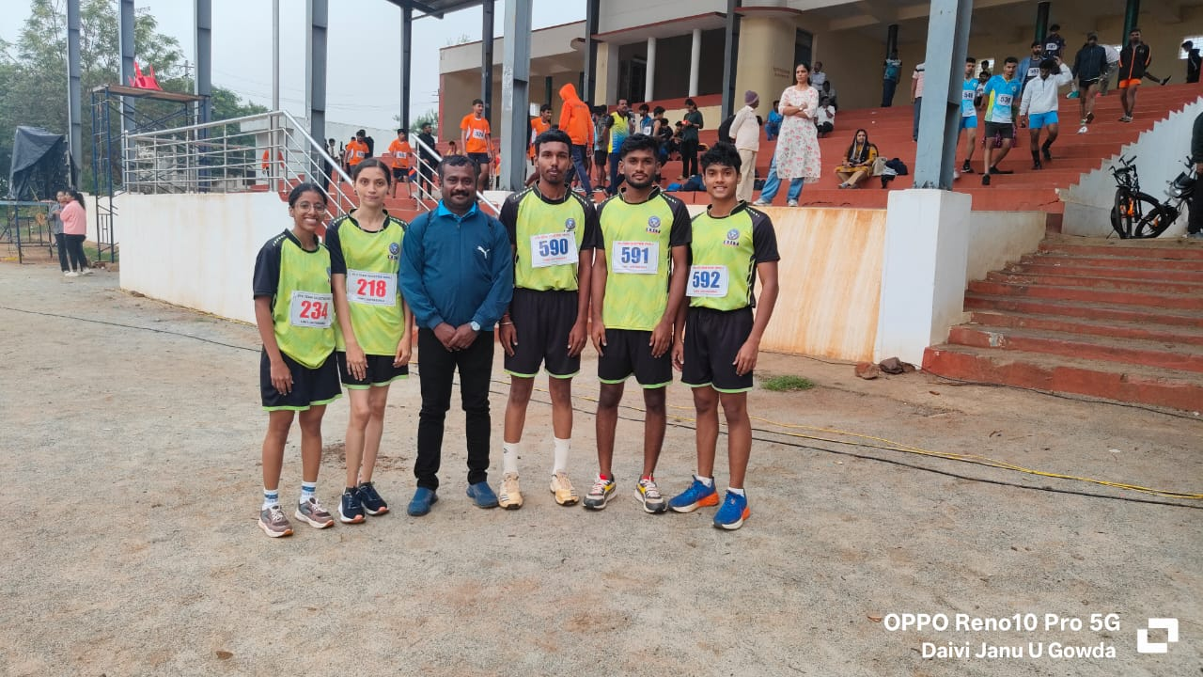
Participated in VTU State Level Inter Collegiate Cross Country (M&W) Competition 2025-26 which was held at SJMIT,Chitradurga, on 16th & 17th October 2025.
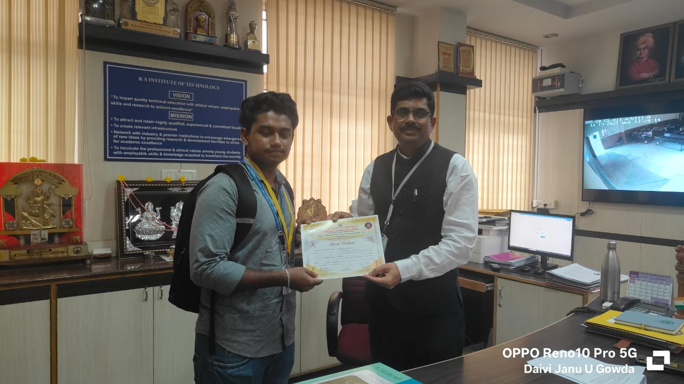
Prathik Kundar 1st sem ME Secured Bronze Medal in above 83Kg Category in VTU State Level Inter Collegiate Wrestling Competition 2025-26 on 16th & 17th October 2025 MIT Mysuru.
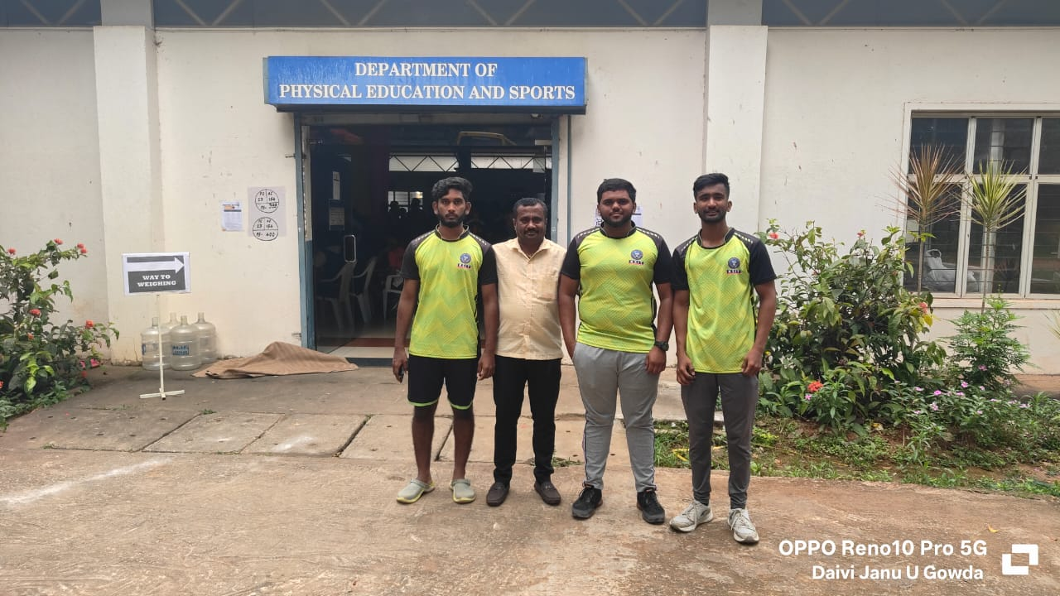
Participated in VTU State Level Inter Collegiate Weight Lifting & Best Physique (M) Competition 2025-26 at GAT Bengaluru, on 27th & 28th October 2025.
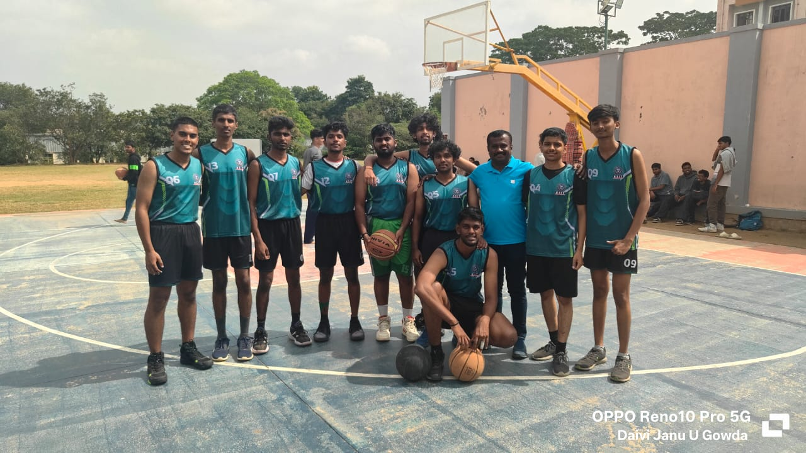
Participated in VTU Bangalore South Division Basketball (M) Tournament 2025-26 which was held at JSSATM, Bangalore on 3rd & 4th November 2025.
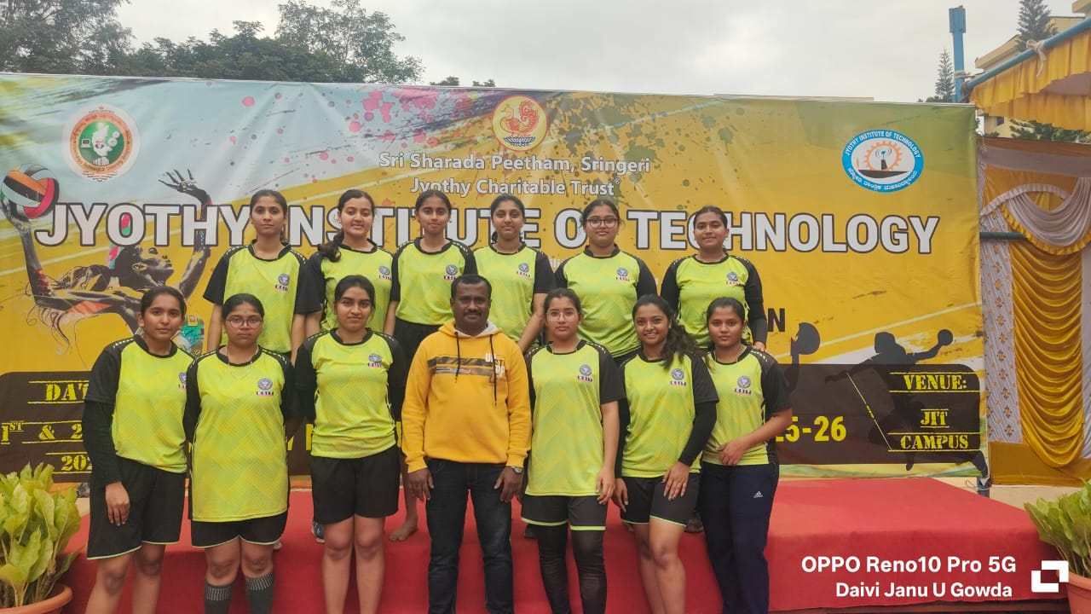
Participated in VTU Bangalore South Division Throw ball (W) Tournament 2025-26 which was held at JIT, Bangalore on 1st & 2nd December 2025.
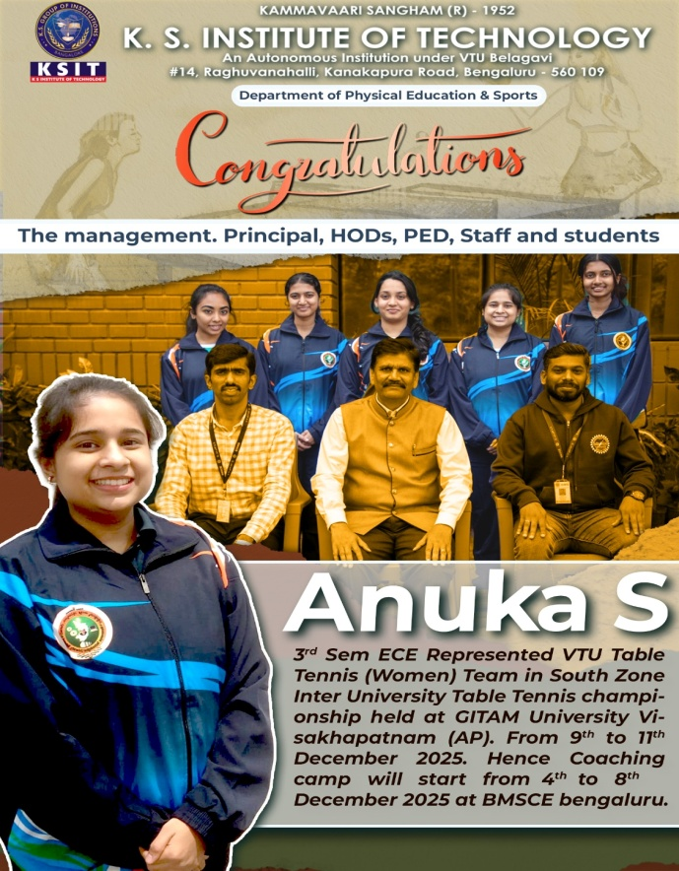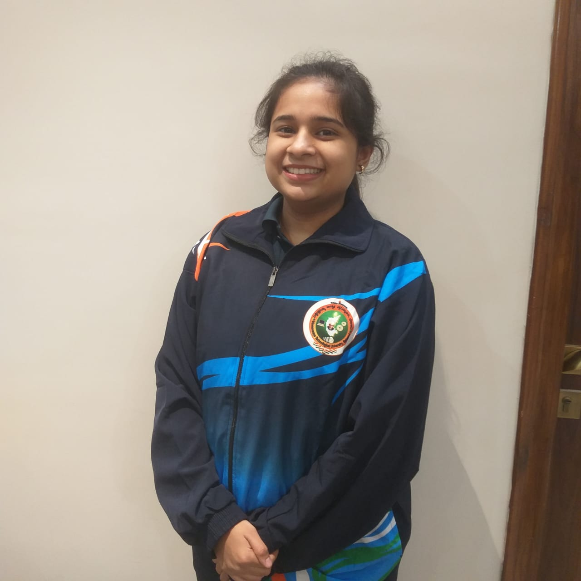
Anuka S 3rd Sem ECE Represented \VTU Table Tennis (Women) Team in South zone inter university Table Tennis championship held at GITAM University Visakhapatnam (AP). From 9th to 11th December 2025.Hence Coaching camp will start from 4th to 8th December 2025 at BMSCE bengaluru.
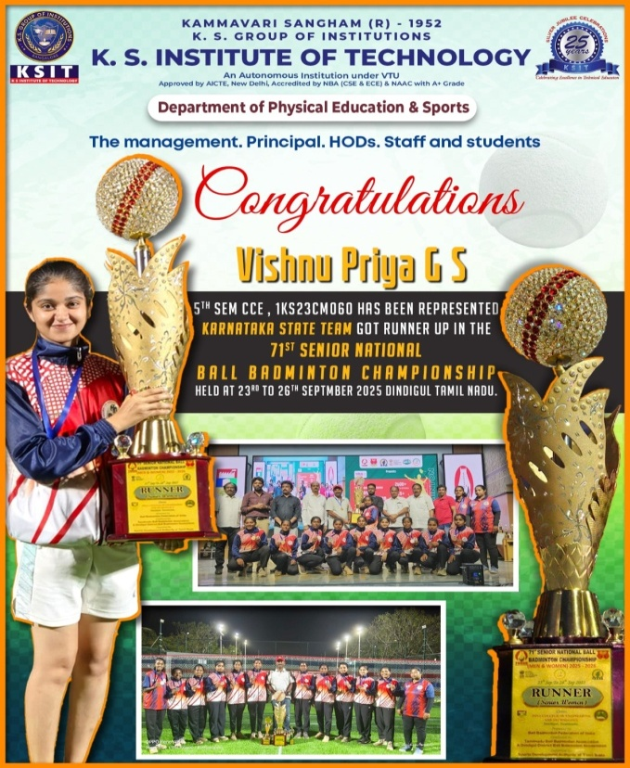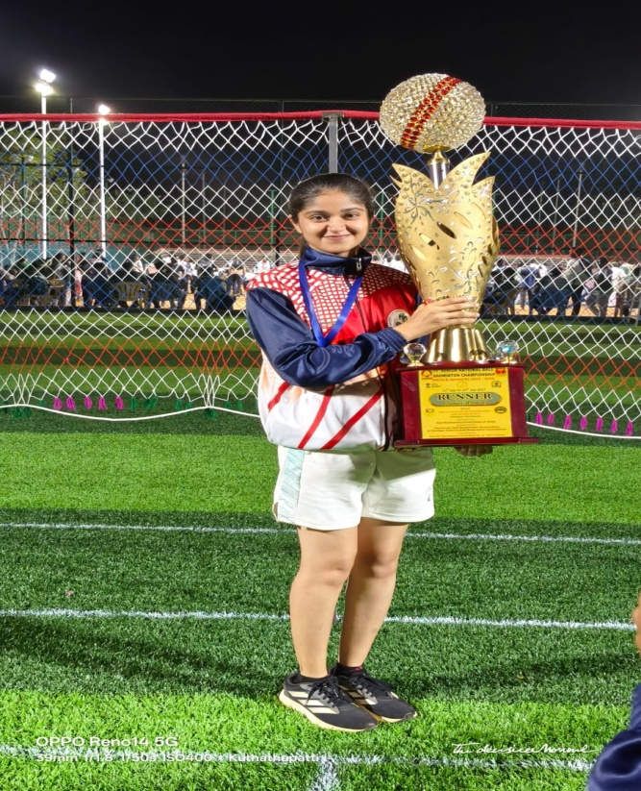
Vishnu Priya G S, 5th Sem CCE, Represented Ball Badminton Association of Karnataka, Karnataka women's team as the Champions of 71st Senior National Ball Badminton Championship, organized by tamilnadu Ball Badminton Association under the auspicious of Ball Badminton Federation of India held from at Dindigul Tamilnadu from 23rd to 29th September 2025.
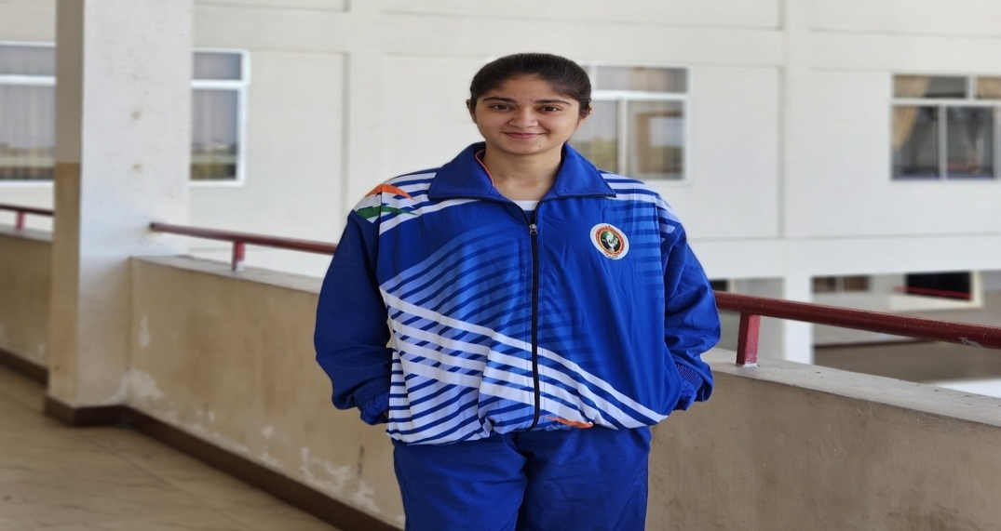
Vshnu Priya G S 6th Sem CCE Represented VTU Ball Badminton (Women) Team in South Zone Inter-University Ball Badminton (Women) Tournament 2025-26 held at Anna University Chennai (TN) From to 11th to 15th February 2026. Hence coaching camp will start from 6th to 10th February 2026 at Govt CE Hassan.
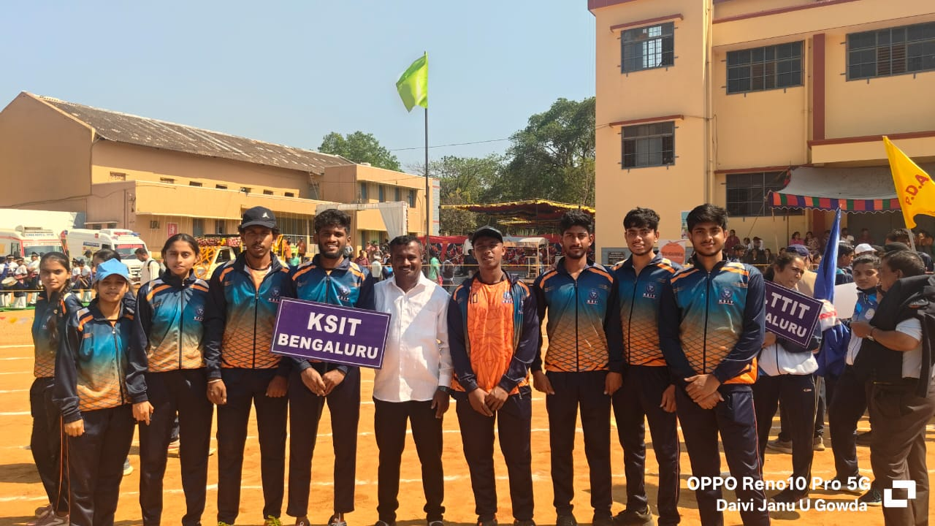
Participated in 25th VTU Inter-Collegiate Athletic Meet 2025-26 on 25th to 29th March 2026 at KIT Tiptur.
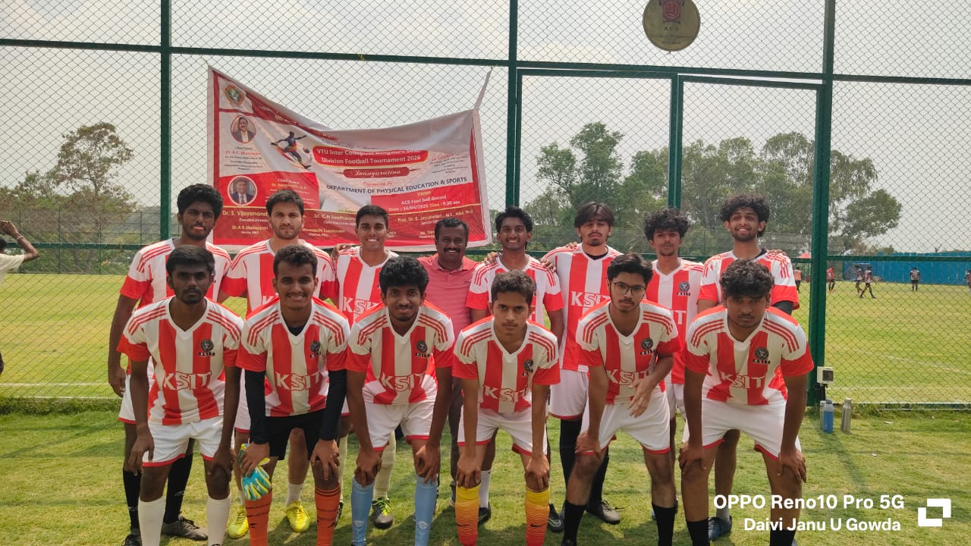
Participated in VTU Inter collegiate Bangalore South Division Football tournament 2025-26 at ACSCE, Bangalore on 16th & 17th April 2026.

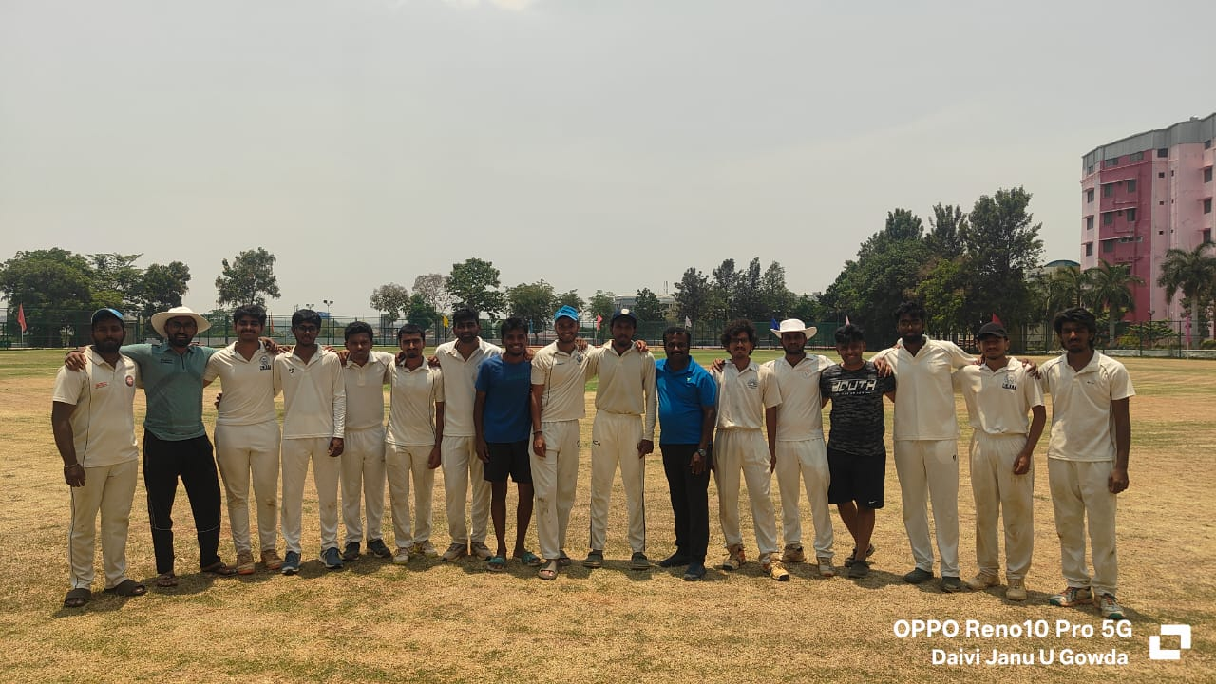
Participated in VTU Bengaluru South Division Inter collegiate Cricket tournament at RRCE, Bangalore On 22nd to 30th April 2026.
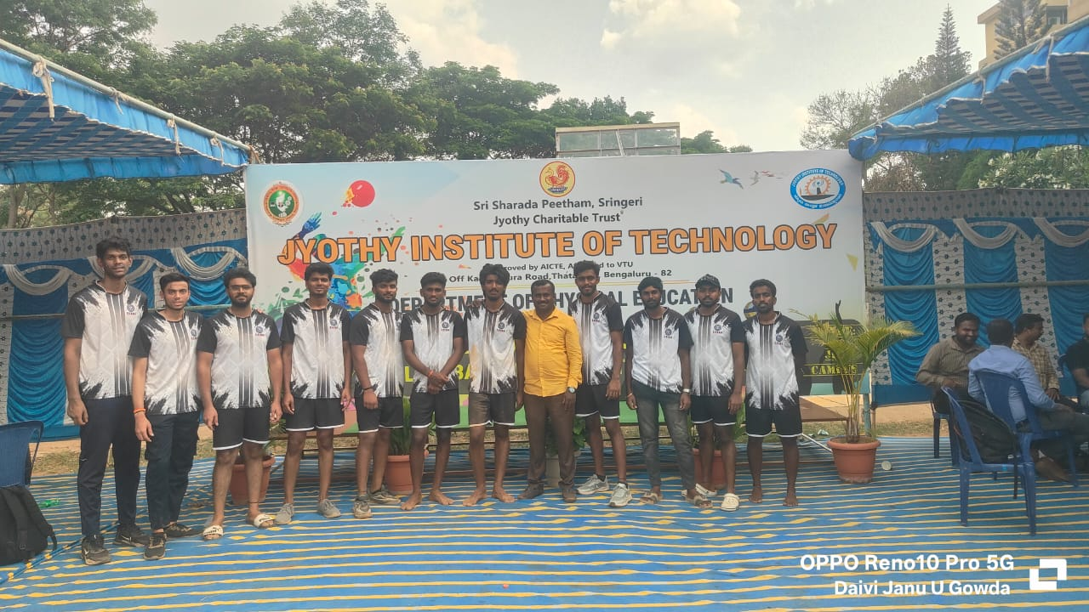
Participated in VTU Bengaluru South Division Inter collegiate Volleyball (M) tournament at JIT, Bangalore on 4th & 5th May 2026

