Sports Day 2025-26 Report
Department of Physical Education and Sports organized the Annual Sports Day on 25th October 2025 at UCPE stadium, Jnana Bharathi Campus, Bangalore University, Bangalore.
The programme started with an invocation song followed by march-past. The ChiefGuest of the day was Sri. Rohith R, National Baseball & Softball Player Alumnus of KSIT, Sri.Vijay basket ball Player, Alumnus of KSSEM was invited. They were welcomed by KSIT Principal Dr.Dilip Kumar K.The Chief Guest &Guest of Honor addressed the gathering and shared their experience during their college days &importance of sports. Our Honorable President Sri. R. Rajagopal Naidu, &Secretary Sri R.Leela Shankar Rao were addressed the gathering &mentioned theimportance of sports extended in the college and encouragement from the Kammavari Sangam., The Treasurer Sri. T.Neerajakshulu Naidu, , Principal Dr.Dilip Kumar of KSIT,Principal,Ar. Thrivikram N.B of KSSAand all the Department Heads and Staff were present on the occasion.
Sl.  No. | No. of Events | No. of Students Participated | Individual championship | Overall teamchampionship  For Department
1 | 10 (Men)  8(women) | 1500 | 1.Vikas M S 1st Sem ECE  2. Prajna Gaonkar,7thSem CSE | Dept of Computer Science and Engineering

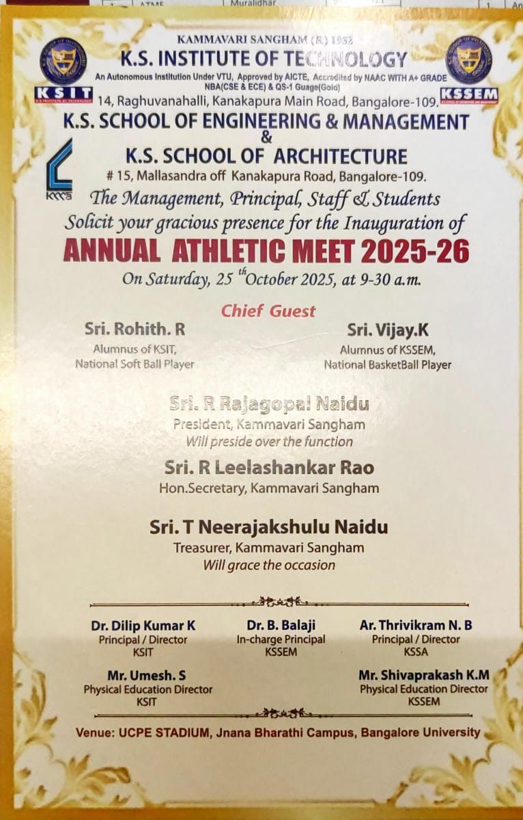

Order of Events
Time | Events
9.30 AM | Inauguration
10.10 AM | 1500Mts(Men),800Mts(Women)
10.15 AM | 100Mts Heats (Men), 100Mts Heats (Women)
10.30 AM | Shot Put(Men) ,Long Jump(Women)
10.40 AM | 800Mts(Men), 400Mts(Women)
11.00 AM | Long Jump(Men),Shot Put(Women)
11.30 AM | 200Mts Heats (Men),200Mts Heats (Women)
12.15 PM | 100 Mts (Staff Men & Women)
12.45 PM | Discus Throw (Men& Women)
1.15 PM to 2.00 PM Lunch Break
2.00 PM | Discus Throw (Men Staff),Shot Put(Women Staff)
2.15 PM | 200Mts Finals (Men),200Mts Finals (Women)
2.45 PM | 4 x 400 Mts Relay (Men),4 x 100 Mts Relay (Women)
3.15 PM | 4 x 100 Mts Relay (Men),400Mts (Men)
3.30 PM | 100Mts Finals (Men),100Mts Finals (Women)
4.00 PM | 4 x 100 Mts Relay (Men)
4.15 PM | Valedictory function

