Sl.  No. | Tournament/Competition | Held at | Date | No. of Students | Inter National /National/State/  University /Zonal | Achievement
1 | Taekwondo (M) | GAT Bengaluru | 21st & 22nd June 2024 | 01 | VTU State Level | Tirumala Ganesh Bharadwaj Sharma, 4th sem ECE ,Secured Bronze Medal in above 87Kg Category
2 | 25thVTU Athletic Meet  (M & W) | VTU Mysuru Regional Center Mysuru | 26th to 29th June 2024 | 14 | VTU State Level | Participated
3 | Table Tennis (M) | SJBIT, Bangalore | 2nd & 3rd July 2024 | 05 | VTU Bangalore South Division | Participated
4 | Table Tennis Selections | VVCE  Mysuru | 19th & 20th July 2024 | 01 | VTU Team Table Tennis Selections | Participated
5 | Badminton (M & W) | RVITM, Bengaluru, | 8th& 9th July 2024 | 10 | VTU Bangalore South Division | Participated
6 | Chess (M & W) | BMSCE, Bengaluru, | 16th& 17th July 2024 | 10 | VTU Bangalore South Division | Participated
7 | Yoga (M & W) | Akshaya IT, Tumakuru | 23rd & 24th Septe 2024 | 04 | VTU State Level | Participated
8 | Ball Badminton (W) | GSSSIEW , Mysore , | 3rd & 4th Oct 2024 | 02 | VTU Ball Badminton Team Selections Trails | Participated
9 | Cricket (M) | SJBIT, Bangalore | 6th to 20th Oct 2024 | 16 | VTU Bangalore South Division | Participated
10 | Kho-Kho (M) | RRCE, Bangalore | 4th & 5th Oct 2024 | 12 | VTU Bangalore South Division | Participated
11 | Kabaddi (M) | Sairam CE Anekal | 19th & 20th Octo 2024 | 12 | VTU Bangalore South Division | Participated
12 | Kabaddi (W) | RRCE, Bangalore | 15th & 16th Nove 2024 | 12 | VTU Bangalore South Division | Our College Team Qualified For Semi Finalist
13 | Kabaddi (W) | RRCE, Bangalore | 19th to 21st Nove 2024 | 01 | VTU Kabaddi (W) Team Selections Trails | Participated
14 | Volleyball (M) | ACSCE, Bangalore | 22nd to 23rd Nove 2024 | 12 | VTU Bangalore South Division | Participated
15 | The South Zone Inter University VTU Kabaddi (Women) Tournament  2024-25 | Alagappa University Karaikudi (TN) | 24th November to 2nd December 2024 | 01 | The South Zone Inter University Tournament | Abhilasha V 7th Sem CSE Represented VTU
16 | The 62nd Nationals Roller Skating Championships (Inline hockey )2024 | Coimbatore | 5th to15th December 2024 | 01 | National / India | Pavithraa G, Department of CSD, Secured Bronze medal
17 | The South Zone Inter University VTU Table Tennis ( Men ) | Vellore IT, Vellor , Tamil Nadu | 6th to 13th December 24 | 01 | The South Zone Inter University Tournament | Srikanth Kashyap 3rd Sem CSE Represented VTU

Sl.  No. | Tournament/Competition | Held at | Date | No. of Students | Inter National /National/State/  University /Zonal | Achievement
17 | Throw ball (W) | JVIT ,Bidadi, | 12th &13thDec 2024 | 10 | VTU Bangalore South Division | Women’s team Secured 2nd Place & qualified for State level Competition
18 | 70th Senior Women National Championship | Kamothe Raygad  (Maharashtra) | 26th to 29th December 24 | 01 | National Championship | 70th senior women national championship winners Karnataka
19 | Criket Selections | SJBIT, Bangalore | 26th to 27th December 24 | 04 | VTU Bangalore South Division Selections | Vivek M S 5th sem ECE & , Vinay C D 5th sem ME got Selected for State level Cricket team selection which is going to be held at NMAMIT Nitte Mangalore on 3rd to 5th January 25
20 | Criket Selections | NMAMIT Nitte Mangalore | 3rd to 5th January 25 |  | VTU Team Cricket (M) Selections | Participated
21 | The South Zone Inter University VTU Ball Badminton ( Women ) | Alagappa University Karaikudi (TN) | 29th March to 1st April 2025 | 01 | The South Zone Inter University Tournament | Vshnu Priya G S 4th Sem CCE Represented VTU
22 | Cricket (M) | DBIT, Bangalore | 3rd to 10th April 2025 | 16 | VTU Bangalore South Division | Participated
23 | Football (M) | T-John IT, Bangalore | 2nd to 3rd April 2025 | 16 | VTU Bangalore South Division | Participated
24 | Taekwondo | BIT Bengalruru | 16th & 17th April 2025 | 01 | VTU State Level | Participated
25 | Ball Badminton | GCE Ramanagara | 12th & 13th June 2025 | 01 | VTU State Level | Participated

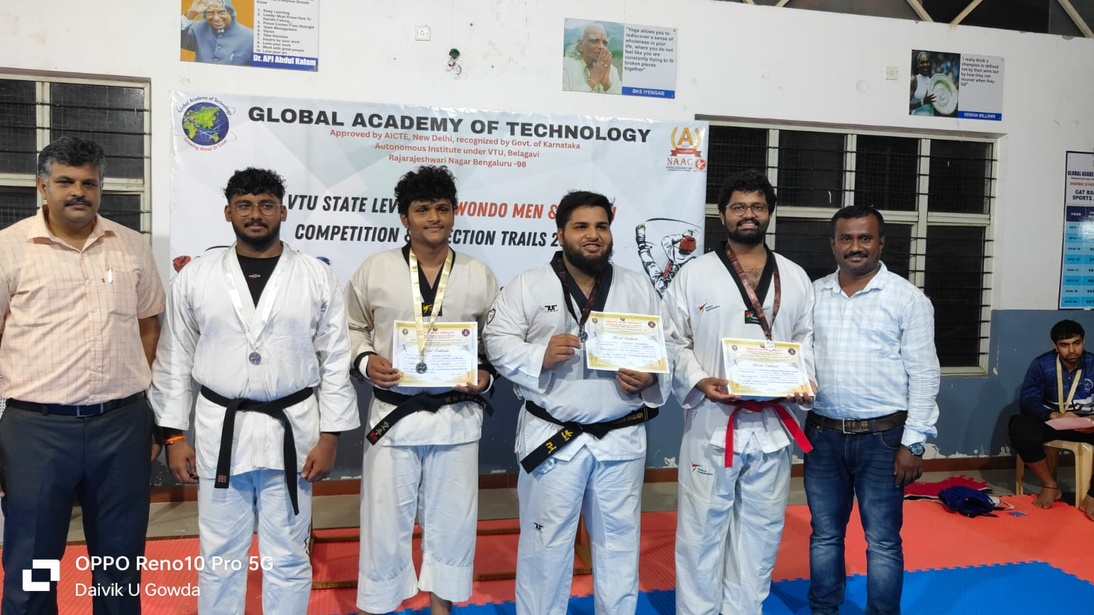
Tirumala Ganesh Bharadwaj Sharma, 4th Sem, ECE,1KS22EC108, Secured Bronze Medal (weight category above 87kg) in VTU State Level Inter Collegiate Taekwondo Competition 2024-25 on21st June 2024 at GAT Bengaluru.

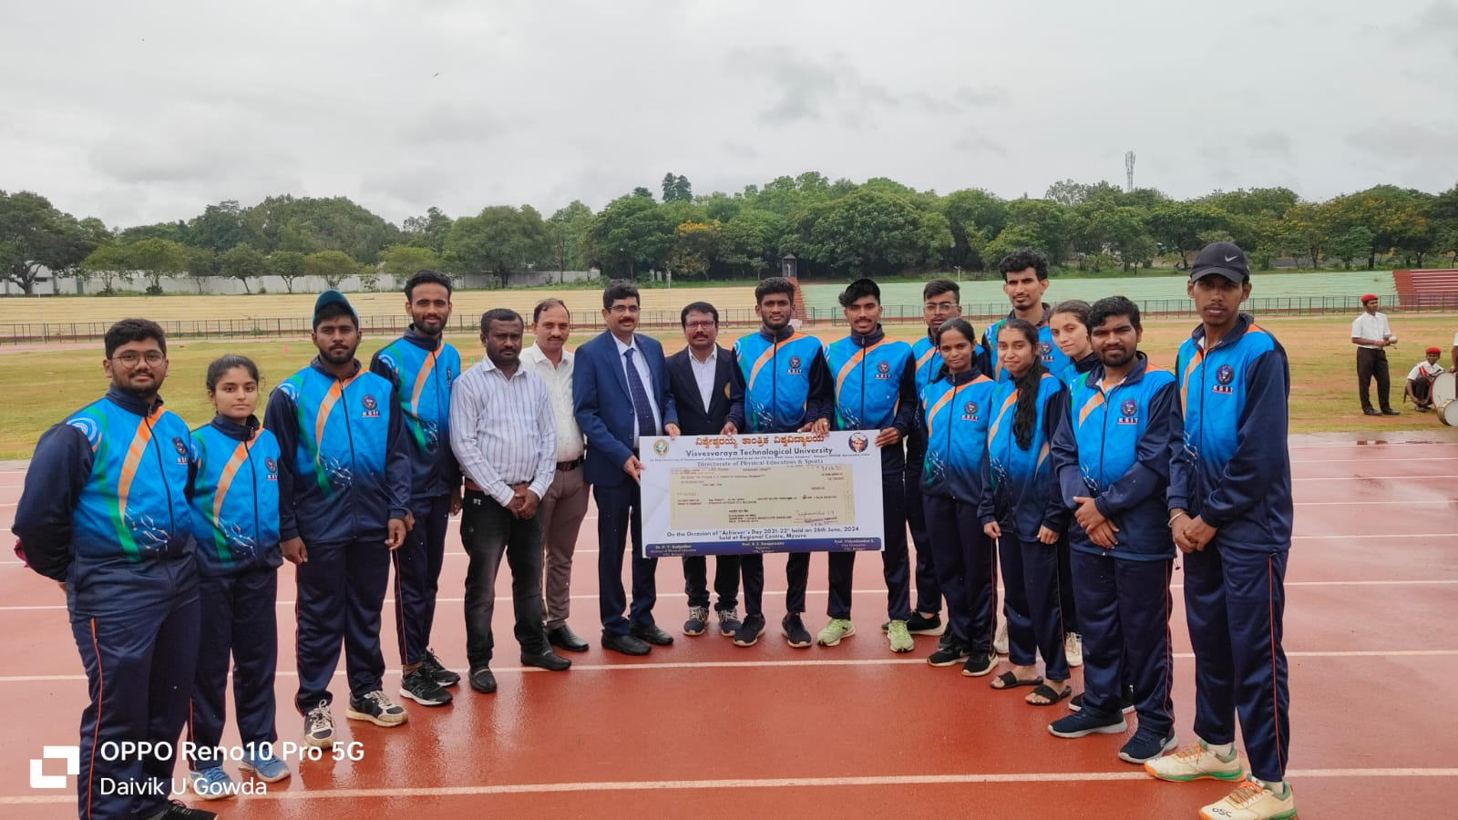
Participated in VTU , State level Athletic Meet held at VTU Mysuru Regional Center Mysuru from 26th to 29th June 2024
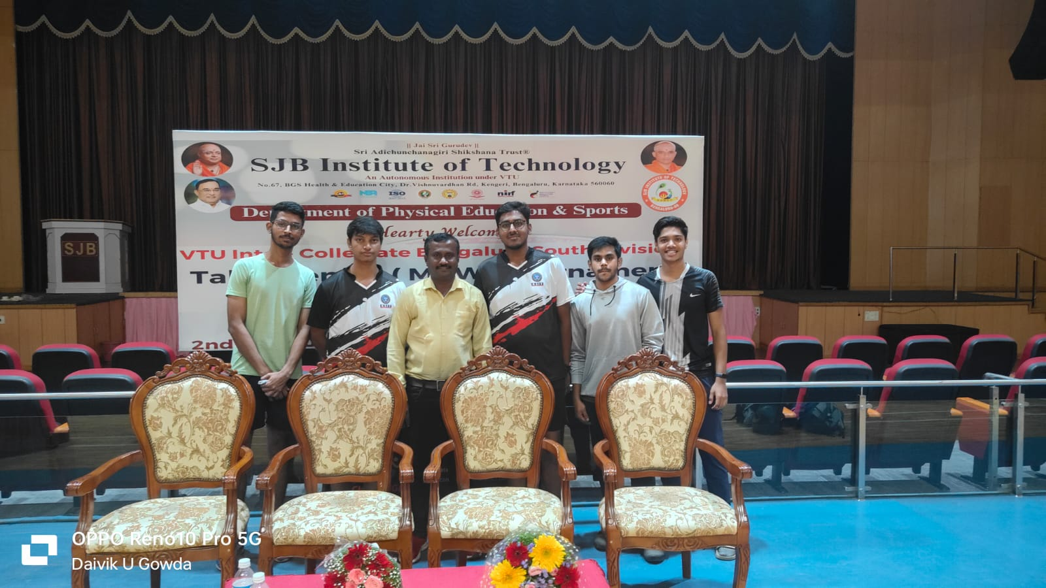
Participated in VTU Bangalore South Division Table Tennis Tournament (M &W) which was held at SJBIT, Bangalore on 2nd & 3rd July 2024.
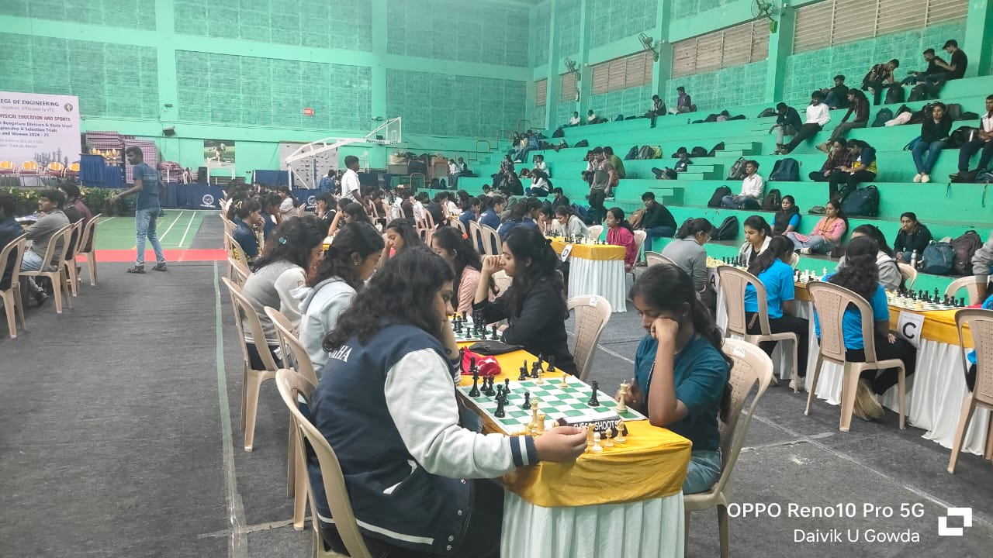
Participated in VTU Bengaluru Division Inter collegiate Chess (M&W) tournament at BMSCE, Bangalore on 16th&17th July2024.
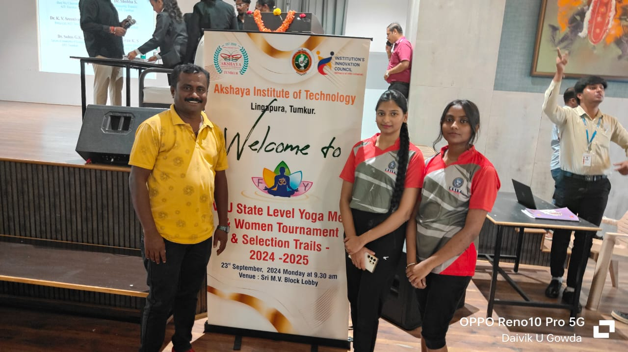Participated in VTU State Level Inter Collegiate Yoga Competition 2024-25 on 23rd & 24th September 2024 at Akshaya IT Tumakuru.
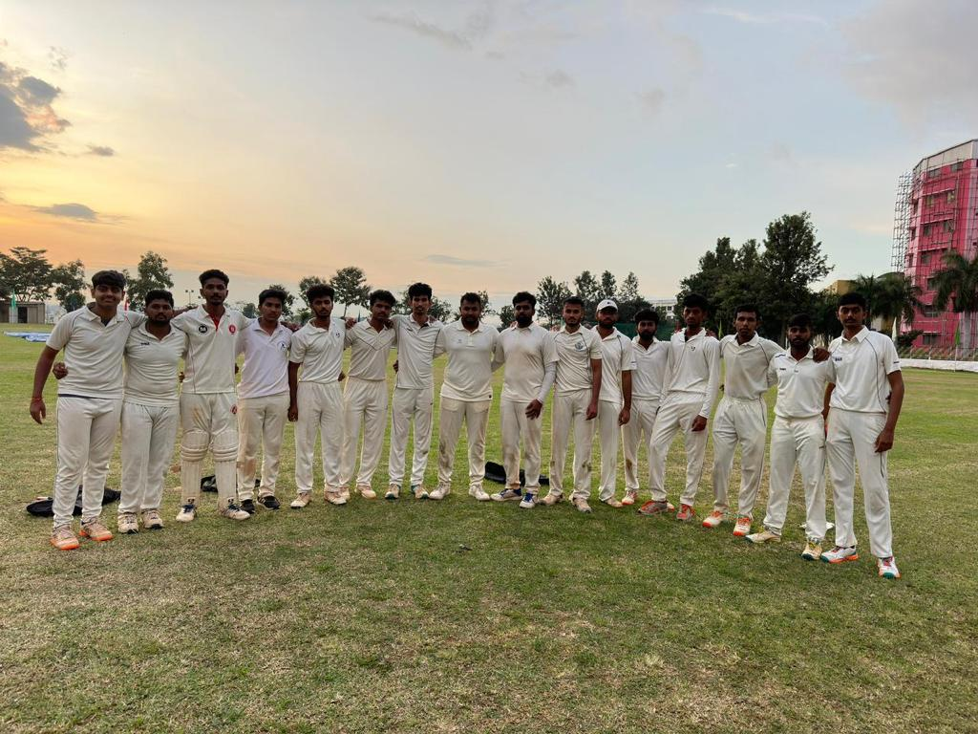
Participated in VTU Inter-Collegiate Bengaluru South Division Cricket Tournament 2024 – 2025. at SJBIT Bangalore on 8th to 20th October 2024.
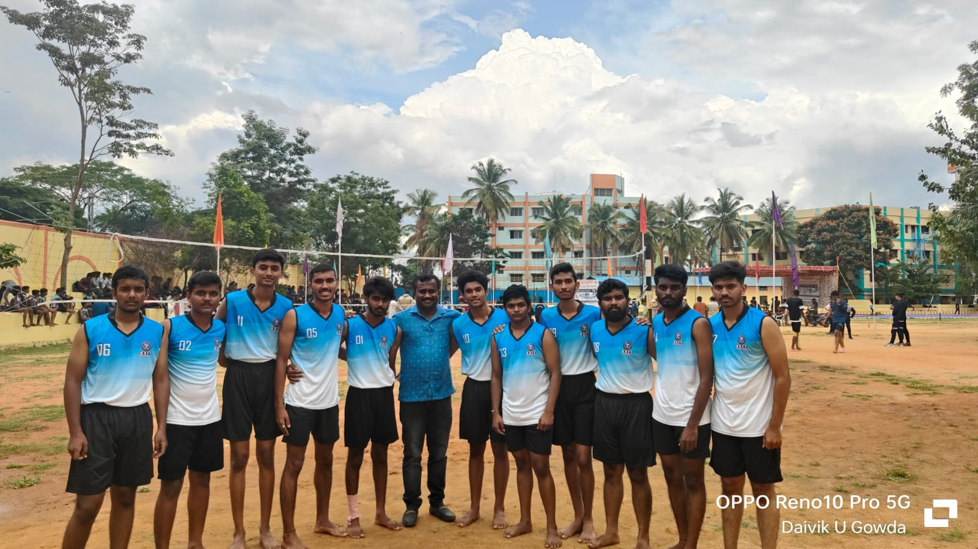
Participated in VTU Inter-Collegiate Bengaluru South Division Kho-Kho (M) Tournament 2024 – 2025. at RRCE Bangalore on 4th to 5th October 2024.

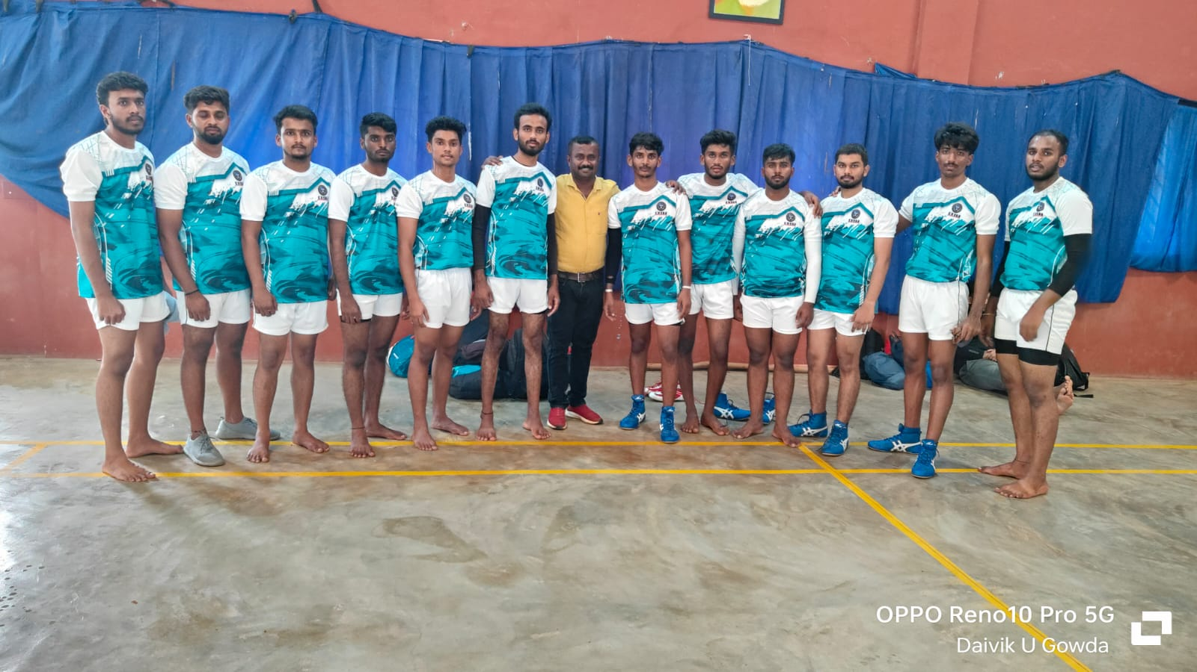
Participated in VTU Inter-Collegiate Bengaluru South Division Kabaddi (M) Tournament 2024 – 2025. at Sairam CE Anekal on 19th to 20th October 2024.
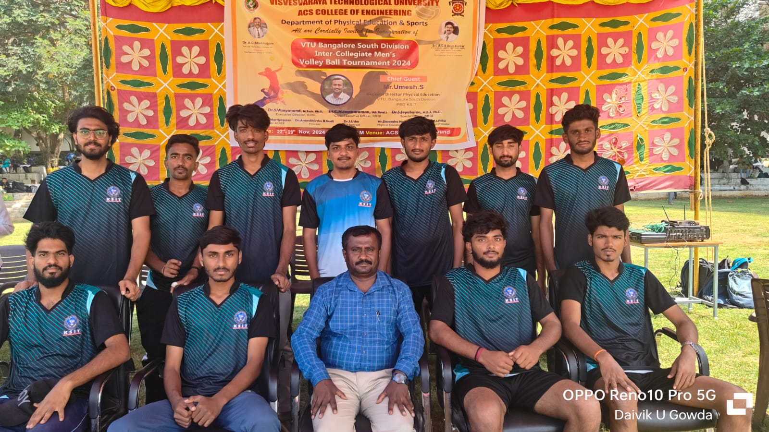
Participated in VTU Inter collegiate Volleyball (M) tournament at ACSCE, Bangalore on 19th & 20th November 2024.
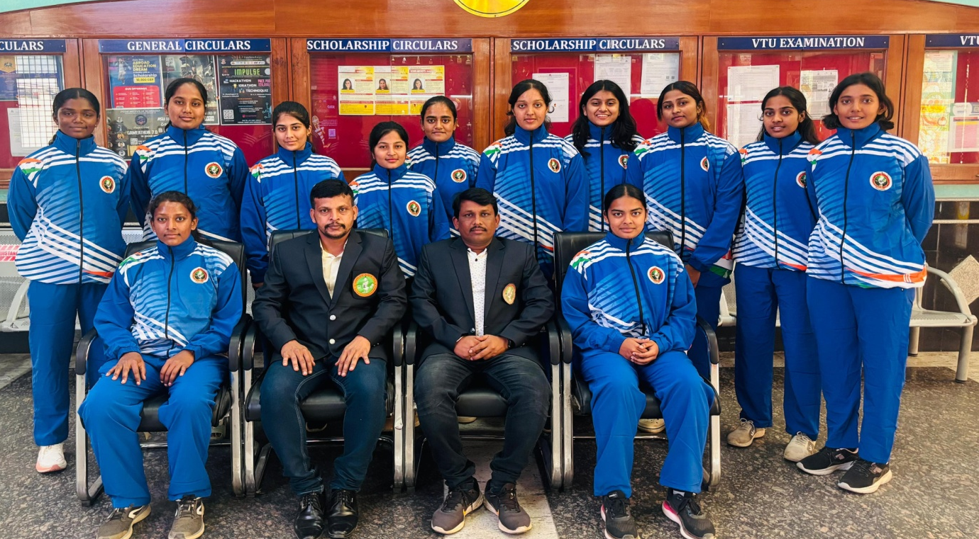
Abhilasha V of 7th Sem CSE Represented VTU Kabaddi (Women) Team in South Zone Inter-University Kabaddi Tournament 2024-25 held at Alagappa University Karaikudi (TN) From to 29th November 2024 to 2nd December 2024. Hence coaching camp will start from 24th to 28th November 2024 at RRCE Bengaluru.
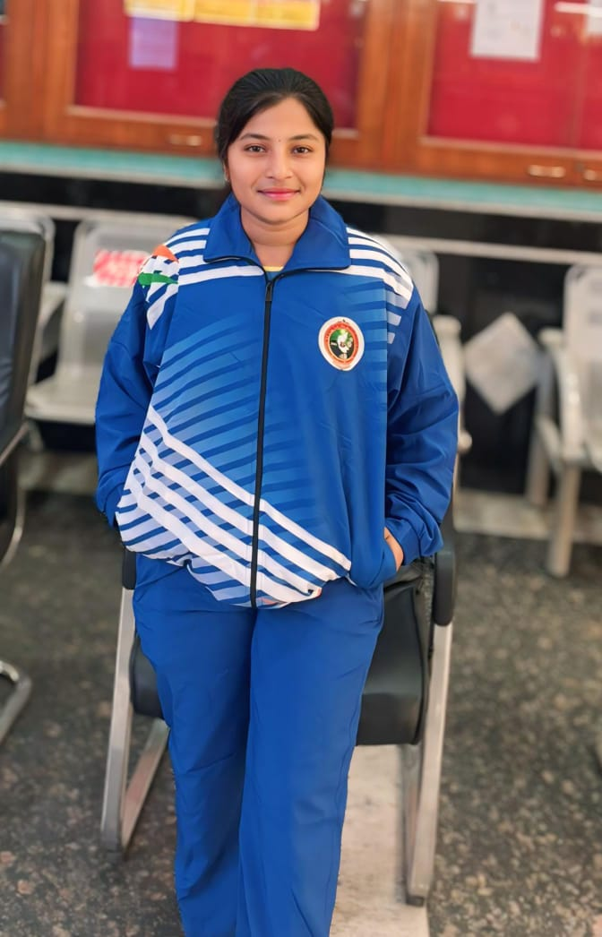

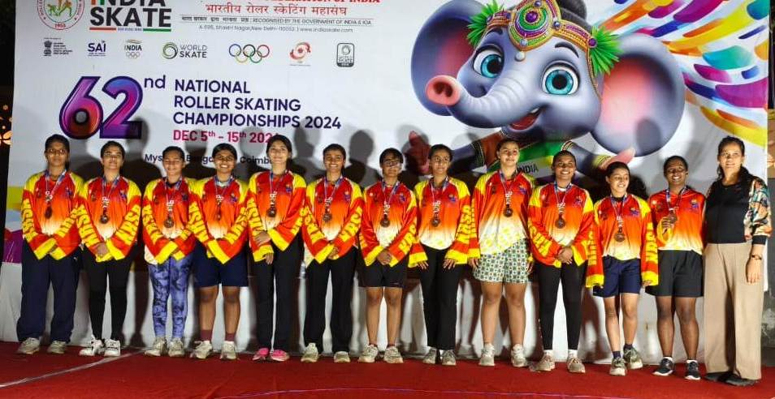
Pavithraa G, Department of CSD, secured Bronze medal in the 62nd National Roller Skating Championship (inline hockey) 2024 - held at Coimbatore from 5th to 15th December 2024.
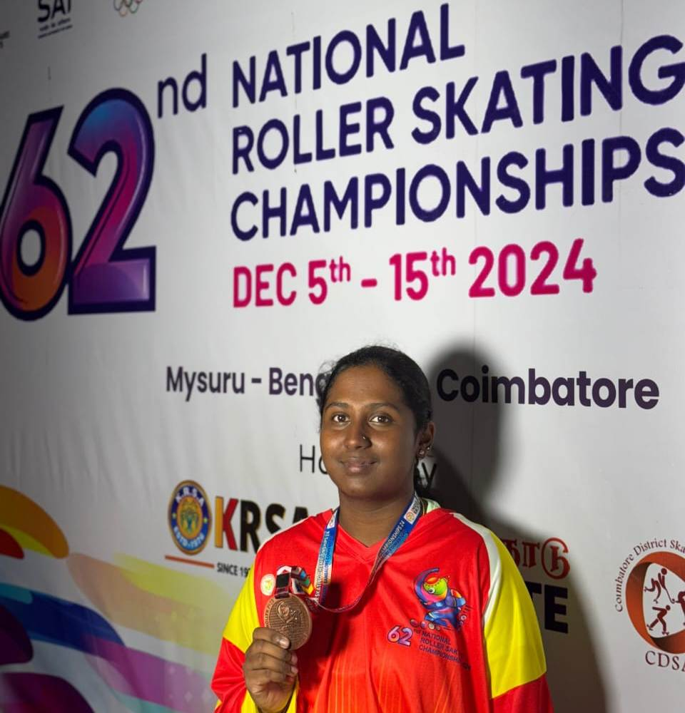

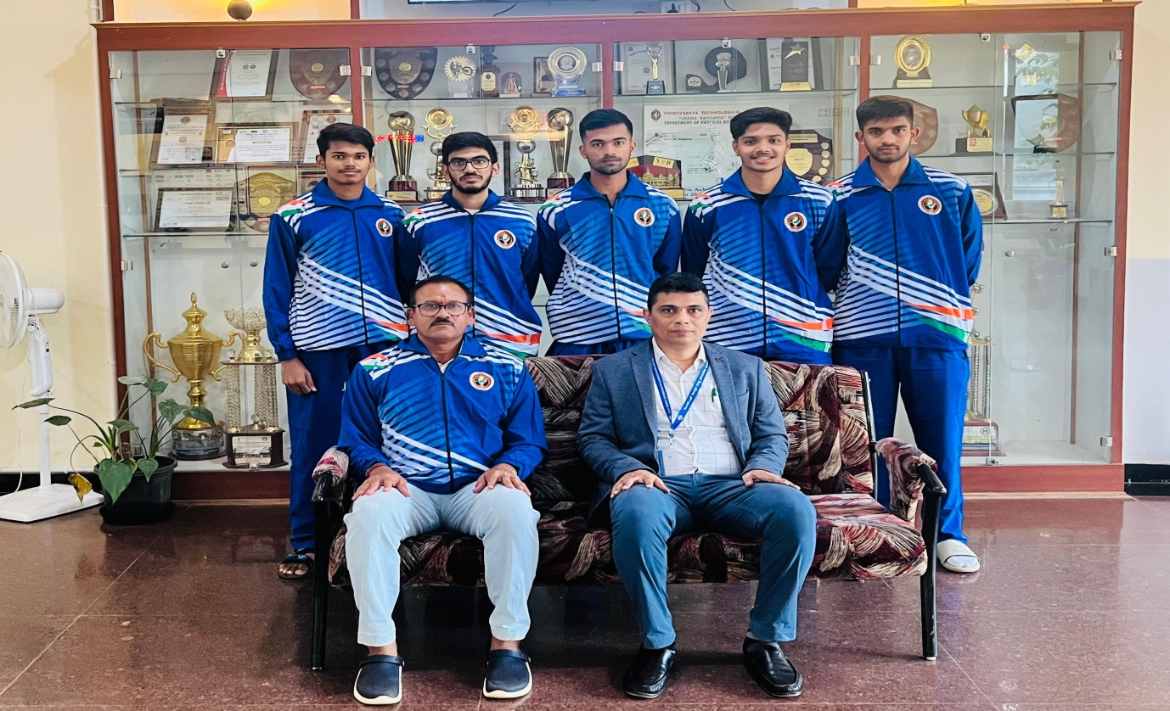
Srikanth Kashyap, 3rd Sem CSE , Represented VTU Table Tennis (Men) team in South Zone Inter University Championship 2024-24 held at Vellore IT, Vellor , Tamil Nadu.From 9th December 2024 to 13th December 2024. Hence coaching camp will start from 6th to 8th December 2024 at BMSIT Bengaluru.
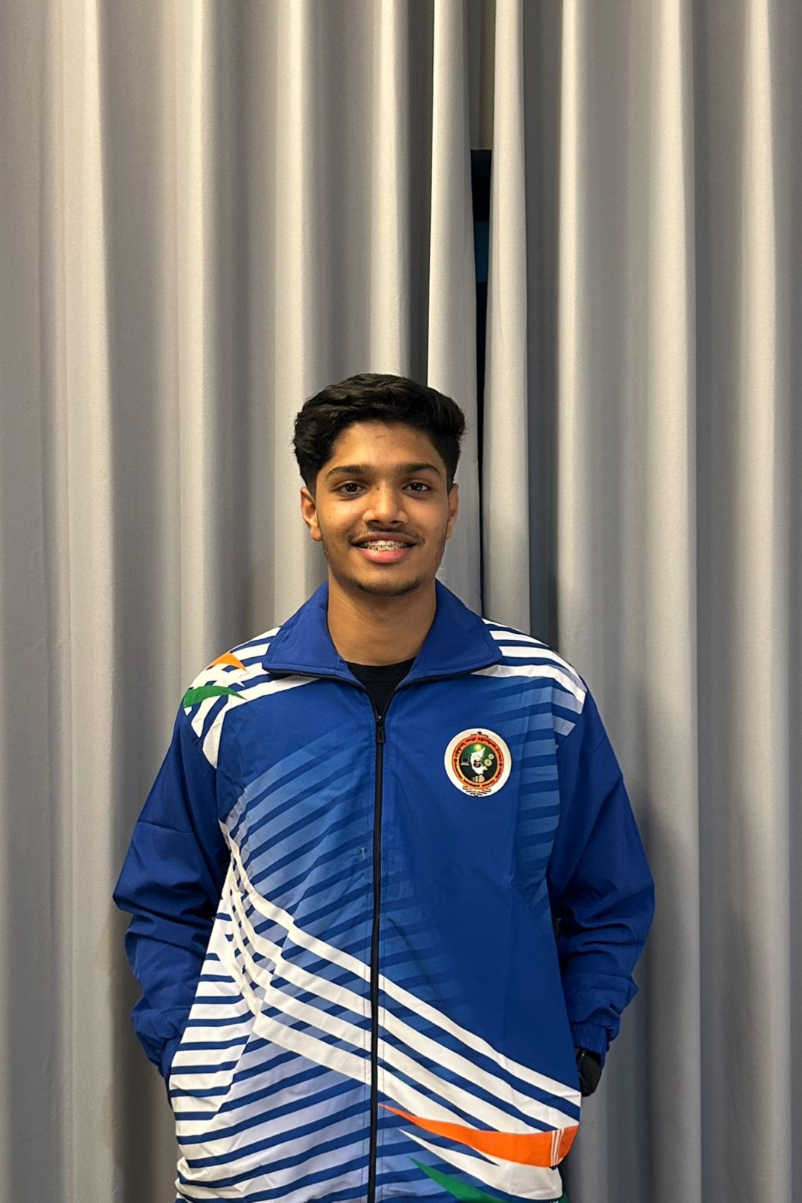
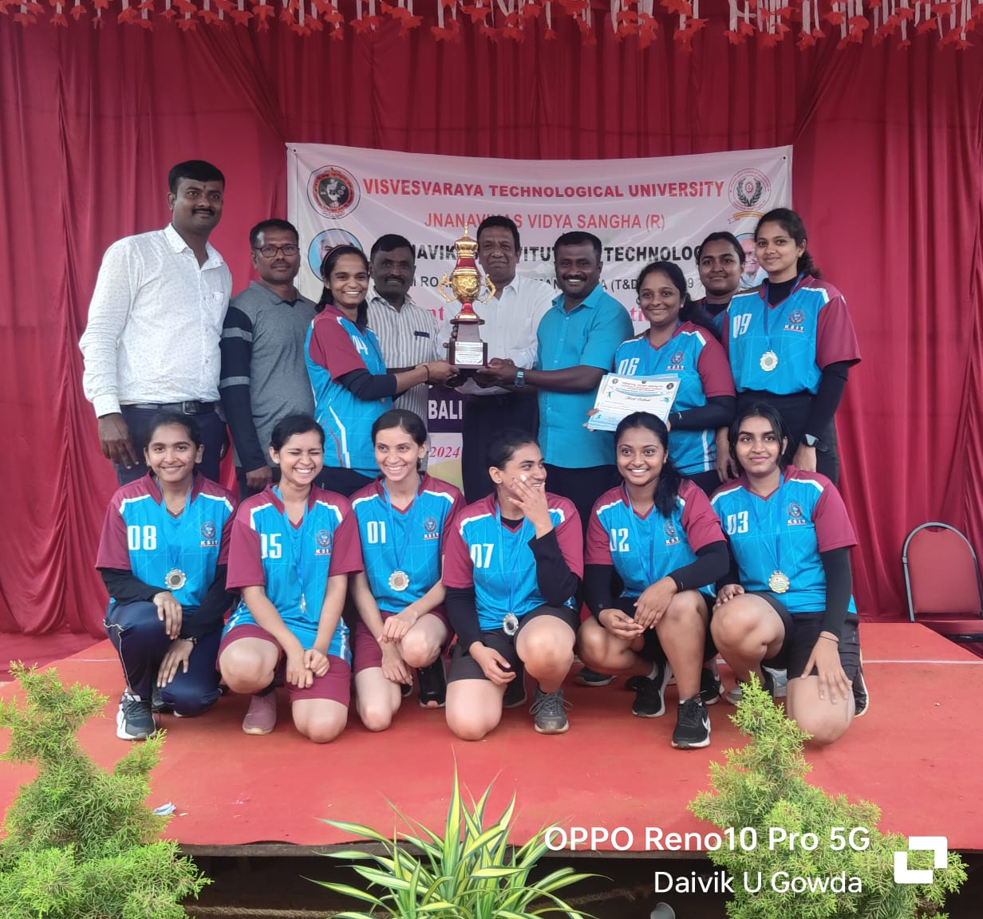
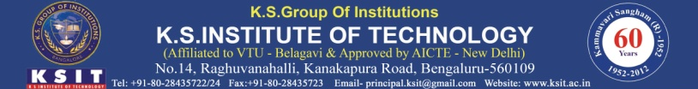
Our college Throw Ball (W) Team Runners Up in the VTU Bengaluru South Division Throw Ball Tournament 2024-25.on 12th & 13th December 2024 at JVIT Bidadi. Qualified for State level Competition.
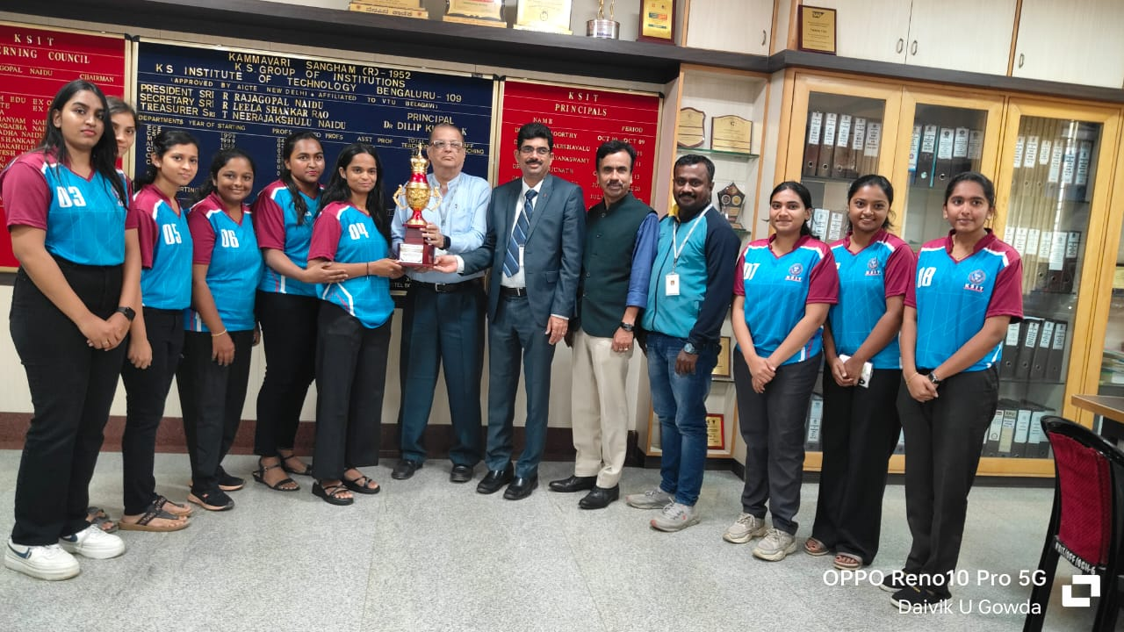
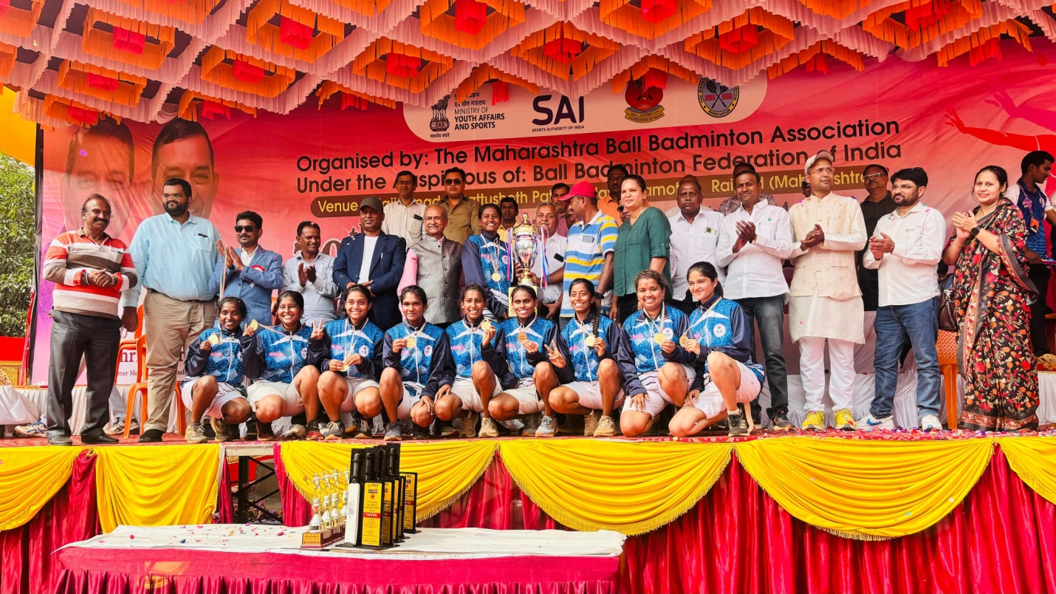
Vishnu Priya GS, 3rd Sem CCE, Represented Ball Badminton Association of Karnataka, Karnataka women's team as the Champions of 70th Senior National Ball Badminton Championship, organized by Maharashtra Ball Badminton Association under the auspicious of Ball Badminton Federation of India held from 26th to 29th of December at Kamothe , Raigad , Navi mumbai, Maharashtra.
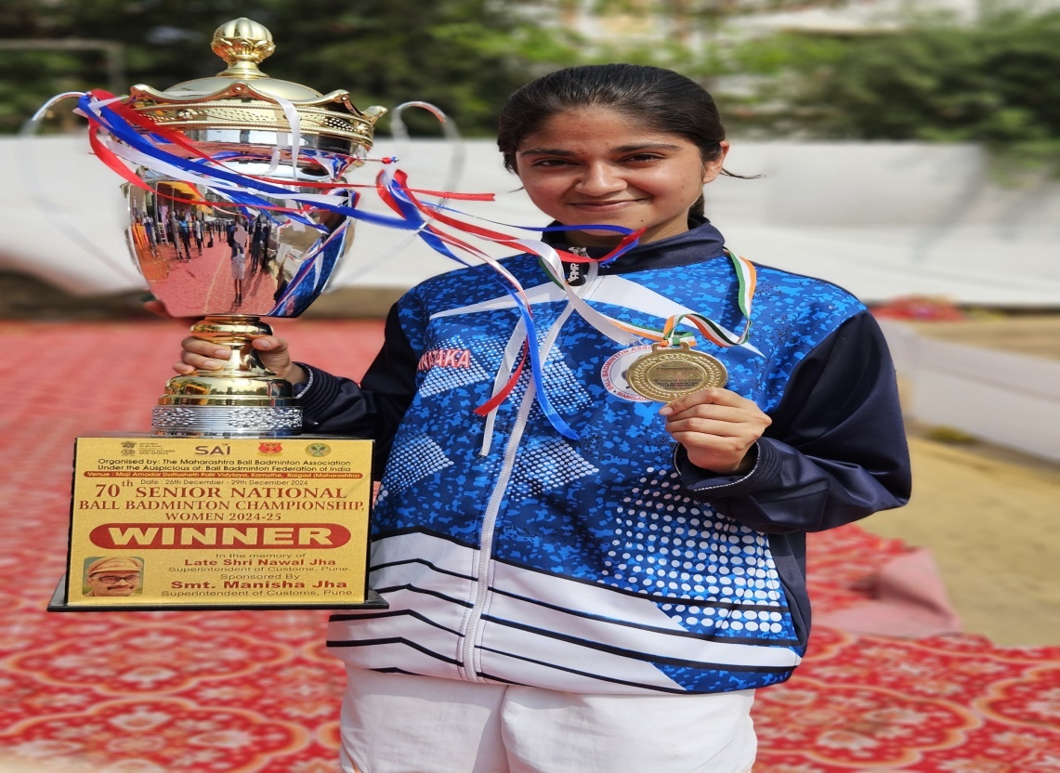

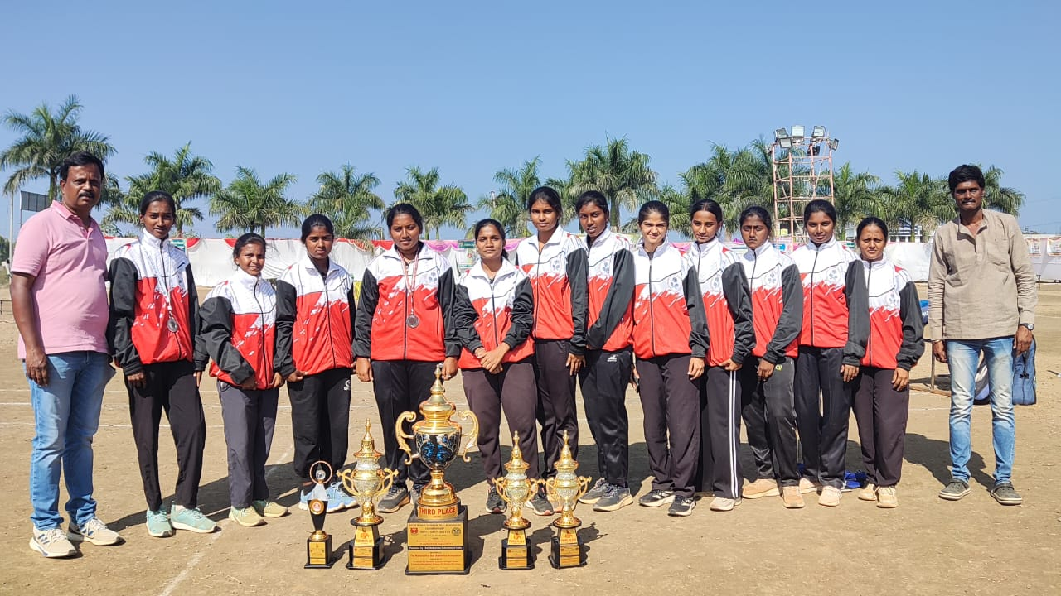
Vishnupriya 3rd Sem of CCE department as the Captain on team karnataka has won the 5th place and 2nd place in Mixed doubles in 69th junior national ball badminton Championship organized by Maharashtra Ball Badminton Association under the auspicious of Ball Badminton Federation of India held from 17th to 21th January 2025 at Devgram, Narkedh ,Nagpur ,Maharashtra.

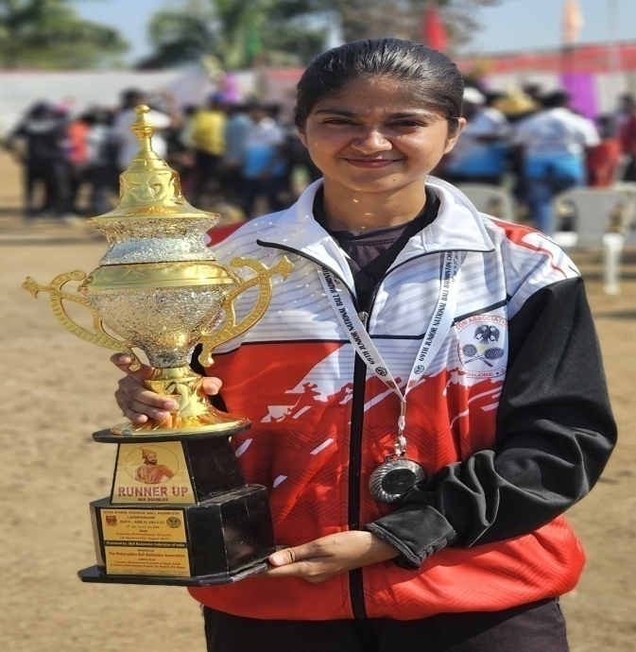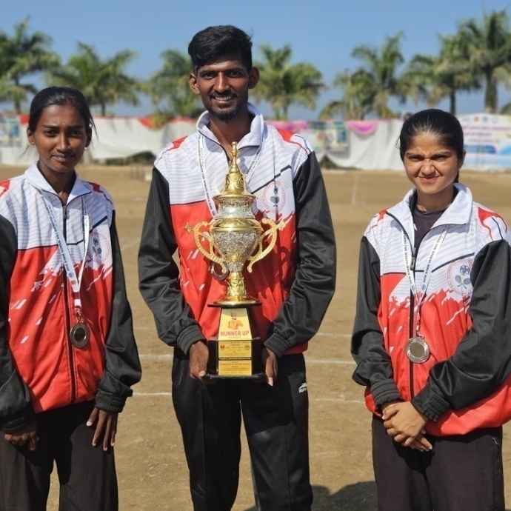

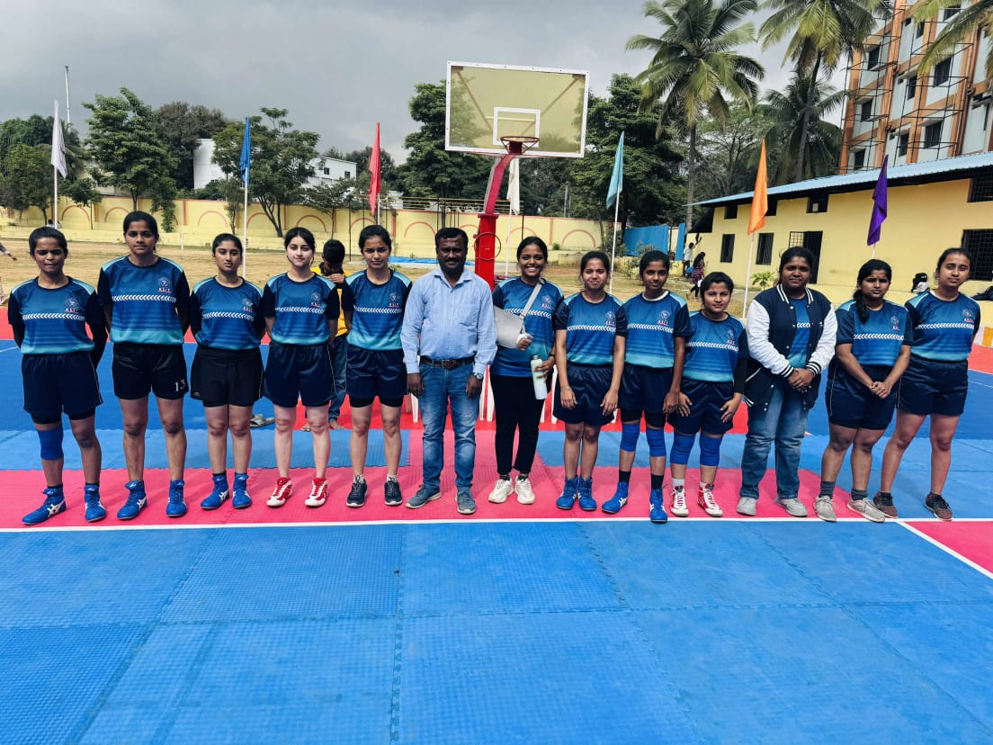
Participated in VTU Inter-Collegiate Bengaluru South Division Kabaddi (W) Tournament 2024 – 2025. at RRCE Bangalore on 15th to 16th November 2024.

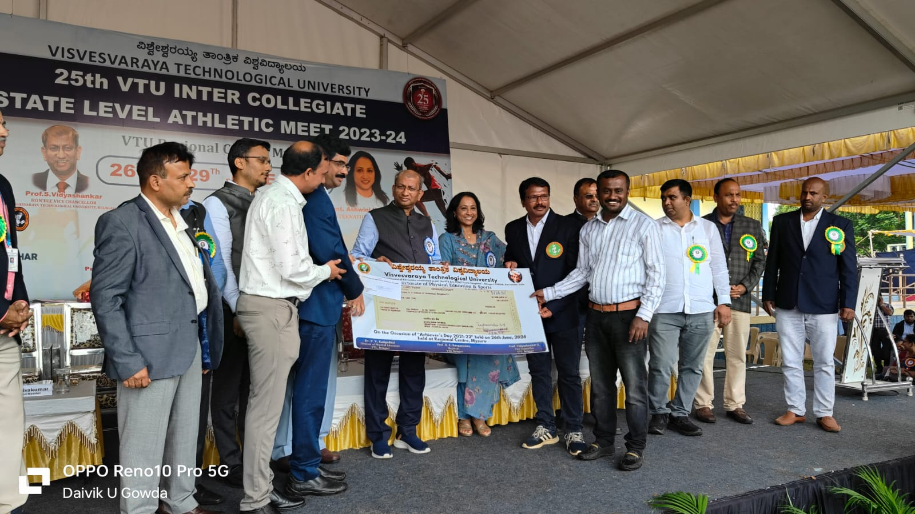KSIT received VTU MERITORIOUS INSTITUTIONS Cash Award of 1 lakh for Sports Achievement for the Academic year 2021-22.
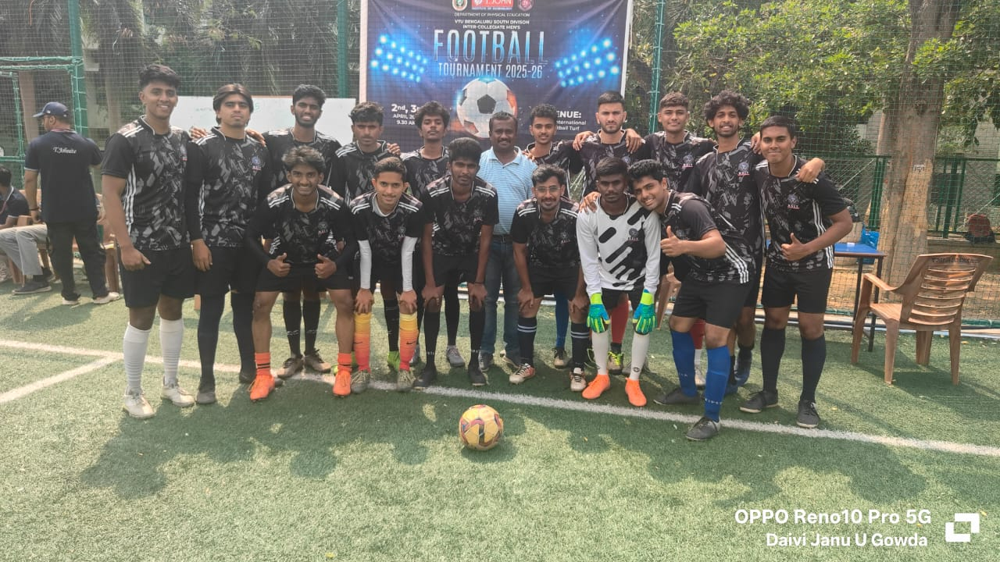
Participated in VTU Inter-Collegiate Bengaluru South Division Football (M) Tournament 2024 – 2025. at T-John IT Bangalore on 2nd to 3rd April 2025.

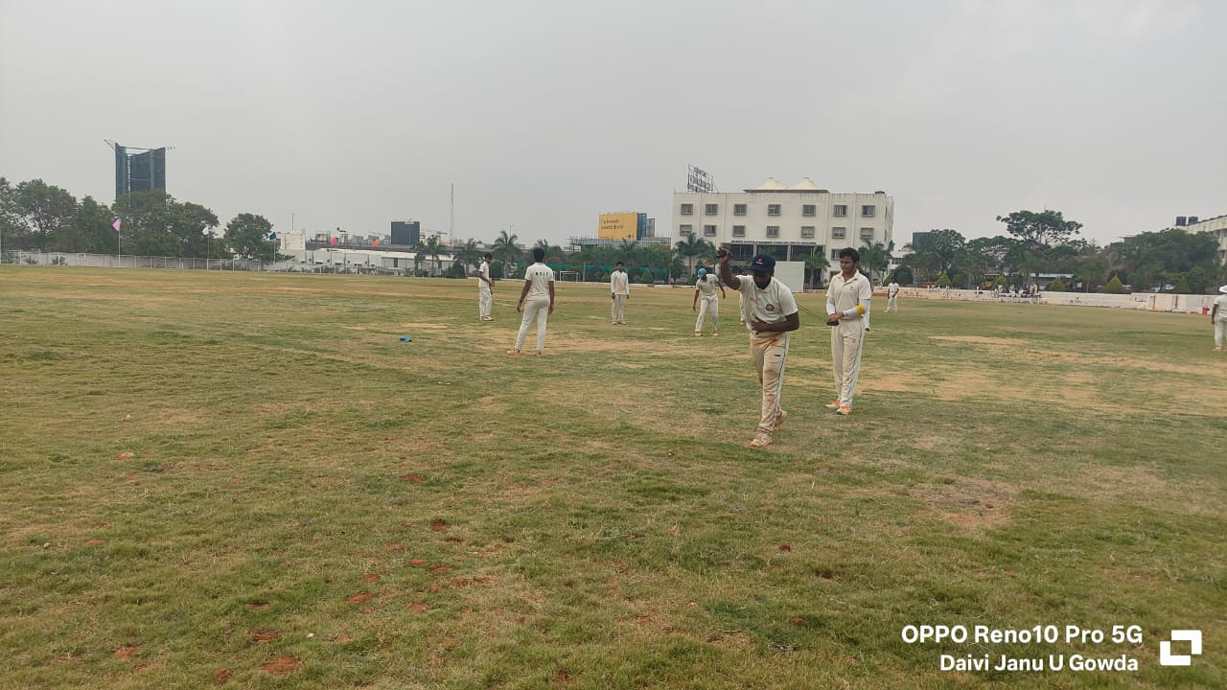
Participated in VTU Inter-Collegiate Bengaluru South Division Cricket (M) Tournament 2024 – 2025. at DBIT Bangalore on 3rd to 10th April 2025.

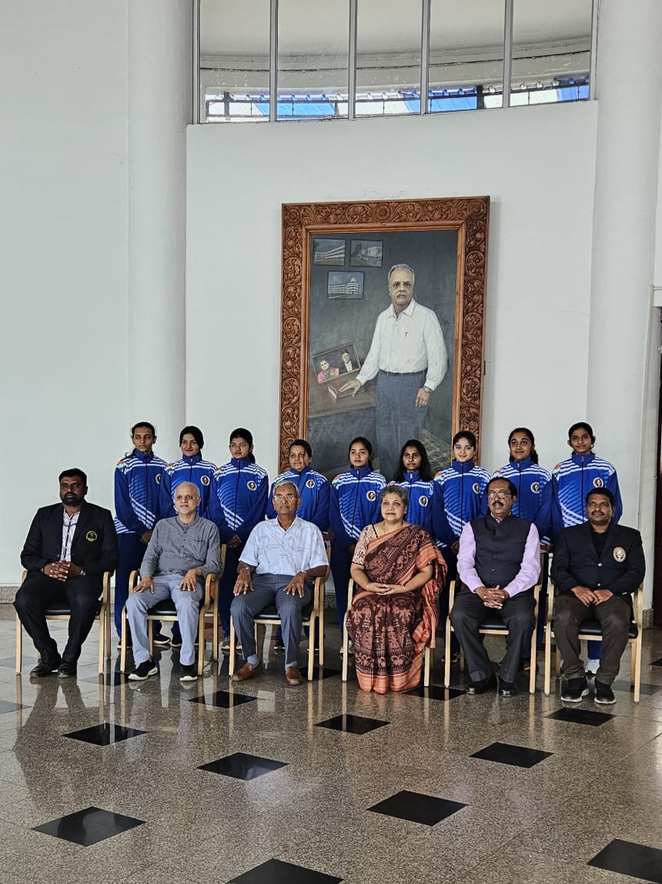
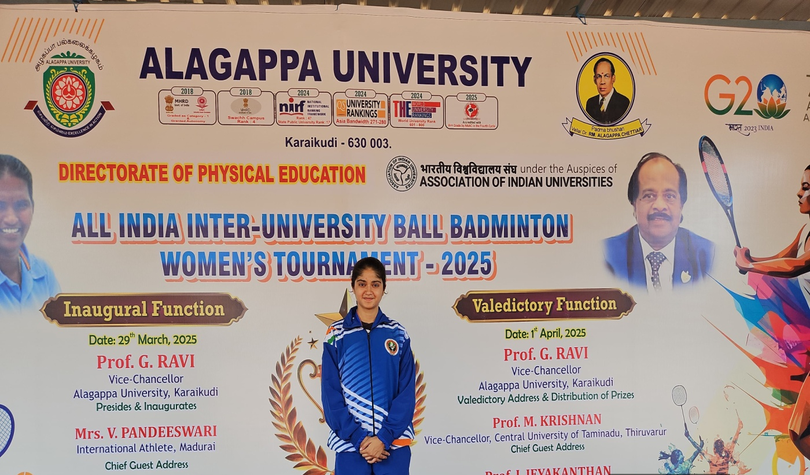
Vshnu Priya G S 4th Sem CCE Represented VTU Ball Badminton (Women) Team in South Zone Inter-University Kabaddi Tournament 2024-25 held at Alagappa University Karaikudi (TN) From to 29th March to 1st April 2025. Hence coaching camp will start from 24th to 28th March 2025 at GSSSIETW Mysuru.

