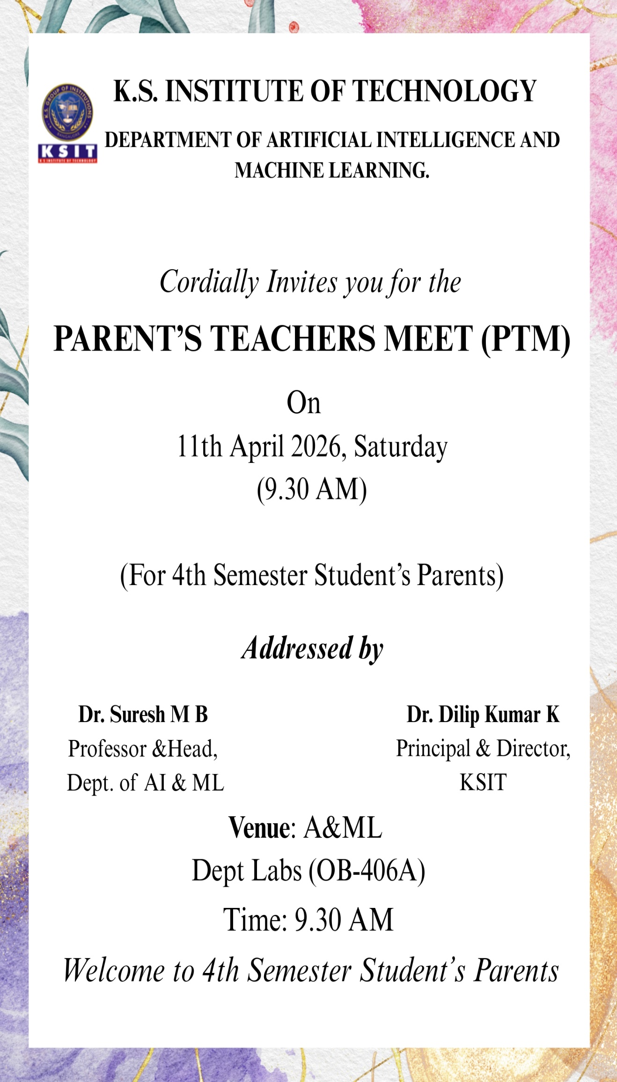

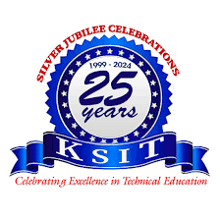
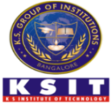
K.S. INSTITUTE OF TECHNOLOGY
DEPARTMENT OF ARTIFICIAL INTELLIGENCE AND MACHINE LEARNING

REPORT ON
PARENT TEACHER MEETING

Semester | 4th Semester - Section “A” & “B”
Event Type | Parent Teacher Meeting
Event Name | Parent Teacher Meeting
Date/Duration | 11/04/20260(One Day)
No. of Students
Venue | Dept. Labs OB-406A
Online link/Offline | Offline

Agenda
- Welcome and Introduction
- Overview of the Engineering Program
- Academic Performance
- Challenges and Support
- Open Forum for Parents
- Closing Remarks

Meeting Overview
1. Welcome and Introduction
The meeting commenced with a warm welcome from all faculties handling 4th Semester A&B Section, who thanked parents for attending and emphasized the importance of collaboration between parents and educators.
2. Overview of the Engineering Program
All faculties of 4th Semester A&B Section provided an overview of the engineering curriculum, highlighting key courses, learning outcomes, and the integration of practical projects. The importance of skills such as teamwork, problem-solving, and critical thinking in engineering education was stressed.
3. Academic Performance
About placement training programme and regular campus interviews with successfully placements. A summary of the overall academic performance of students was presented. The average grades, participation in classes, and attendance records were discussed. Specific attention was given to the performance in subjects.
4. Challenges and Support
Common challenges faced by students were discussed, such as time management, workload, and stress. Strategies for support, including tutoring sessions, mental health resources, and workshops on study skills, were presented.
5. Open Forum for Parents
An open discussion allowed parents to voice their concerns, ask questions, and share feedback. Topics included communication between teachers and parents, student engagement, ways to support students at home and one-on-one meetings for concerned parents.

6. Closing Remarks
The meeting concluded with all faculties thanking parents for their involvement and encouraging them to stay engaged in their child's education. A reminder about the next parent-teacher meeting and upcoming events was also shared.

Glimpse of the Event
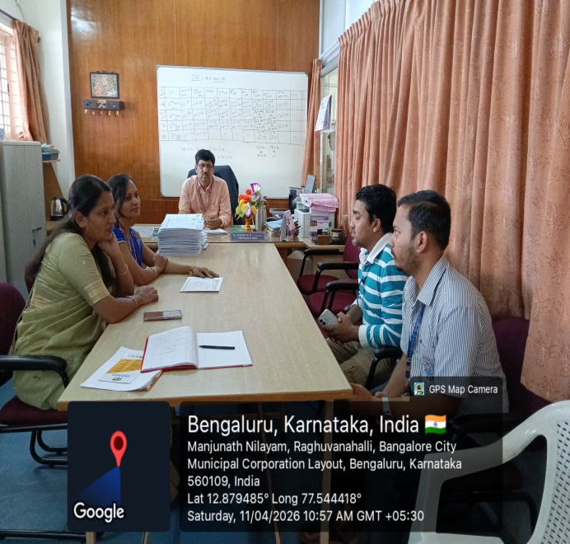 | 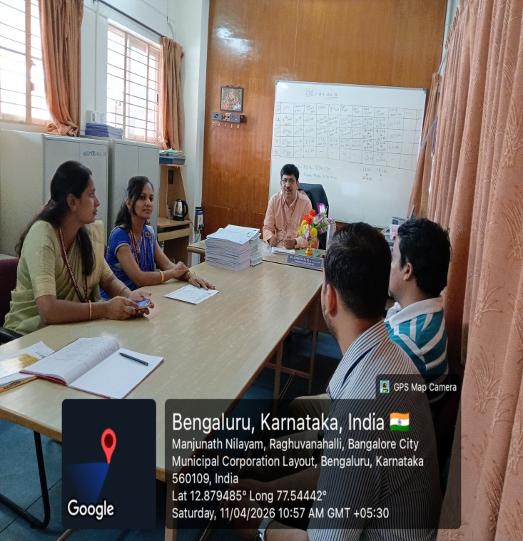
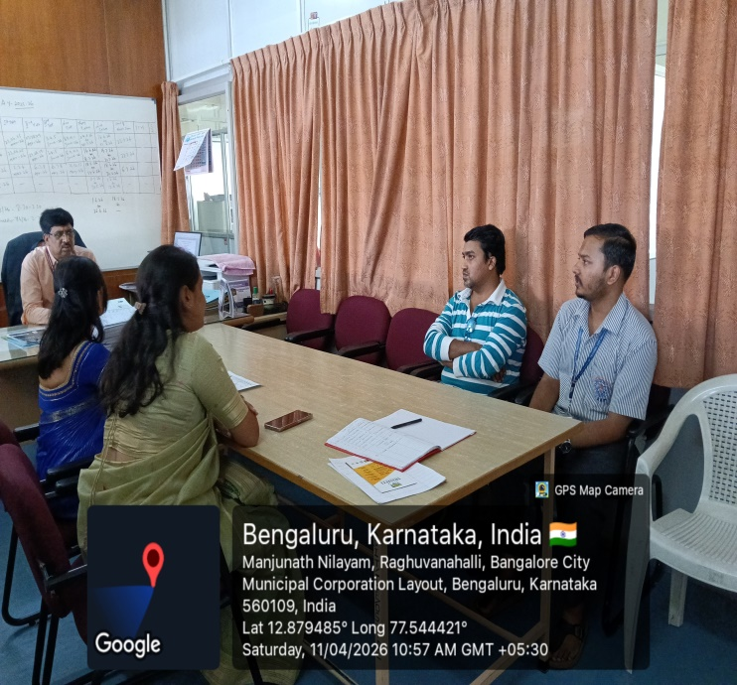 | 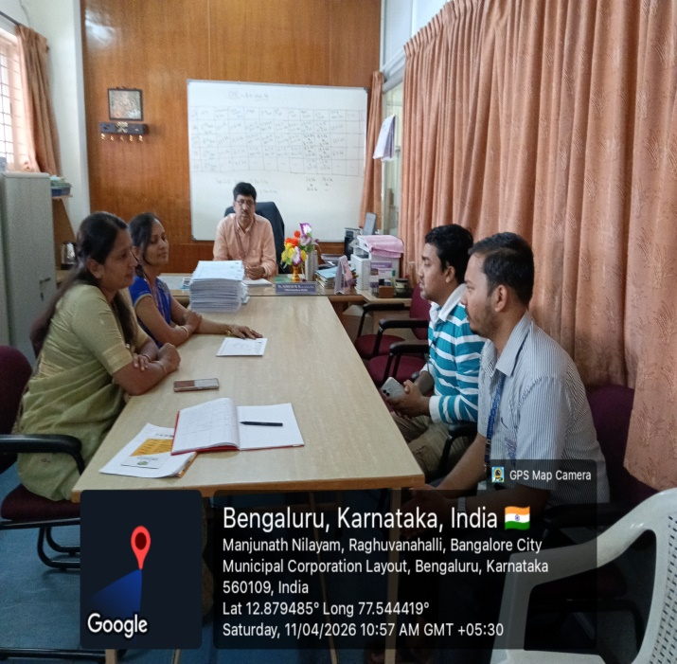

Co-Ordinator Sign HOD AI&ML Principal

