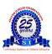

K.S. INSTITUTE OF TECHNOLOGY

DEPARTMENT OF ARTIFICIAL INTELLIGENCE AND MACHINE LEARNING

TECHNICAL SEMINAR
ON
Mentorship & Project Based Sponsorship for
Engineering Innovators

Semester | 4th Semester
Event Type | Technical Seminar
Event Name | Mentorship & Project Based Sponsorship for Engineering Innovators
Date/Duration | 05th March 2026
Associated  Professional Bodies | Dr.Vijay Rao  Founder-VS Pro Trading Academy LLP
No. of Students | 54
Online link/Offline | Offline

Introduction:
This Mentorship & Project Based Sponsorship for Engineering Innovators organized by Department of AI&ML, K.S. Institute of Technology aims to bridge the gap between theoretical knowledge and real-world Exposure by Organizing Technical Seminar by Dr.Vijay Rao Founder-VS Pro Trading Academy LLP.

Overview of Mentorship & Project Based Sponsorship for Engineering Innovators

1. Mentorship for Engineering Innovators
Mentorship connects innovators (students, researchers, or early-stage founders) with experienced professionals who guide them through technical, business, and career challenges.

Key Goals
- Improve technical design and problem solving
- Provide industry insights and best practices
- Support research commercialization
- Help innovators avoid common mistakes

Types of Mentorship
1. Technical Mentorship
- Guidance on engineering design, architecture, and tools
- Example areas: AI, robotics, electronics, manufacturing, renewable energy
2. Research Mentorship
- Support for publishing papers, patent development, and experimentation
3. Startup / Product Mentorship
- Market validation
- Product-market fit
- Go-to-market strategies
4. Career Mentorship
- Skills development
- Networking
- Internship and job opportunities

Typical Mentorship Structure
- Regular meetings (weekly or monthly)
- Prototype/design reviews
- Problem-solving sessions
- Access to mentor networks

2. Project-Based Sponsorship
Project-based sponsorship is when organizations (companies, foundations, or government bodies) provide funding, tools, or resources for specific engineering projects.

What Sponsors Usually Provide
- Financial support
- Hardware, software, or lab equipment
- Access to datasets or proprietary tools
- Industry mentorship
- Testing facilities

Why Companies Sponsor Engineering Projects
- Discover new technologies
- Recruit talented engineers
- Solve real industry problems
- Support innovation ecosystems

3. Typical Sponsorship Model
Stage | Support Provided
Idea Stage | Small grants, concept validation
Prototype Stage | Hardware/software resources, mentor support
Development Stage | Larger funding, industry collaboration
Commercialization | Business support, partnerships

4. Key Stakeholders
Engineering Innovators
- Students
- Researchers
- Early-stage startups
Mentors
- Industry experts
- Professors
- Senior engineers
Sponsors
- Technology companies
- Government innovation programs
- Venture funds
- Foundations

5. Benefits

For Innovators
- Access to expert guidance
- Funding and resources
- Faster prototype development
- Industry exposure

For Sponsors
- Early access to innovation
- Talent pipeline
- Corporate social responsibility (CSR)
- Research collaboration

6. Example Implementation
A typical Engineering Innovation Program might include:
- Application & project proposal
- Selection of teams
- Mentor assignment
- Sponsored funding for prototype
- Regular reviews and progress checks
- Final demo day or technology showcase

7. Success Metrics
Programs often measure success through:
- Number of prototypes built
- Patents filed
- Startups launched
- Research publications
- Industry adoption
In simple terms:
Mentorship provides guidance and expertise, while project-based sponsorship provides funding and resources to turn engineering ideas into real products or technologies.
If you want, I can also explain:
- How to design a Mentorship & Sponsorship program for a university or innovation lab
- Funding models used by global engineering innovation programs
- A practical framework to launch one in India (very relevant for engineering colleges & startups).

Glimpse of the Events

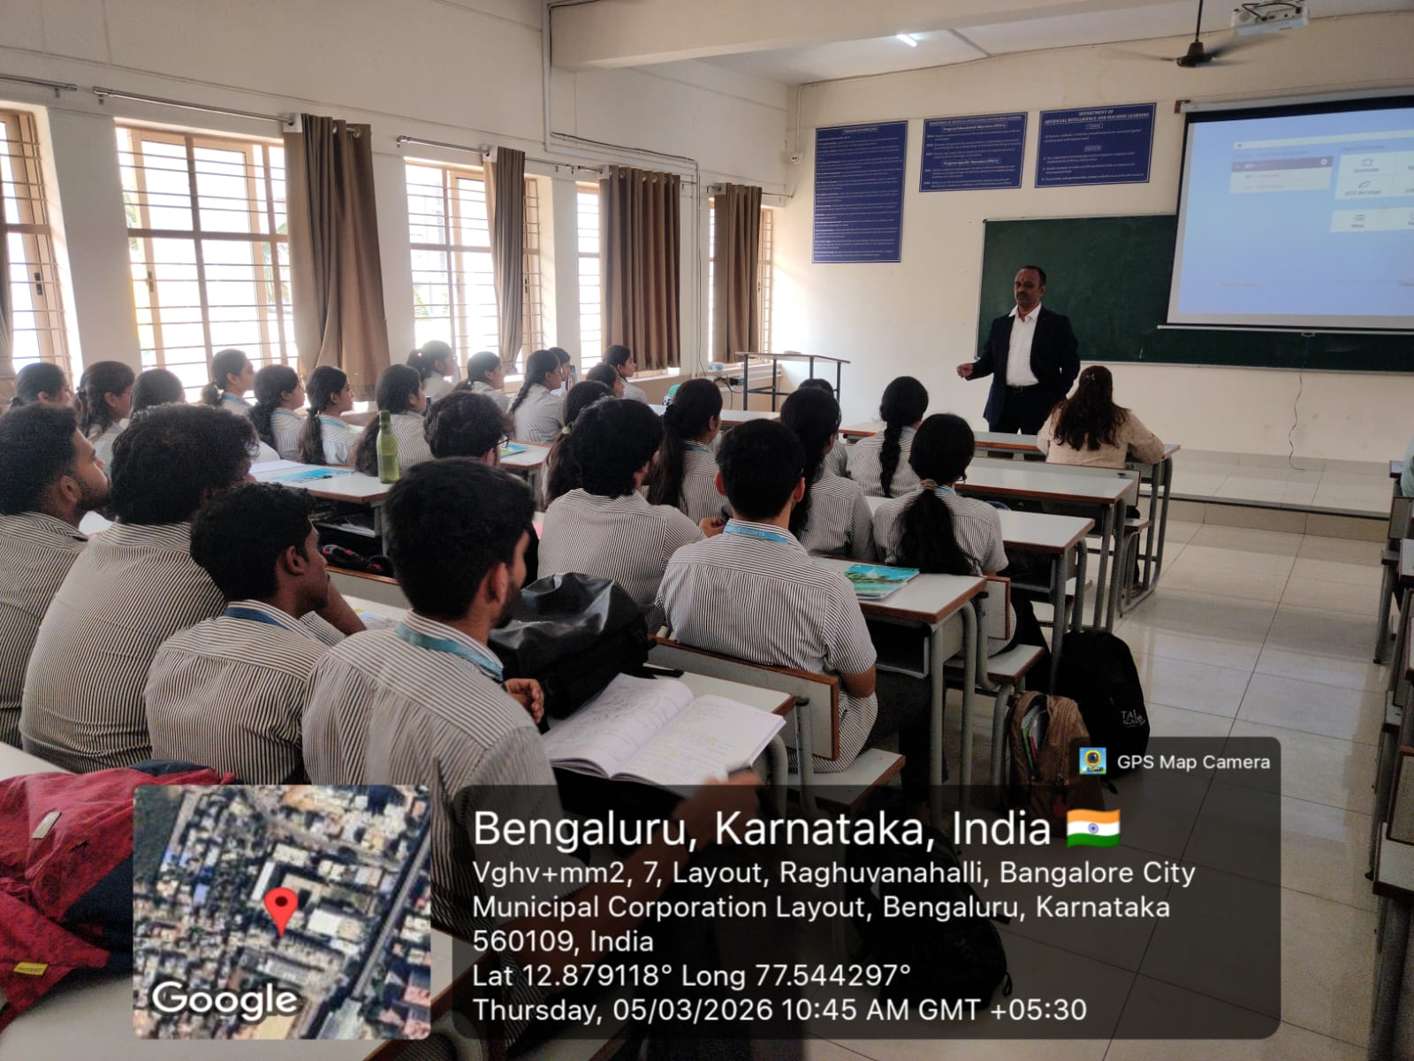 | 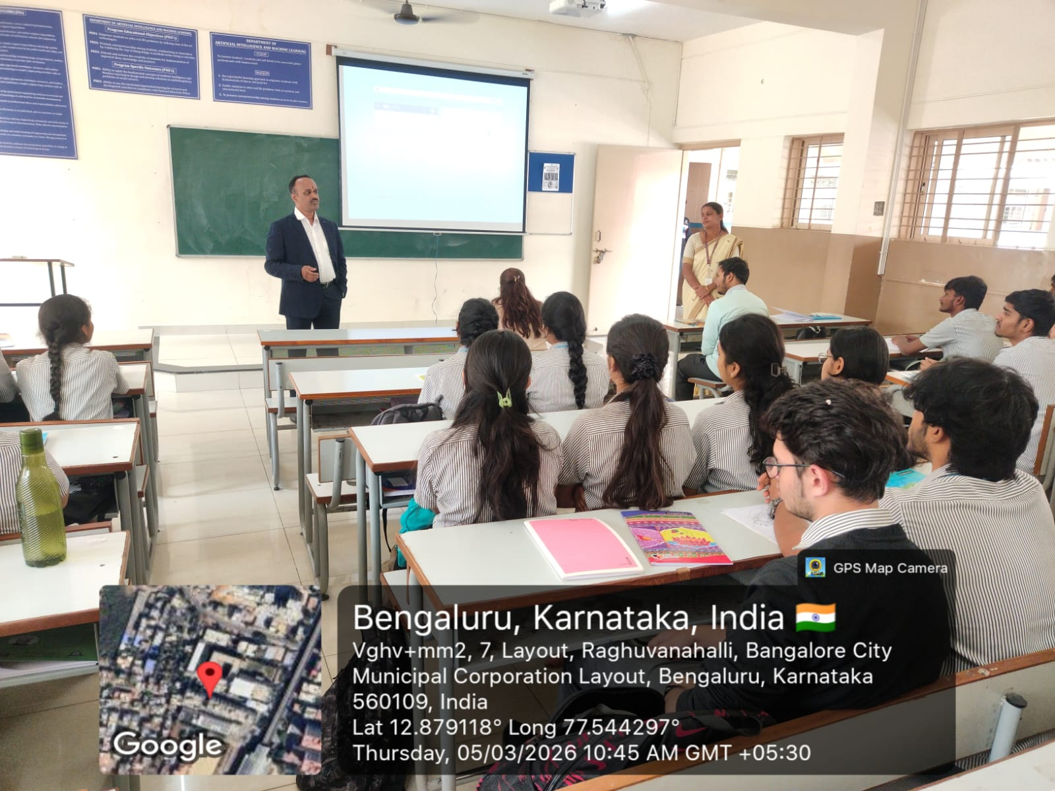
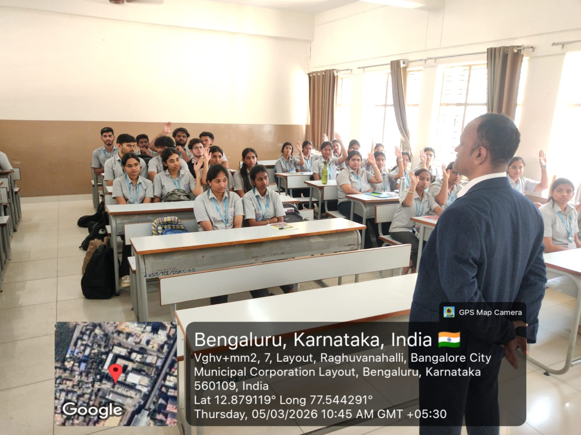 | 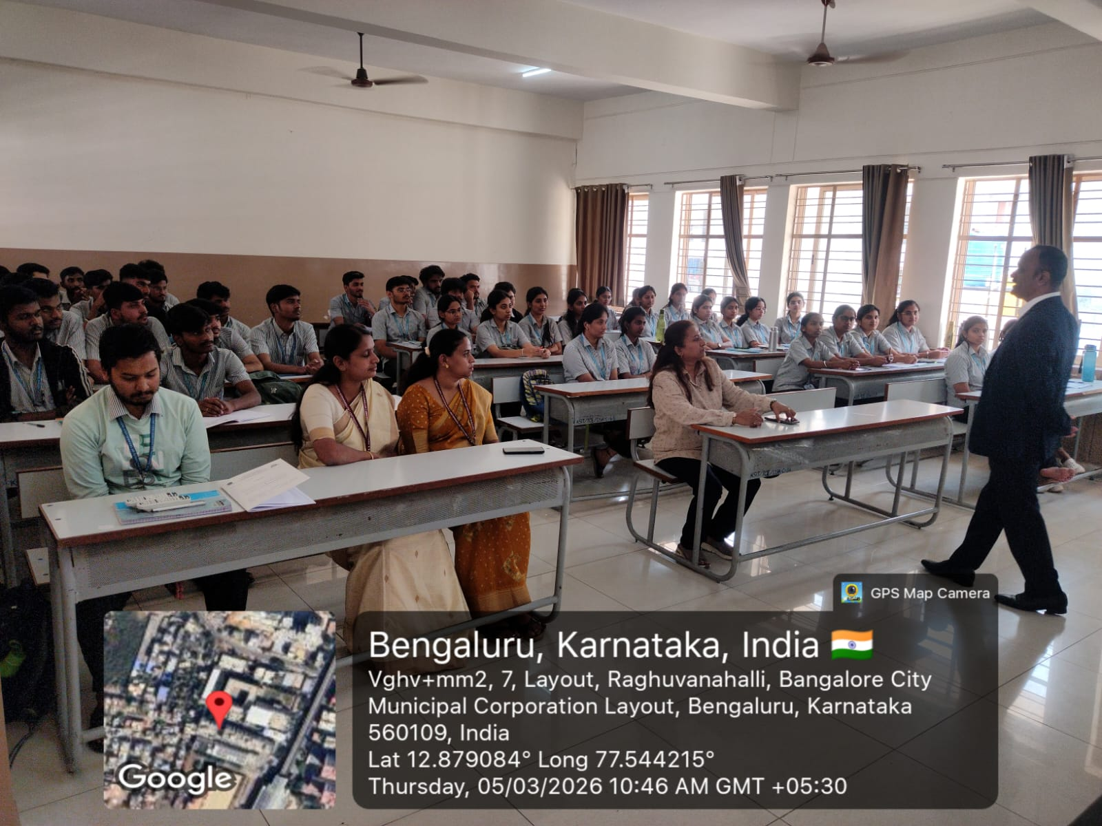

CO/PO Mapping:

CO/PO  &PSO | PO1 | PO2 | PO3 | PO4 | PO5 | PO6 | PO7 | PO8 | PO9 | PO10 | PO11 | PO12 | PSO1 | PSO2
Industrial  Visit | 11 | _ | - | - | - | 2 | - | - | 2 | 2 | - | 2 | 2 | 2

Coordinator Sign HOD AI&ML Principal

K.S. INSTITUTE OF TECHNOLOGY

DEPARTMENT OF ARTIFICIAL INTELLIGENCE AND MACHINE LEARNING

TECHNICAL SEMINAR
ON
Mentorship & Project Based Sponsorship for
Engineering Innovators

