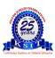
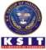
K.S. INSTITUTE OF TECHNOLOGY

DEPARTMENT OF ARTIFICIAL INTELLIGENCE AND MACHINE LEARNING

GUEST LECTURE REPORT ON

Productive Use of E-Waste & Recycling Process

Semester | 7th Semester
Event Type | Guest Lecture
Event Name | Productive Use of E- Waste & recycling Process
Date/Duration | 25th March 2025
Associated  Professional Bodies | Cdr. Sanjay R Jangam (Retd.)  Founder, Ewa Upcycles Pvt Ltd. Bengaluru
No. of Students | 57
Online link/Offline | Offline

Introduction:
This Productive Use of E- Waste & recycling Process organized by Department of AI&ML, K.S. Institute of Technology aims to bridge the gap between theoretical knowledge and real-world Exposure by Organizing guest lecture by Cdr. Sanjay R Jangam (Retd.) Founder, Ewa Upcycles Pvt Ltd.

Overview of Productive Use of E- Waste & recycling Process

- Metal Recovery – Gold, silver, copper, and platinum from circuit boards used in electronics, automotive, and jewelry.
- Plastic Reuse – Casings and cables recycled into furniture, tiles, or packaging.
- Glass Recovery – Screen glass reused in building materials and fiberglass.
- Battery Recycling – Lithium, cobalt, and nickel reused in new batteries and electric vehicles.
- Refurbishment & Reuse – Old devices repaired, upgraded, and donated.
- Upcycling – Creative repurposing into art, furniture, or educational kits.

Topics Covered:

• Introduction to E-Waste
- Definition, sources, and examples of electronic waste.
• Need for E-Waste Management
- Rising e-waste generation, environmental and health hazards.
• Objectives of E-Waste Recycling
- Conservation, pollution control, resource recovery, employment.
• Productive Uses of E-Waste
- Metal recovery
- Plastic reuse
- Glass recovery
- Battery recycling
- Refurbishment and upcycling
• E-Waste Recycling Process
- Collection & transportation
- Sorting & dismantling
- Shredding & size reduction
- Separation techniques (magnetic, eddy current, chemical, water/air)
- Refining & recovery
- Safe disposal of hazardous waste
• Benefits of E-Waste Recycling
- Environmental, economic, and social benefits.
• Challenges in E-Waste Management
- Informal sector handling, lack of awareness, high recycling costs, improper disposal.
• Government Policies & Regulations
- E-waste management rules, producer responsibility, international guidelines (e.g., Basel Convention).
• Case Studies / Examples
- Successful e-waste recycling initiatives (India & global).
• Future Scope & Sustainable Practices
- Circular economy, green design, consumer awareness.

The Students are interacted with resources person & discussed many ways of E-Waste recycling Process. The Guest lecture was Effective & useful and Students of 7th Semester were participated.

Glimpse of the Events

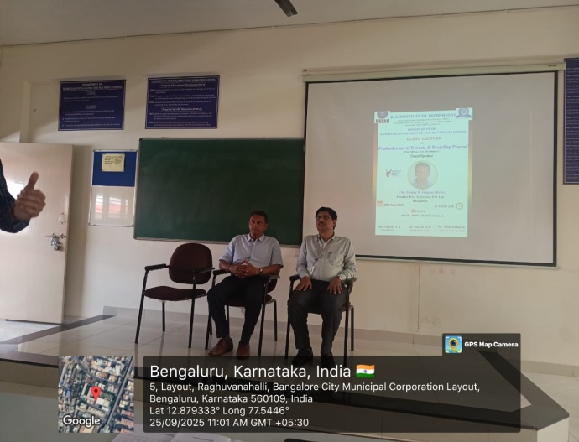 | 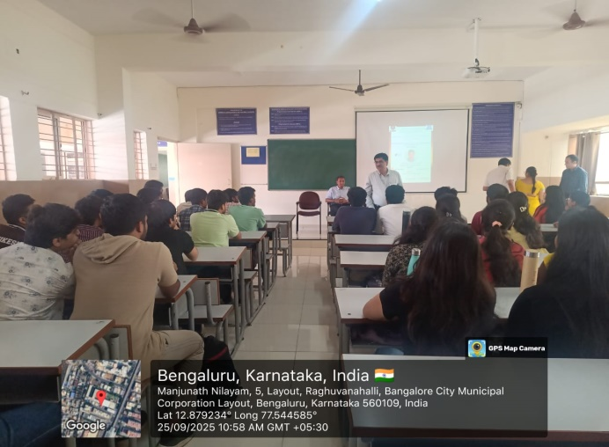
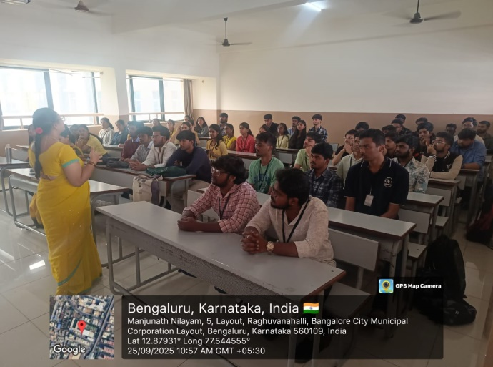 | 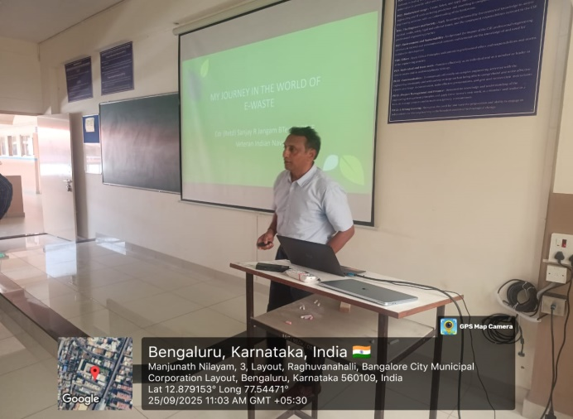

CO/PO Mapping:

CO/PO  &PSO | PO1 | PO2 | PO3 | PO4 | PO5 | PO6 | PO7 | PO8 | PO9 | PO10 | PO11 | PO12 | PSO1 | PSO2
Industrial  Visit | 2 | _ | - | - | - | 2 | - | - | 2 | 2 | - | 2 | 2 | 2

Coordinator Sign HOD AI&ML Principal

K.S. INSTITUTE OF TECHNOLOGY

DEPARTMENT OF ARTIFICIAL INTELLIGENCE AND MACHINE LEARNING

GUEST LECTURE REPORT ON

Productive Use of E-Waste & Recycling Process
