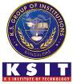
K. S. INSTITUTE OF TECHNOLOGY
#14, Raghuvanahalli, Kanakapura Road, Bangalore-560109.
Faculty Name | WASIM YASIN | 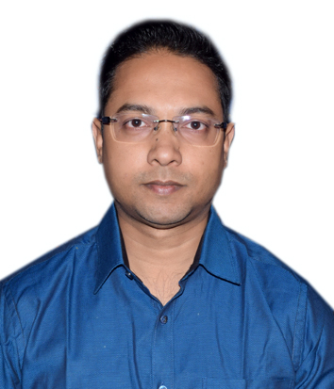
Designation | ASSISTANT PROFESSOR
Educational Qualification | B.E, M.Tech
Experience in Years | 9 Years
Areas of Interest | Machine Learning, Programming Languages
E-mail | wasimyasin@ksit.edu.in

Educational Details
Examination/  Degree | College / University | Year of  Passing
UG | Dibrugarh University | 2007
PG | CHRIST Deemed to be University | 2023
PhD (Pursuing) | CHRIST Deemed to be University | --

Publications
[1] W. Yasin and N. Jayapandian, ”A Review on Cyber Security Issues and Research Challenges in Internet of Things,” 2021 4th International Conference on Recent Trends in Computer Science and Technology (ICRTCST), Jamshedpur, India, 2022.
[2] W. Yasin, K. Harimoorthy and D. Vetriveeran, ”Identification of Consumer Buying Patterns using KNN in E-Commerce Applications,” 2023 3rd International Conference on Pervasive Computing and Social Networking (ICPCSN), Salem, India, 2023.
Awards
Professional Membership
Contact Details
Name: Wasim Yasin
Official Address: K. S. Institute of Technology, #14, Kanakapura road, Raghuvanahalli, Bengaluru-560109.
Phone Nos: 8011551290
Alternate Email: wasim2222@gmail.com

