
K. S. INSTITUTE OF TECHNOLOGY
#14, Raghuvanahalli, Kanakapura Road, Bangalore-560109.
Faculty Name | MADESHA.B.P | 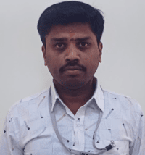
Designation | Attender
Educational Qualification | SSLC
Experience in Years | 20 Years
Areas of Interest
Aadhar Number | 938864153604
E-mail | 96madesha@gmail.com

Educational Details
Examination/  Degree | College / University | Year of  Passing
SSLC | RMPHS,KANAKPURA | 2012
 | -

Publications
1.
2.
Professional Membership
1.
Contact Details
Name: MADESHA.B.P
Official Address:#65,NANJUNDESHWARA LAYOUT,1ST MAIN.2ND CROSS,VAJARAHALLI,BANGALORE
Phone Nos: +91 9845660703
Alternate Email: 96madesha@gmail.com

