
K. S. INSTITUTE OF TECHNOLOGY
#14, Raghuvanahalli, Kanakapura Road, Bangalore-560109.
Faculty Name | S. Om Prakash | 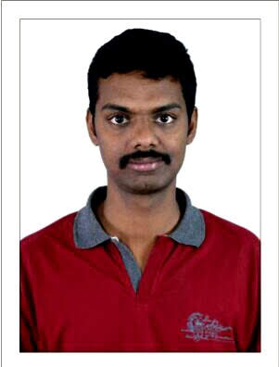
Designation | Foreman
Educational Qualification | DEEE
Experience in Years | 20 Years
Areas of Interest
Aadhar Number | 53051436224
E-mail | omprakashs@ksit.edu.in

Educational Details
Examination/  Degree | College / University | Year of  Passing
DIPLOMA | GOVT.POLYTECHNIC,GUDUR, A.P | 2010-2012
 | -

Publications
1.
2.
Professional Membership
1.
Contact Details
Name: S. Om Prakash
Official Address: #570,1st floor ,6th mail,4th phase,BEML Layout, RR Nagar
, Bnagalore - 560109
Phone Nos: +91 9964231616
Alternate Email: sarpurprakash@gmail.com

