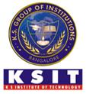 K.S.INSTITUTE OF TECHNOLOGY

KSIT Alumni Association
‘Chiranthana’

The Alumni Meet was organized on 10th November 2019 in KSIT conference hall at 11.00 am
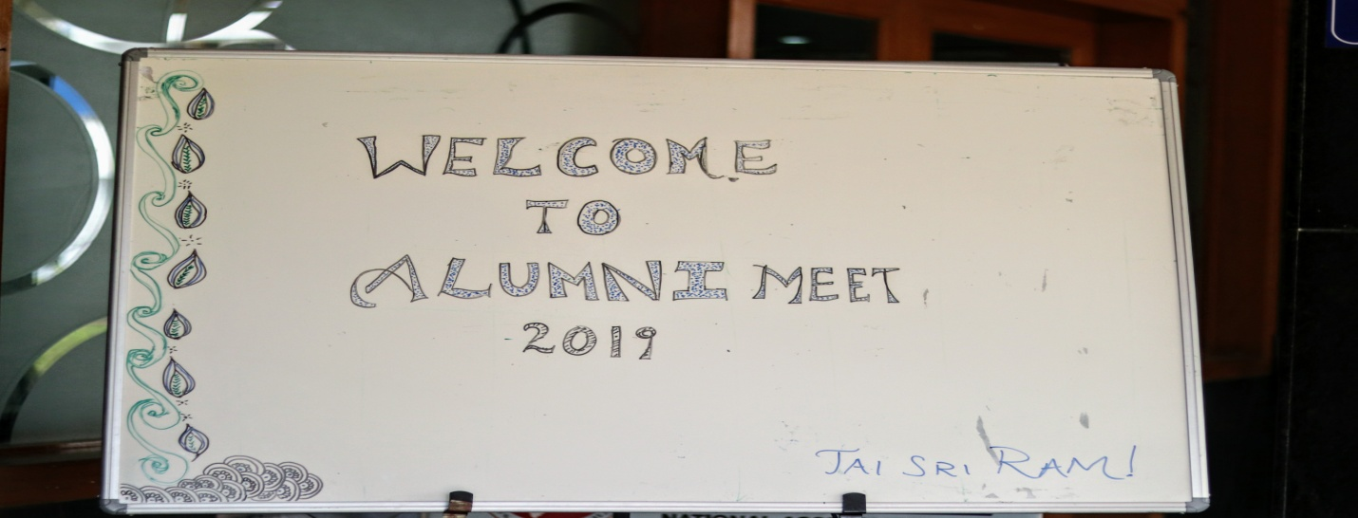
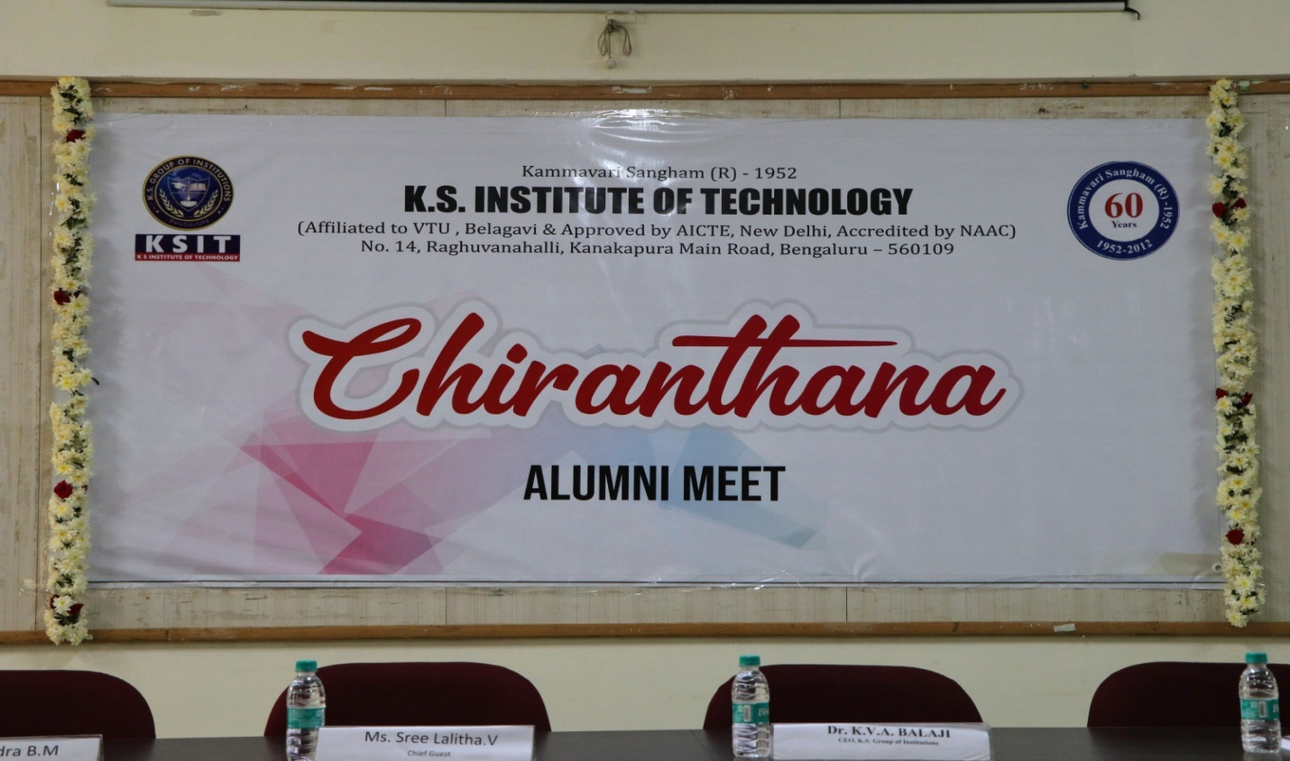
The Registration for the Alumni Meet started at 10.00 am. The total number of Alumni who attended the meet was 137
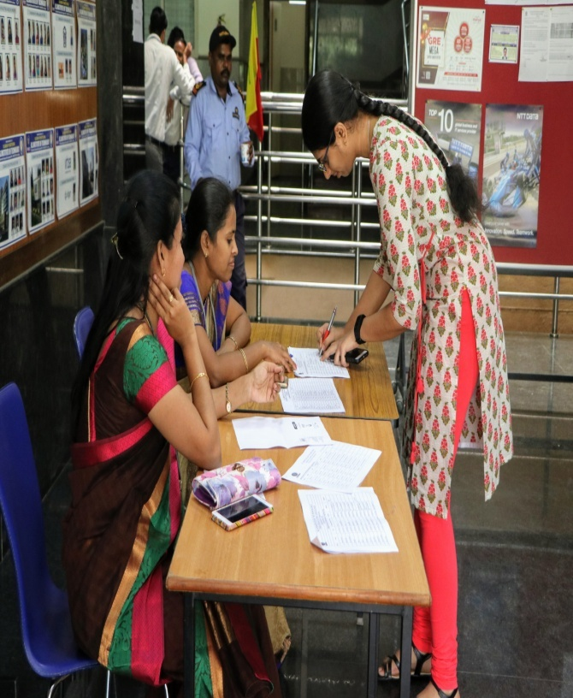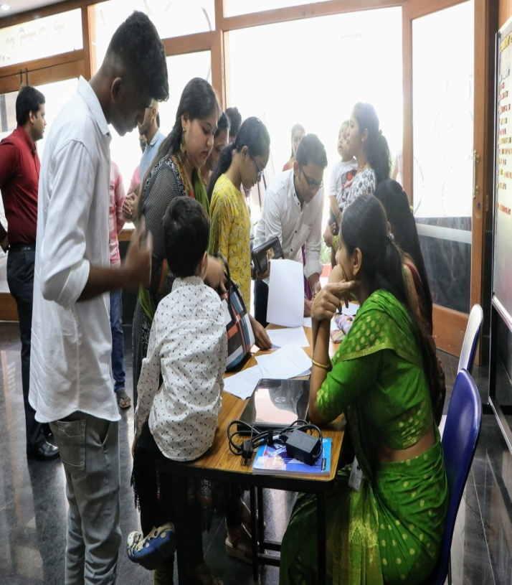\
Registration Desk
Ms.Sree Lalitha.V , Alumni of 2010 and currently working as Deputy Manager, Continental India Pvt.Ltd. was present as the Chief Guest for the Alumni Meet. Mr.Nagendra B.M an Alumni of 2014 and working as Script Writer and Content Director for Kannada Film and TV Industires, was present as Guest of Honor. Mr.K.V.A.Balaji, CEO K.S.Group of Institution, and Mr.K.Ramanarshima, Principal of KSSEM and Dr.T.V.Govindaraju Principal of K.S.I.T and Rector of the Alumni Association were also graced the occasion

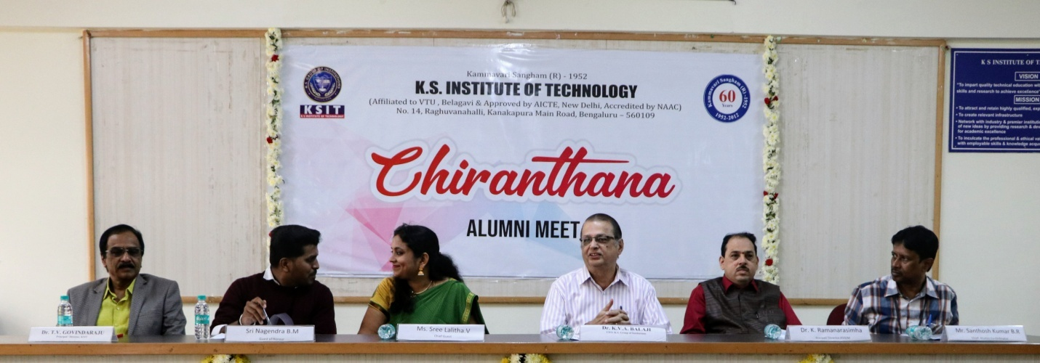

Dignitaries on the Diaz

After the registration Meet begin at 11.00 am .with an invocation song by the students of ECE and C.Sc Department.
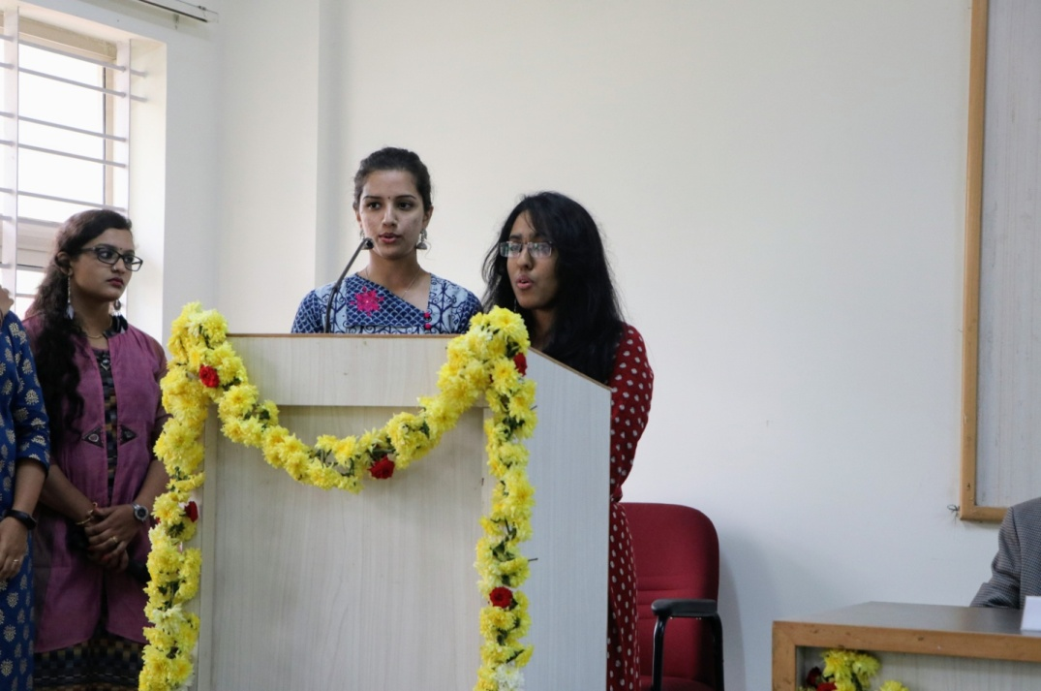
Invocation Song
Ms. Ananya, Telecommunication student welcomed the Alumni Guests and other Dignitaries for the meet.

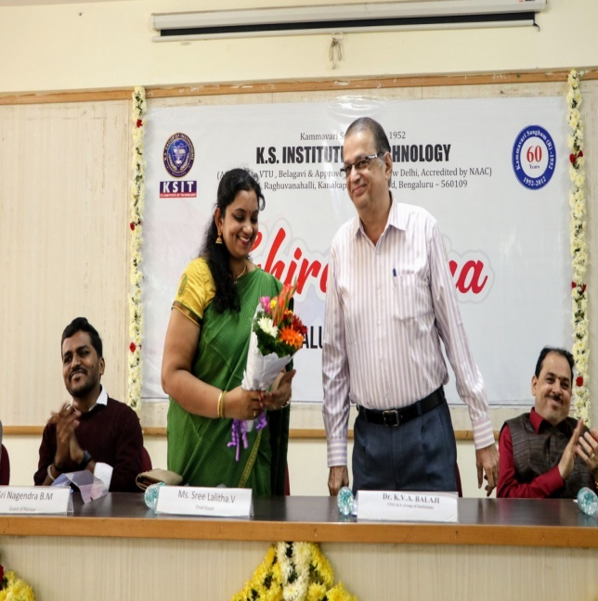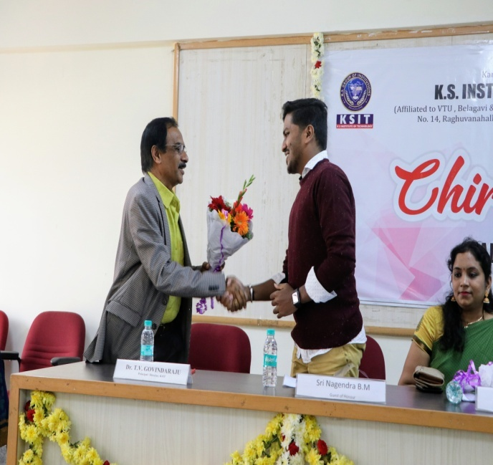

CEO Welcoming Chief Guest Principal Welcoming Guest of Honor

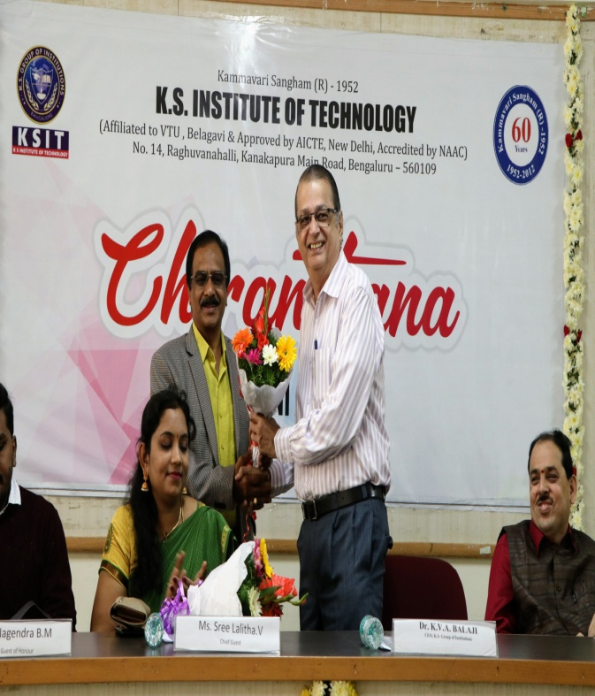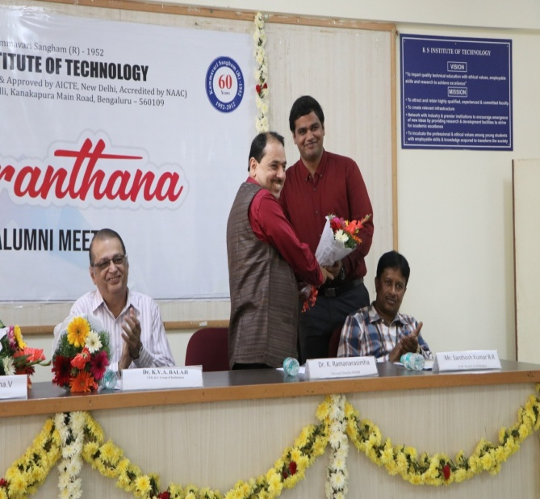
Principal Welcoming Dr.K.V.A. Balaji CEO, Alumni Association President Welcoming KSSEM
K.S.Group of Institutions Principal

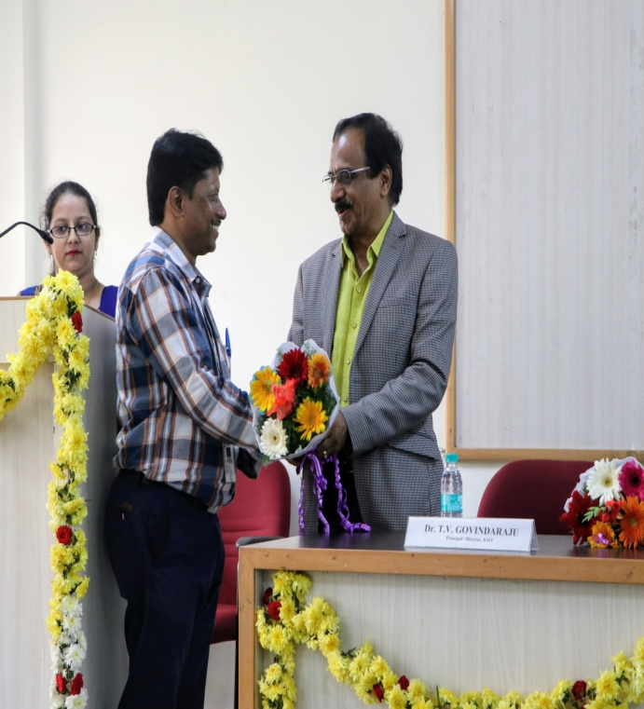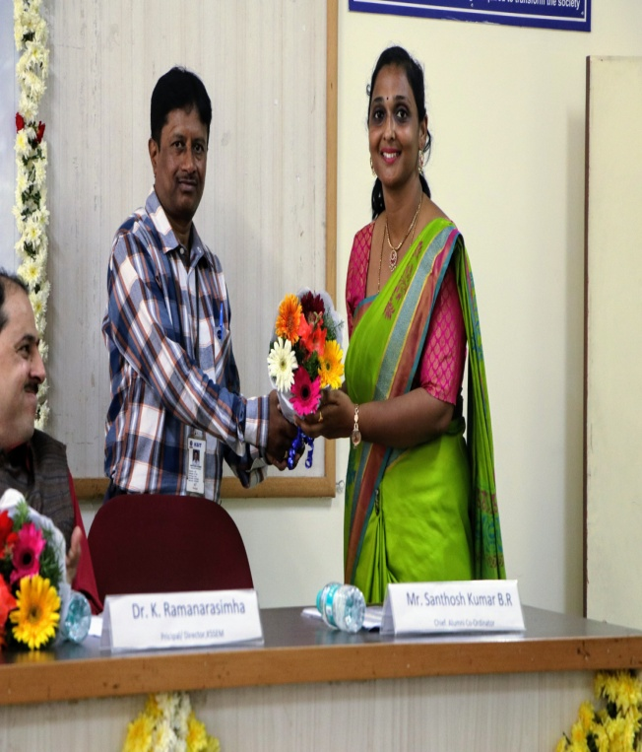
Alumni Coordinator welcoming the Principal Alumni Association Secretary Welcoming the
Alumni Coordinator

After Welcoming the Alumni Guests, Dignitaries and Alumni’s present did the lighting of the lamp
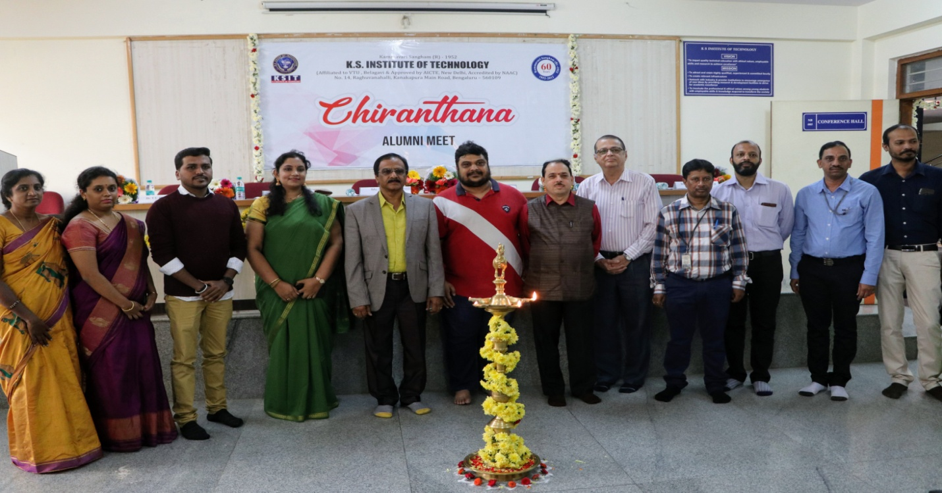D
Dignitaries Lighting the Lamp
After lighting the lamp the Mr.Santhosh Kumar Alumni Association Coordinator presented the report about the activities of the association. Then Chief Guest and Guest of Honor addressed the gathering. The Chief Guest in her address refreshed her memories of KSIT and also she remembered the help she got from the faculty members during her studies. The Guest of Honor shared his experience of the film industry and also said the difficulties he faced when he changed his career from company to industry.
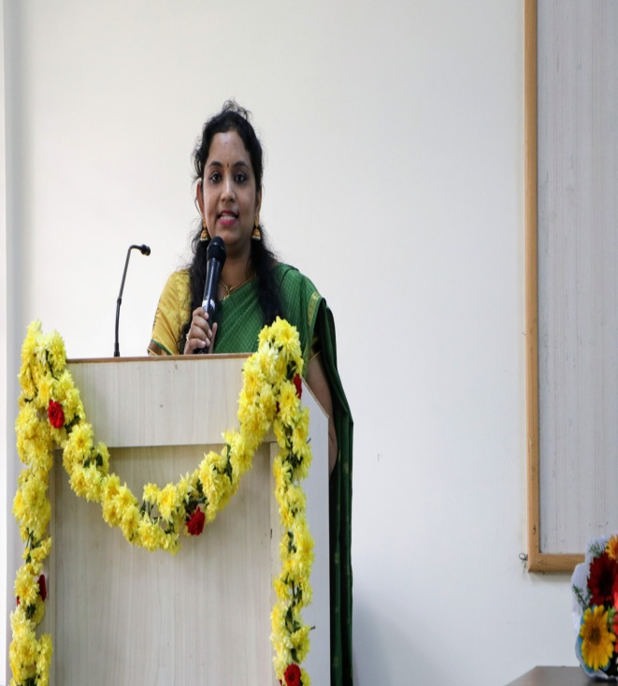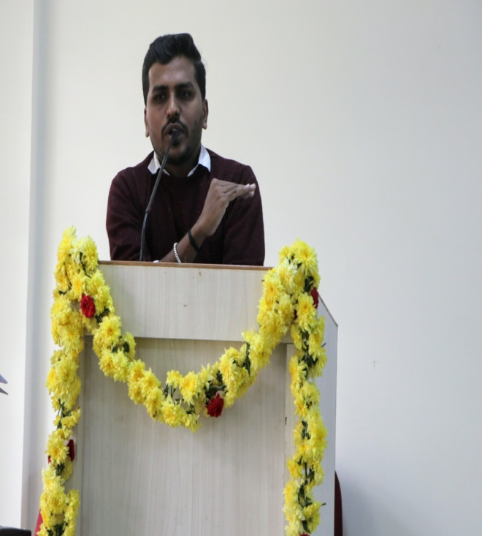
Ms..Sree Lalitha Chief Guest and Mr.Nagendra Guest of Honor Addressing the gathering
After the Alumni Guests address the Alumni’s present were requested to share their view s and also the share the memories of the college days.
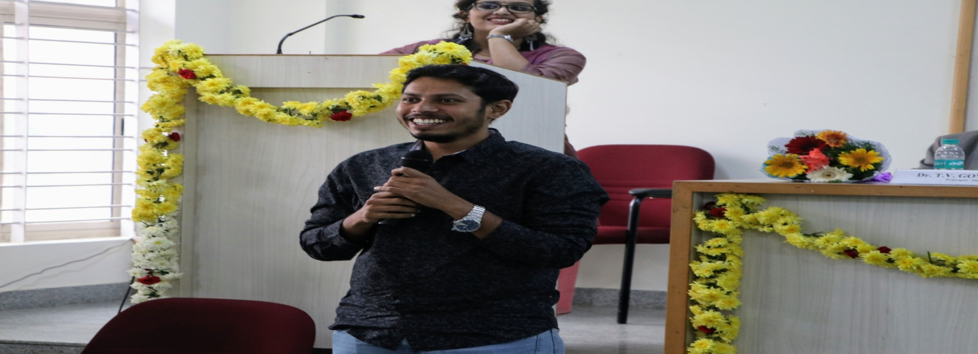
Alumni sharing the memories and successes
After the Alumni’s view the Chief Guest was presented a Memento by Dr.K.V.A.Balaji, CEO K.S.Group of Institutions

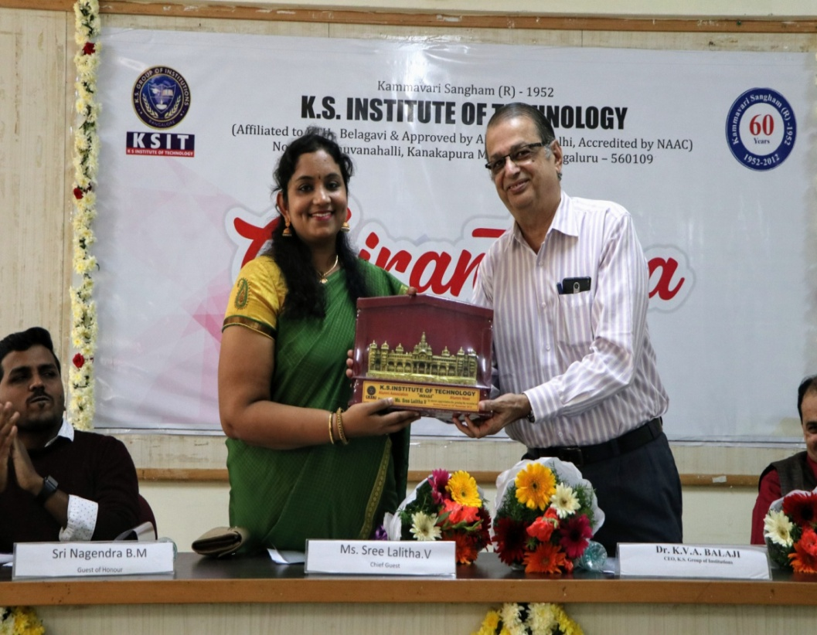

Then the Guest of Honor was presented a Memento by the Principal K.S. Institute of Technology

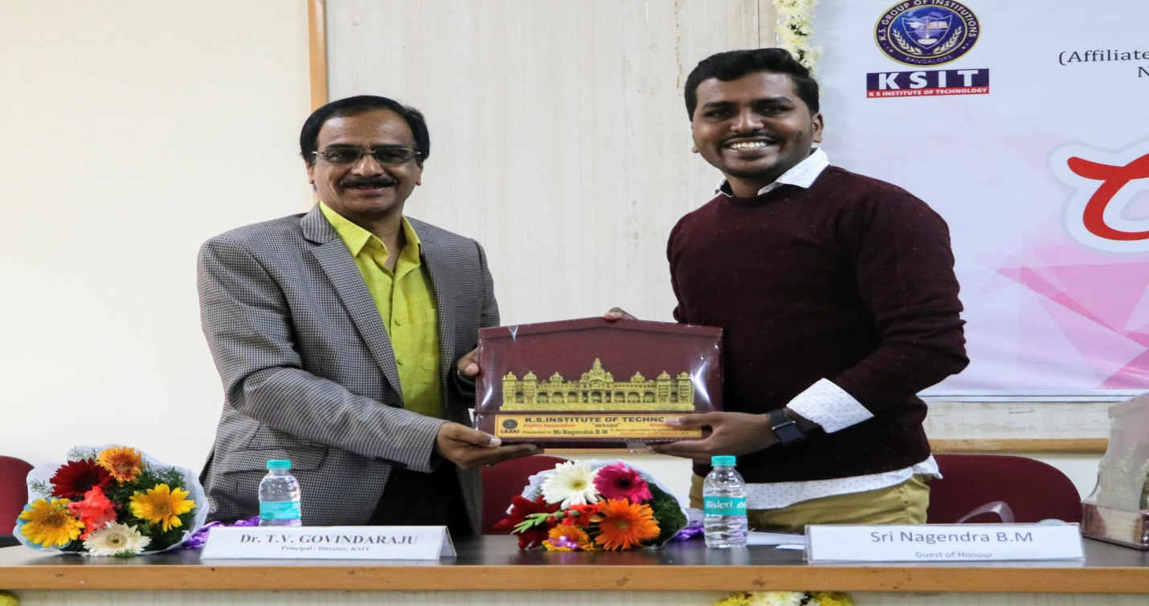

Then the Alumni Contributors were presented award for the contributions they have made to the organization. Mr.Ashwik Prabhu Alumni of 2010 batch was awarded for the activities conducted for the Mechanical students through Alumni Association. Ms.Girishma an Alumni of 2017 batch was also awarded for the support extended to computer science department in organizing the Centinal Hackthon 2019.

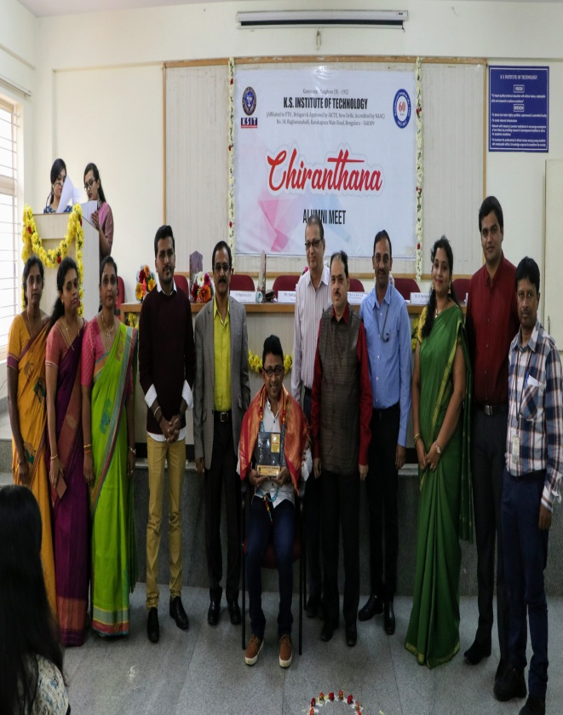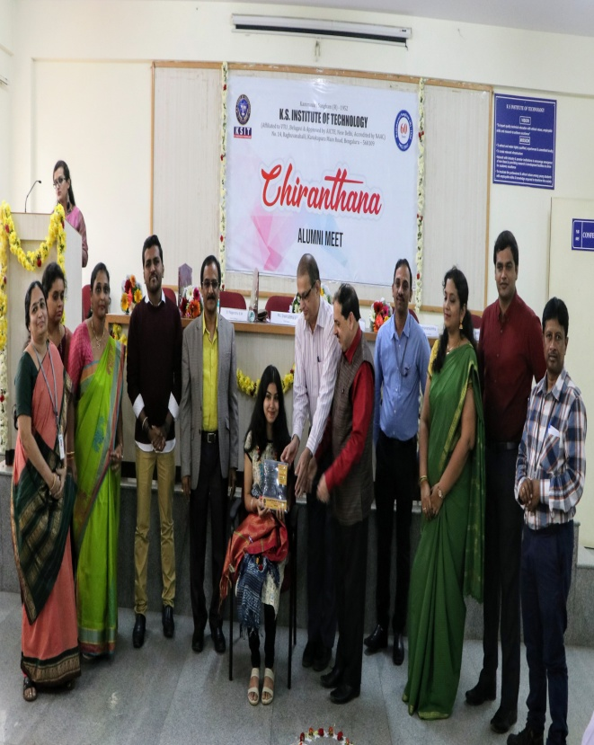
Mr. Mr.Ashwik Prabhu and Ms. Girishma receiving Alumni contributor award from the Dignitaries

After the felicitation Dr.K.V.A.Balaji, CEO ,K.S.Group of Institutions addressed the Alumni’s present. In his address he thanked the Alumni’s for attending the meet and also requested them to keep visiting the institute.
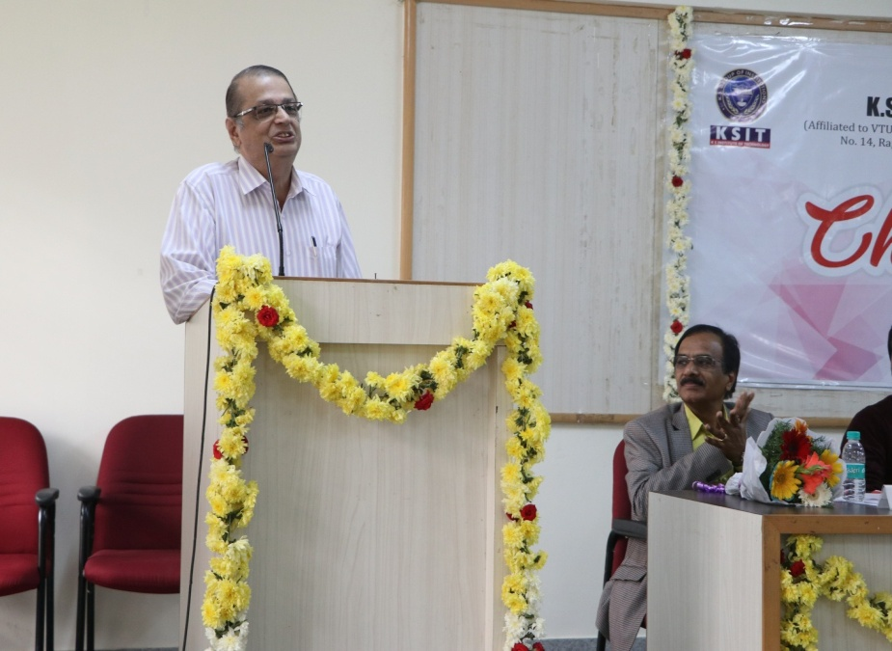
Dr.K.V.A.Balaji, CEO K.S.Group of Institutions addressing the Alumni

After the CEO addresses Dr.T.VGovindaraju, Principal and also Rector of the Alumni association addressed the Alumni’s present. In his address he appreciated the Alumni who have come forward to conduct the various activities for the benefit of the present students. He also motivated the Alumni’s to come forward to help in organizing more events for the benefit of the student community though Alumni Association.
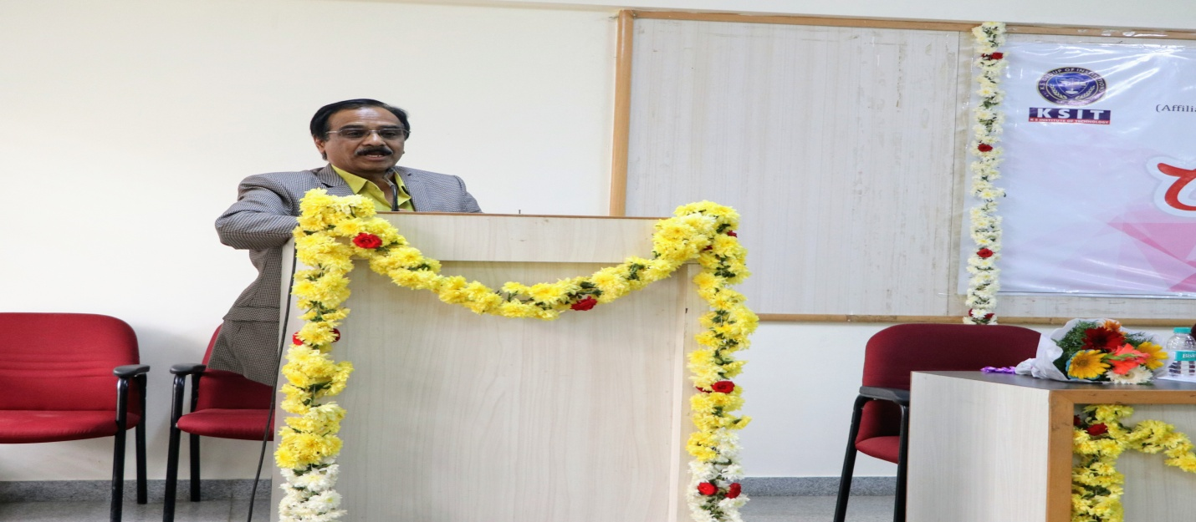
Principal and Rector of the Association addressing the Alumni’s

After the Principal address the entertainment program was presented by Mr.Hrthvik and team
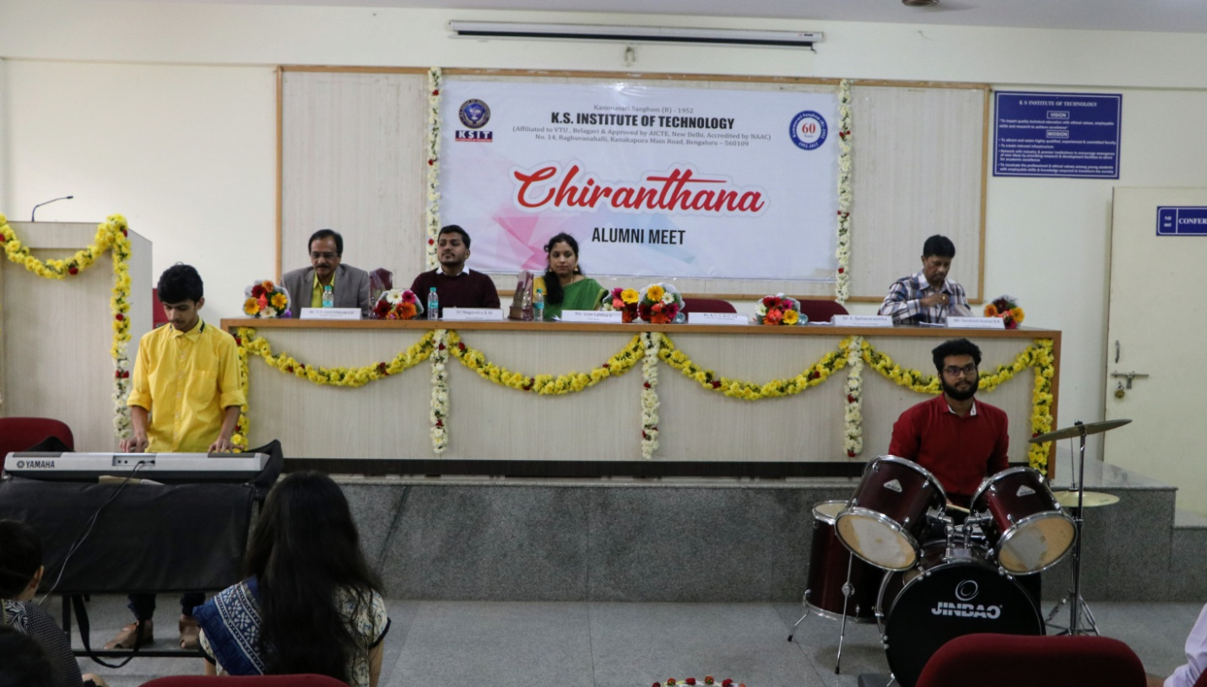
Mr.Hruthvik and team presenting the entertainment
After the entertainment program the meet was concluded by presenting the vote of thanks. After the vote of thanks the Principal distributing ributed the mementoes to the Alumni present

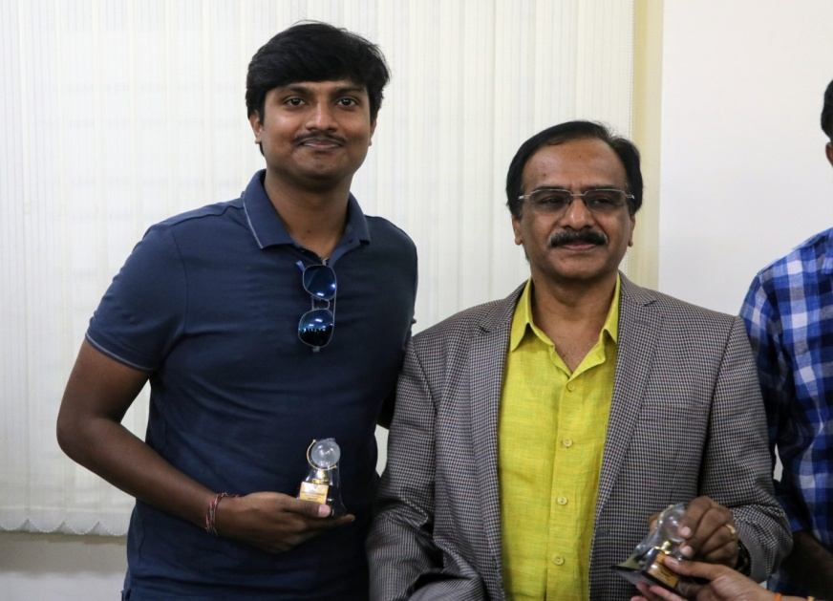
Principal Distributing the Mementoes

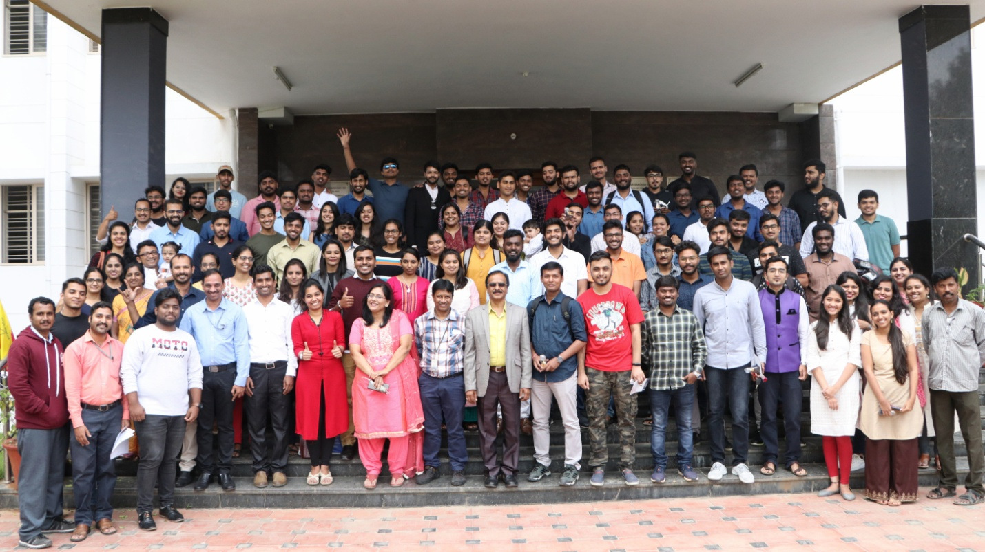

Group Photo after the Meet 2019

Alumni Coordinator
Santhosh Kumar B.R

