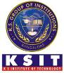
Industrial Visit Report

HAL Heritage Centre and Aerospace Museum- 19th November 2019
Hindustan Aeronautics Limited (HAL) Heritage Centre and Aerospace Museum, the first of its kind in India was established in the year 2001 at HAL Airport Road.
The Museum is a repertoire of knowledge for the academically minded as it houses a library on Aerospace and traces the development of the industry’s exciting phases since 1940.The Museum has got the prized possession of various types of Aircraft models on static display.
There is also an ATC Radar perched with L-band surveillance radar having a range of 200 nautical miles which rotates at a speed of 3-4 RPM, with the frequency of 1250-1350 MHz .In addition, PSLV model and PSLV Heat shield are displayed to give a glimpse of forays made by the country in the space technology. There is a true motion simulator to accentuate the user experience by giving a very realistic feel of flying fighter jets and commercial aircrafts.
Apart from this, an Orchidarium, herbal garden, children’s play area, a Souvenir shop and a sustainability development park are the added attractions in the campus. The sustainability park aims to educate visitors and students by displaying working models of solar systems, bio-gas plant and hybrid wind mills.
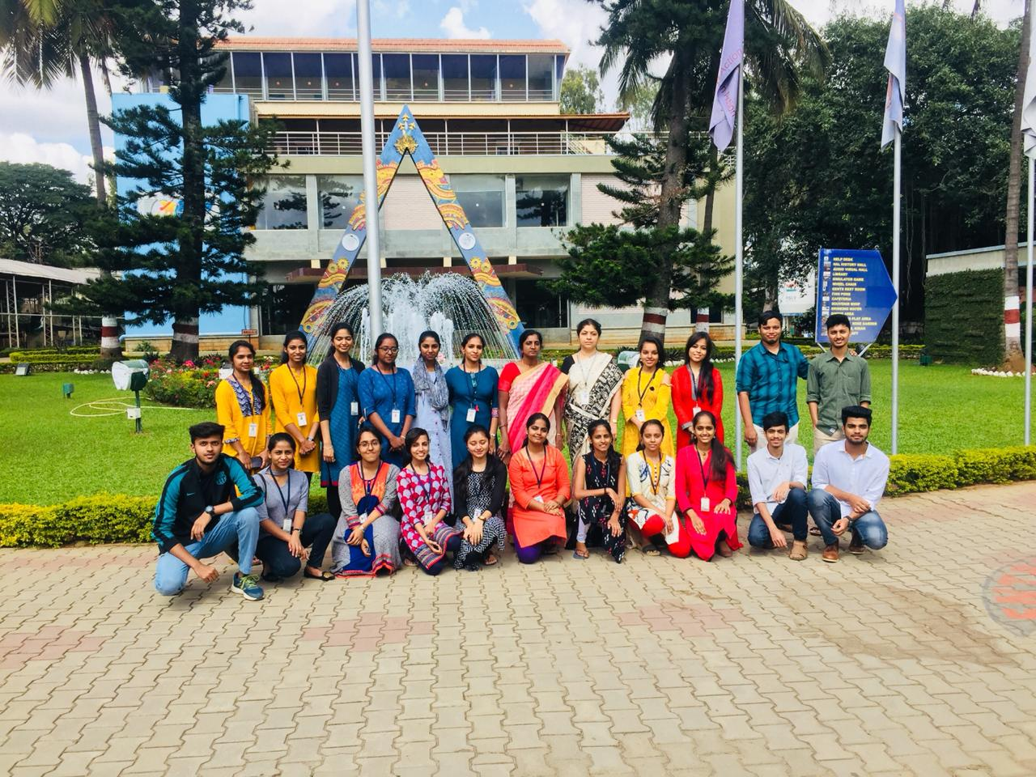
3rd Semester students at HAL Heritage Center and Aerospace Museum
The students view regarding visit to HAL Heritage Center and Aerospace Museum is summarized below.
Visit to HAL Heritage Center and Aerospace museum was informative. It increased our knowledge about different aircraft, solar power generator, orchidarium and also got to know more about PSLV (Polar Satellite Launch Vehicle) and RADAR (Radio Detection & Ranging) models and motion simulator. This visit made us more curious to gain more and more knowledge about different aircrafts and their design. We got to know about various scientists & politicians who visited HAL aircraft manufacturing wing during past few decades. It would have been still more interesting if there were guides to explain the models in detail.

MAPPING OF INDUSTRIAL VISIT WITH THE PO’s and PSO’s
Program | PO1 | PO2 | PO3 | PO4 | PO5 | PO6 | PO7 | PO8 | PO9 | PO10 | PO11 | PO12 | PSO1 | PSO2
Industrial Visit to  Vigyan Samagam | - | - | - | - | - | - | 1 | - | 1 | - | - | 2 | 2 | 2

Justification:
- PO7: It maps to PO7 weakly. Students gained knowledge as to how the displayed aircraft models can help the society after implementation.
- PO9: It maps to PO9 weakly. Students learnt about how to work as a team in developing a project.
- PO12: It maps to PO12 moderately. Students learnt about how they can use the engineering knowledge and bring a change in technology.

Srividya.R Dr. Chanda.V.Reddy Dr.T.V.Govindaraju
Industrial visit’s Co-ordinator HOD, Dept of TCE PRINCIPAL

