Latest Technology :

Chaotic Maps for Biometric Template Protection
  - A new approach to Cancellable Biometrics based on chaotic maps which are known to posses desirable properties of pseudo randomness, high sensitivity to initial conditions and very large key space can be used to address these concerned to conventional biometrics. The properties of chaotic systems are:
  - Deterministic: This means that they have some determining mathematical equations controlling their behavior.
   I take immense pleasure and honor to pen down the departments travails. Along with highly qualiﬁed post graduate and doctoral staﬀ department is committed and dedicated to build best electronics graduates who are inbuilt with good foundation in engineering along with a clean vision of their goal and mission, and in turn they must be highly resourceful to society and building a better India. It is also my pleasure to quote here that my students have excelled in technical, cultural and sports activities. My students posses the ability to adapt to the rapid changing scenario of electronics . Wishing them all the very best.
Dr.P.N.Sudha PROF & HOD, ECE DEPARMENT
  - Unpredictable and non-linear: This means they are highly sensitive to initial conditions. Even a very slight change in the starting point can lead to entirely diﬀerent outcomes.

- Information security and ensuring personal privacy are growing concerns in today's society. Current authentication schemes use tokens and passwords but this does not really distinguish between authorized users and persons who are in the unauthorized possession of the token or password. Moreover, managing multiple passwords/tokens presents usability issues. Biometric authentication promises to overcome these problems. Biometrics refers to the automatic identiﬁcation (or veriﬁcation) of an individual (or a claimed identity) by using certain physical or behavioral traits associated with the person viz. ﬁngerprints, hand geometry, iris, retina, face, vasculature patterns, signature, gait, palm print, or voice print. Biometric authentication systems are commercially spreading, aGer years of research have proven them to be suitable for large scale authentication systems recent one being its usage in the Aadhar card or the Unique Identiﬁcation card for the citizens of India. But some of problems concerned to conventional biometrics are:
- 1] Biometrics are not secret: Biometrics (even ﬁngerprints) can be recorded and misused without a user's consent.
- 2] Biometrics cannot be revoked or cancelled: Biometrics are permanently associated with a user.
- 3] A compromised biometric is forever compromised: All applications that use the biometric are compromised.
- 4] Cross-matching can be used to track individuals: A user can be tracked if organizations share their databases.
- “Cancellable Biometrics” is one of the original solutions to address these concerns. Instead of storing the original biometric, the biometric is transformed using a one-way function. This transformation can be in the signal domain or the feature domain. This preserves privacy since it is impossible (or computationally very hard) to re-cover the original biometric from a transformed version. It also provides revocability since a compromised biometric can be re-enrolled using another transformation. The cross-matching between databases prevents because each application uses a diﬀerent transformation.
- They appear to be random and disorderly but in actual they are not. Beneath the random behavior there is a sense of order and pattern. The highly unpredictable and random nature of chaotic output is the most attractive feature of deterministic chaotic system that makes it suitable to use in image transformation techniques.
- Chaos theory is a ﬁeld of study in mathematics discovered by Edward Lorenz, with applications in several disciplines including meteorology, sociology, physics, engineering, economics, biology, and philosophy. Chaos theory studies the behavior of dynamical systems that are highly sensitive to initial conditions, a response popularly referred to as the butterﬂy eﬀect. Small diﬀerences in initial conditions yield extensively diverging outcomes for such dynamical systems, rendering long-term prediction impossible in general.
- Logistic Map is a one-dimensional chaotic map proposed by
R. M. May. It represents an idealized conservation model for describing yearly variation in the population of an insect species. The population at (n+1)th year is related to that at the (n)th year by the following mathematical equation:

- Here xn represents the chaotic sequence which lies between zero and one. When the system parameter r was varied over the interval [0,4] diﬀerent scenarios of evolutionary behavior are established. The iterates are conﬁned to [0,1]. Depending on the value of r equation (1) has got several properties. With r between 0 and 1, the population will eventually die, independent of the initial population xn. When r is between 3 and 3.45 the value of xn will oscillate between two values. With slightly bigger r values the value of xn will oscillate between 4 values, then 8,16,32 etc. Like a period doubling cascade. When the value of r is 3.57 it will start exhibiting chaotic behavior.

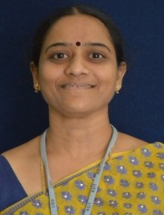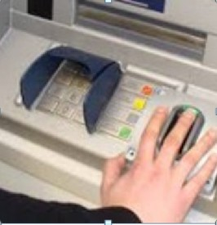
“ Attitude is a little thing that makes a big difference .” 2

- The bifurcation property of chaotic function for bifurcation factor r between 3 and 3.5 can be used to generate random, unpredictable key streams for biometric template transformation which addresses the problem of preventing guessing of biometric keys and compromising of Biometrics.
- The second property of chaotic maps, which are highly sensitive to initial condition can be used to generate diﬀerent transformed templates from same biometric data by very slight change in initial condition to generate diﬀerent key streams, so that diﬀerent applications with diﬀerent transformed templates appear random to themselves which addresses the problem of cross matching.
- Considering most commonly used 16 bit PC plaVorm as an example and key streams = { k1, k2, k3} three diﬀerent keys, with each key consisting of key = (x0, r0) (x0= initial value and r0= bifurcation factor), the expected key space size is (1016)6≈2319, which is very much greater than world total population. This property provides privacy and security by providing it impossible to guess the keys and addresses the problem of revocability of biometric templates.

Guest Lecture :

- Synopsis organized Synopsys' University Symposium – 2014 for the academicians of various universities held on October 10th at ITC My fortune , Bangalore . Mr . Praveen A (Asst . Professor , ECE) attended this guest lecture. The program was attended by faculties and research scholars from various universities, South Region , Bangalore. The highlights of the program were new challenges and opportunities i n Custom Design Implementation, Layout and Device Modeling. The program mainly provided an exposure to Synopsys TCAD tool. The symposium gave an exposure to the latest design automation solutions, methodologies and standards.

Events Conducted :

- An International conference was conducted on 20th of April 2014 organized by Dr. P.N. Sudha, HOD of ECE dept.
- A National conference was held on 12th of May 2014, 76 students attended this conference, organized by ECE department KSIT.
- A training in Embedded System as per mission VTU empower 1000 scheme was conducted on 1st of June 2014 organized by Dr.M.J. Shantiprasad ,Asst.Prof.
- Alumni Meeting: The ﬁrst KSIT alumni meeting was held on 19th July 2014 . The need for alumni association and objectives of the same was presented . The principal addressed the students and briefed about the plans and programs planned for the KSIT alumni association and appealed to the alumni's to become the executive members of association and help in pursuing activities of association.
- The second alumni meeting was held on 9th august 2014, based on alumni nominations 20 executive members were selected. As core constituents , alumni were well informed to have an inﬂuential voice and stake in their college. Their aspiration is to be inﬂuential and foster positive change . It is vision focused , growing in capacity to serve and engage.

Principal addressing Alumni's and Staﬀ member

Principal and Alumni Members

- International Conference on Advanced Trends in VLSI and Signal Processing : The Department of Electronics and Communication Engineering organized Second International conference on advanced trends in VLSI and signal processing on 13th August 2014. The Department received papers and from various parts of the country and papers were selected aGer the review. The advent of technology has revolutionized the industry and the society . Despite this success, there are several aspects which need signiﬁcant improvements and an comprehensive interdisciplinary research and development eﬀort to address these issues. This conference mainly aimed in bringing engineers and the academicians to provide insights to address these challenges through their talks and in depth discussions. The dignitaries who presided over the conference were Dr T . V. Govindaraju
- Director / Principal KSIT, Dr P N Sudha , HOD , ECE KSIT, Dr R Manjunath Senior domain scientist from Philips India Ltd and Dr Kanverjeet Singh ,CEO, Tejas Networks were the chief guests. Followed by the invocation was the welcome speech addressed by Mr Sangappa, ECE, KSIT. There were two sessions and keynote address for the ﬁrst session was delivered by Dr R Manjunath and for the second session Mr Shridhar H Rangarajan , senior engineer IBM enterprise senior division , Bangalore delivered the keynote address. Few papers presented were power eﬃcient asynchronous 8 bit processor core, automated detection of cancer nodules in lungs CT image, multi user detection for DS-CDMA using interleave division multiple access technique, development of intelligent video surveillance system for human fall detection ,design of register bank and read/write buﬀers for LPDDR-2 memory controller and many more.

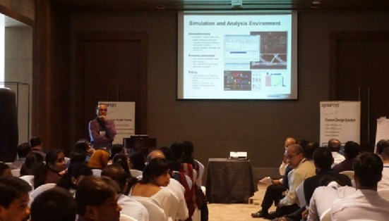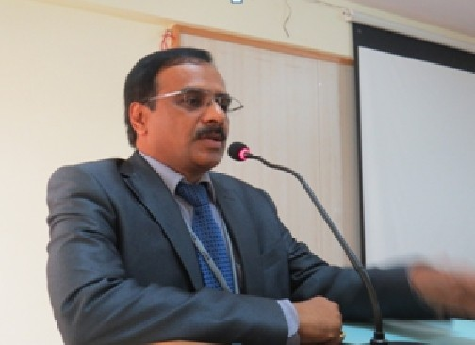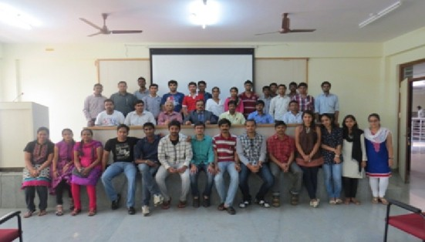
“ Success is not ﬁnal , failure is not fatal .” 3

•

Dignitaries on the dias are Dr . T. V. Govindaraju , Dr . R. Manjunath , Dr . Kanvarjit Singh,
Sri . K. Subramanyam Naidu, President KSIT, Dr . P N. Sudha , Prof & HOD ECE, KSIT.

Mr. L. Venkatarangan, HR, System controls, B'lore, Dr. K. Suresh, HOD, Mech, KSIT, staﬀ of ECE, KSIT and students of Embedded system Design training program witnessing the valedictory function

Dignitaries along with the conference delegate lighting the lamp. Thus the conference provided an ample opportunity to interact with internationally acclaimed professionals in various ﬁelds.

VALEDICTORY FUNCTION OF VTU MISSION EMPOWER 10000
INITIATIVE (ESD) : A valedictory function of VTU empower mission was held on 5th September. This mission embarks with an objective of empowering 10,000 engineering graduates for a successful professinal career. The mission has the ambitious plan of embedding industry relevant skills into VTU `s young engineers and enabling them in their pursuit of professional careers. The program also has the loGy agenda of augmenting domain knowledge, soG skills, relevant competancy and leadership skills. As a part of the program during the months July – September ,industry speciﬁc training on Analog electronics was given in the ﬁrst week, followed by Digital electronics in the second week ,SoG skills training was given during the third week of the training. Hands-on experience on Embedded C , LINUX, device drivers in the subsequent weeks . ESD students were given opportunities to participate in Placement activities conducted during the fourth week of the training.

INAUGARATION OF KSIT-IEEE-WIE AFFINITY GROUP : The
inaugural function of KSIT-IEEE-WIE AFFINITY group was held on 15th September 2014 on the occasion of Engineers day. The mission of IEEE WIE is to facilitate the global recruitment and retention of women in technical disciplines
.IEEE WIE envisions a vibrant community of IEEE women and men collectively using their diverse talents to innovate for the beneﬁt of humanity. It is the largest international professional organization dedicated for promoting women engineers and scientists and inspiring around the world to follow their academic interests to a career in engineering. The chief guests were Dr Shiva Yellampali , IEEE ,student activity co-chair and Dr Preeta Sharan, the chair of SIGHT(special group of humanitarian technology) . She delivered the keynote address regarding the beneﬁts of joining IEEE -WIE AFFINITY group. Dr M J SHANTI PRASAD
KSIT IEEE branch member delivered the welcome address. Followed by the inauguration on the eve of engineers day a technical event called Renaissance was conducted.

Dignitaries on the dais are Dr. Preeta Sharan, SIGHT(Special Group of Humanitarian Technology) Chair, Sri. K. Subramnaiyam Naidu, President, Kammavari Sangham, Dr. Siva Yellampalli, IEEE Student activity co-chair, Dr. T. V. Govindraju, Principal/Director, KSIT(from right to left )

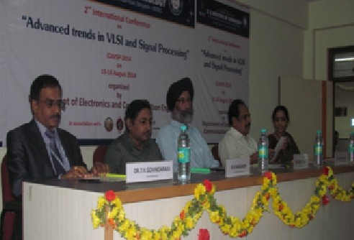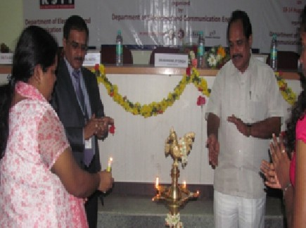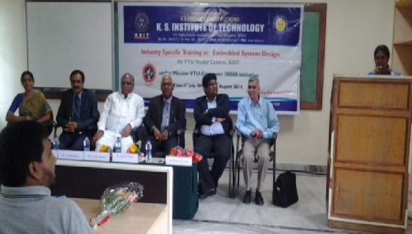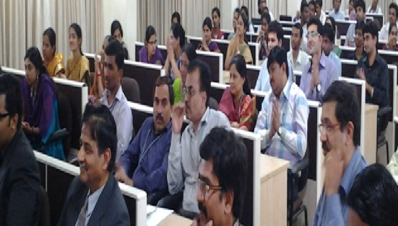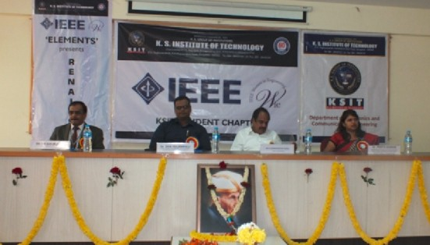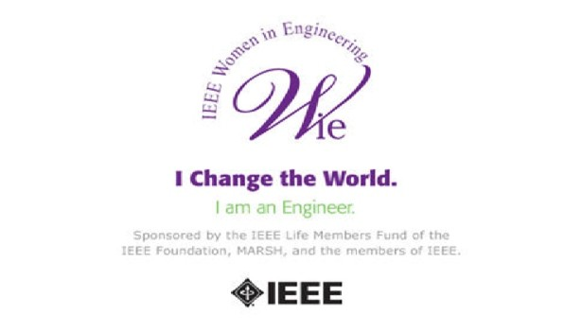

Dignitaries on the Dias are Dr .P. N. Sudha , Prof & HOD, ECE, KSIT, Dr. T. V. Govindaraju, Principal & Director, KSIT, Sri. S. R. Naidu , Secretary, Kammavari Sangham, Dr. Kalaivanan, Member, Executive council, VTU, Belgaum, Mr. Karthik Mahalingam, Applications Group Lead, Cypress Semiconductor, India, Mr.Kanakaraju , Sytems Control Technology Solutions Pvt. Ltd, Bangalore. Mrs. Jayasudha BSK, ECE dept., KSIT during compeering.
“ A smooth sea never made a skilled sailor. ” 4

•

(Various dignitaries lighting the lamp and showering ﬂower petals to photo of Sir. M. Vishveshwaraya).

Presentation of Dr. Preetha Sharan, Guest of honour, about the advantages of forming the WIE aﬃnity group and a huge gathering witnessing the presentation.

Execom Members: Mrs. Jayasudha.B.S.K, KSIT-IEEE Branch Counselor, Dr.P. N. Sudha,KSIT-IEEE-WIE Branch Chair, Prof. Chanda. V. Reddy, KSIT-IEEE-WIE Branch Mentor, Mrs. B. Surekha, KSIT-IEEE-WIE Branch Counsellor
- He also stressed the importance of data communication and networking in service and product based IT companies. He also encouraged students to create something better from available. He concluded by deﬁning innovation as it's all about thinking outside the basic box!!'
- A technical talk on “Mobile communication and networks” was conducted on 2nd March of 2015 by Mr. Prashanth Wali, research scholar, IIT Bangalore for 100 students. The event was convened by Mrs. Sahana Salagare,Asst.Prof.
- A guest lecture on “Career Guidance on the International Education Scene and Advantages of Research” was conducted on 9th of March 2015 by Mr. Sreejit Narayan and Ms. Sreelatha. The event was organized by ECE & TCE dept.
- A guest lecture on “Wireless sensor networks” was organized on 10th March, 2015 for eighth semester students by Dr. Sunil Kumar S Manvi, Principal Reva Institute of Technology and Management. The event was convened by Dr. Surekha B , Professor. The lecture focused on how the wireless sensor networks are established, corresponding protocols for communication to take place and how the contents are delivered in the network, applications of sensor networks, design factors along with issues and challenges of sensor networks.
- The Institute of Electronics and Telecommunication Engineers is a leading professional society devoted to the development of Science and Technology. The IETE Student Forum (ISF) was jointly inaugurated by Department of ECE and TCE on 12th March 2015. The chief guests were Dr. M H Kori (TPC Chairman, IETE HQ) and Dr. D C Pande (IETE Chairman, Bangalore). The IETE membership cards were issued to all students and keynote address by the guest of honor Dr. M H Kori on wireless communication followed the inauguration function

- Renaissance : On the occasion of Engineers day a technical mega event Renaissance was organized by the IEEE-WIE Aﬃnity group. Students from various colleges also participated in the event. The event helped the students to improve their knowledge related to the modern technical aﬀairs, communication and organizational skills. About 202 teams registered and 177 teams participated. The event had four rounds technical quiz , paper art, tech hunt and ﬁnally technical solution round where the contestants were supposed to give solution to a real time problem.

- 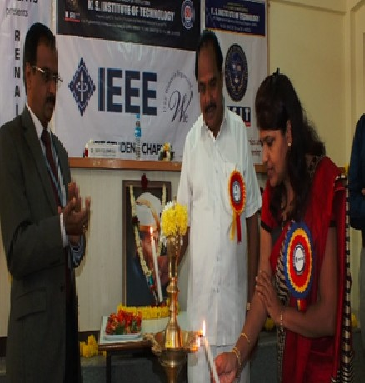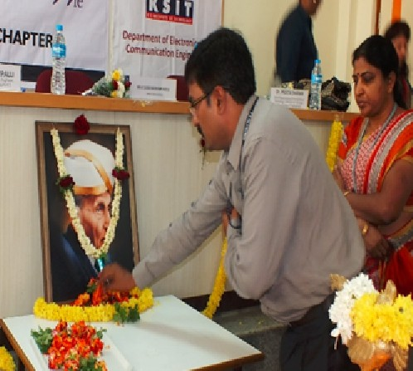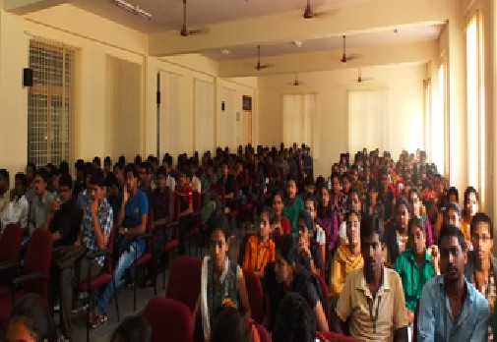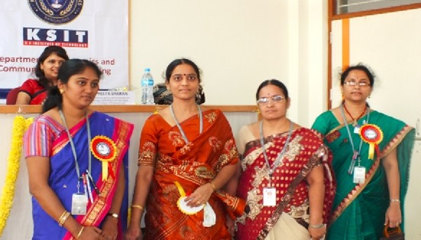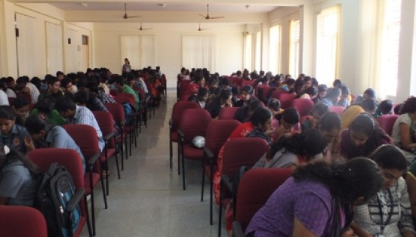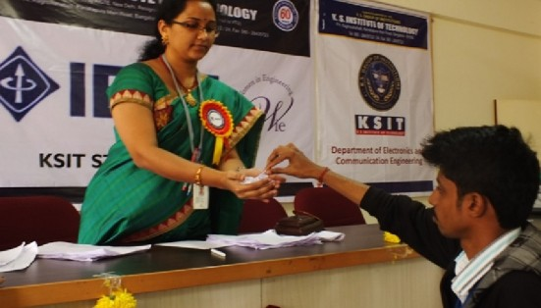17th ISTE State level Faculty Convention was conducted on 20th of November2014, also Dr. Shivashankar, Principal of RNSIT, Bangalore was invited as a resource person for this event, organized by Mr. Sangappa. B, Asst.Prof.
- A guest lecture on “Data Communication and Innovation” by Mr. Akhil Bhardwaj , Associate Technical Solution Engineer from Akmai Technologies was organized for sixth semester ECE students on 11th February 2015. This lecture mainly focused on web designing which encompasses many diﬀerent skills and disciplines in the production and maintenance of website. A detailed description about various routers, mappers, clients, servers, IP protocols and structure of URL was given. The highlight of the session was DNS (Domain Name System) which is the standard technology for managing public names of websites and other internet domains.
“ Work hard in silence , let the result be your noise .” 5

FDP/Workshop attended by faculties:
- A faculty development Program on “Cognitive soGware deﬁned radio and open source soGware programming” was attended by Ms. Nithya Kumari, Mrs. Sangeetha V and Mrs. Prathima B A, Asst.Prof. at Dr Ambedkar Institute of Technology in association with AMITEC Electronics Limited and Silicon Microsystems on 7th January 2015. The program concentrated on the emerging advancements in wireless communication and signal processing. The highlights of the program were Cognitive SoGware Deﬁned Radio and its application in various ﬁelds like MIMO, base terminal station and many more.
- A Faculty Development Program on “Sensor enabled smart computing using Rasberry Pi” held at Jyothi Institute of Technology on 8th and 9th January , 2015 was attended by Mrs. Jayasudha B S K , Asst. Prof. The program gave an awareness about raspberry pi and its applications. The resource person was Mr. Nayan Mulhadiya from Synopsys. The program was very helpful to beginners working on Raspberry pi.
- Mrs. Jayasudha B S K , Asst. Prof. participated in the 13th International conference on embedded systems with theme of “Internet of Things” on 9th and 10th of January 2015 held at Leela Palace, Bangalore.
- A two day faculty development program on “VLSI Design and Intellectual Property” organized by Jyothi Institute of Technology on 9th and 10th of January 2015 was attended by Mr. Praveen A and Mr. Karthik B R , Asst. Prof. This program provided an opportunity for the faculty members to enrich their teaching skills and research in the ﬁeld of VLSI design. The program intended to develop the knowledge of participants for simulation with advanced soGware in the relevant ﬁled for including learning vales in students and guiding, monitoring their progress.
- One week faculty development program on “Electronics communication and Trends” at BNMIT from 19th to 23rd January 2015 was attended by Mrs. Sahana Salagare , Asst. Prof. The workshop gave an overview of advance trends in analog and digital communication along with the use of various tools like modeltech and simulink. The participants were enlightened with the most widely used technologies in the recent communication trends.
- A ﬁve day faculty development program on “Programmable Logic Controller & SCADA Systems” at BNMIT from 19th to 23rd January 2015 was attended by Mrs. Vishalini Diwakar , Asst. Prof. The program trained the faculty members to use Graphical User Interface (GUI) through SCADA system and PLC called stardom which is widely used in many organizations like GAIL. The program helped to improve the professional skills as a whole.
- A ﬁve day faculty development Program on “Signals and Systems” was attended by Mr. Karthik B R , Asst. Prof. at BMS Institute of Technology and Management, Bangalore from 27th to 31st January 2015. The program provided a platform for faculties, researchers and technologists to understand the basis of signals and system using diﬀerent mathematical approaches and their practical applications.
- One week workshop on “Entrepreneurship Development Program” organized by BNMIT in association with Entrepreneurship Development Institute of India from 27th to 31st January was attended by Mrs. Jayasudha B S K , Asst. Prof. The workshop provided information concepts of entrepreneur and various competencies required to become a successful entrepreneur.
- Dr. Sudha P N , Professor & Head and Mr Dr. Shanthi Prasad M J, Professor , participated in the IESA Vision Summit 2015 held at Leela Palace, Bangalore on 2nd February 2015.
- Dr. Sudha P N , Professor & Head and Mrs. Supriya V G , Associate. Prof. attended three day workshop on “Graphical System Design In Engineering Technology Using NI Lab View” conducted from 5th to 7th Feb 2015 at SJB Institute of Technology.
- A two week workshop on “Techno Entrepreneurship Development Program” organized by Entrepreneurship Cell, MSRIT from 16th to 27th March ,2015 was attended by Mrs. Jayasudha B S K , Asst. Prof. This program helped to gain the insights on techno entrepreneur development skills and training.
- Mrs. Supriya V G , Associate. Prof. attended work shop on “Digital Image processing” , conducted by Karnataka Science and Technology Academy (KSTA) in association with the Aerospace Engineering Division, IISc, Bangalore for engineering teaching faculty and research scholars. The purpose of the workshop was to give an overview on the use of Digital Image Processing techniques and its wide range of applications.

“ It is our choices , that show what we truly are , far more than our abilities .” 6

Industrial Visit :

- To provide industrial exposure to the students, the present ﬁGh and third semester students were taken to BIEC (Bangalore International Exhibition Centre) on 11th and 25th of September respectively. The 8th edition of EMMA(electronics moulds machines automation)Expo India 2014 at BIEC hall presented with a fresh plaVorm for electronics, machinery and moulds from Taiwan to match the Indian market. The show provided with an unprecedented opportunity to view more 500 exhibitors under the same roof . Delivering the best at the heart of India's Silicon valley EMMA Expo opened a slate of new age products for a robust India of the future. EMMA also exposed one to the glistening awarded products of the Taiwan Excellence Campaign.

Students of third semester during industrial visit

Students of ﬁfth semester during industrial visit

Teachers day :
- Teachers day was celebrated on 6th September with much pomp and revelry. All the faculty members and students of E&C department were present . Followed by invocation there were vibrant array of performances .All the faculty members were then presented with memento as a token of appreciation for their hard work and constructive support.

Parent teachers meeting:
- Parent teacher meeting was held on 26th of September in the ECE conference hall. It was an excellent opportunity for parents to sit down one -on-one with the teacher and talk about the progress of the students.
- Dr. T V Govindaraju ( Principal , KSIT) and
- Dr. Ranjana Jain (Placement Oﬃcer , KSIT) spoke about comprehensive programmers designed to train students for all the stages of the Campus Recruitment .

Achievements : Positive Aspects of Department :
- Research Activities :The department of Electronics and communication has also started its own Research and Development Group . The primary function of the R & D group is to discover and create new knowledge about scientiﬁc and technological topics for the purpose of uncovering and enabling the development of valuable electronic products , processes , services. The main objective of the R and D cell is to support all the aspiring candidates pursuing PhD under VTU.
- P . G. Course :The department of Electronics and communication has also started PG courses (M .Tech) which opens many paths in the career and also aims to ensure a good standard and solid knowledge of the technical terms.
- Mrs. Prathima B . A . Asst . Professor , Department of Electronics and Communication has contributed in performance improvement projects in multi core processors in optimizing speeds of trackers and checkers for Intel India Limited. She has undergone several trainings like Specmen from Cadence , Embedded Systems from IISC , VHDL and FPGA
`s from NITK, Suratkal. She has also conducted several development programs and student workshops using her industry knowledge to bridge the gap between industry and academics.
- Mrs. B . Surekha , Associate Professor, chaired the session
–Signal Processing at 2nd National Conference on Advanced Communication, VLSI Design and Signal Processing (NCCVS- 14), organized by the Department of Electronics and Communication Engineering, KSSEM, Bangalore, on 15th May 2014.

Faculty Achivements:

- Mrs. B. Surekha , Associate Professor, reviewed research papers under signal processing category, for the International Conference on Advanced Trends In VLSI and Signal Processing (ICAVSP-2014), held during August 13th & 14th in K.S. Institute of Technology, Bangalore.
- Student Project entitled “LEG EXOSKELETON”, guided by B.Surekha, Associate Professor, got selected as one of the top 10 ﬁnalists out of more than 2000 registrations in Quest Ingenium 2014, held on June 2014, Bangalore.
- Mr. Sangappa S B, Associate Prof. and PRO has been elected as National Executive Council member of Indian Society for Technical Education, New Delhi for a term of three years. Prior to this he has served as Hon. Secretary and Treasurer of ISTE Karnataka state section.

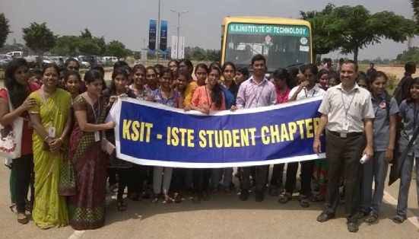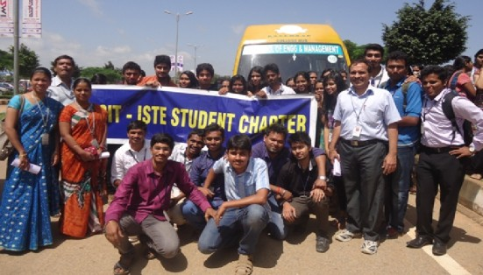
“ Life is about making an impact , not making an income .” 7

Students :

- The ISTE student members have bagged various prizes at the conferences, workshops and paper presentations held at SDM College of Engineering, Ujire and Sri Shirdi Sai college of Engineering, Anekal.
- Gowtham R of first semster has won first place in Freestyle Dance Competetion held at Ambedkar Medical College, Bangalore.
- Aishwarya M S of first semester has won third place in District Level Swimming (Freestyle). She has also represented our college during VTU intercollege swimming competition held in Mathikere, Bangaore.
- Aravind B, Shravani B, Deepthishree and Harini J of eighth semester have presented a paper titled "Multifunction Constant Health Monitoring Sweat Band" at National Symposium held at Sri Siddhartha Institute of Technology, Tumkur on 9th and 10th March 2015.

Publications:
- Supriya V G, Ramachandra Manjunatha, "Chaotic Maps for Biometric Template Protection-A Proposal", International Journal of Biometrics and Biostatics, Vol.6, No. 6, 2015, pp.1-8. [Impact Factor: 1.27]
- B Sudarshan, R Manjunath, "Survey on Static Image Storage and Retrieval Mechanisms, International Journal of Engineering Research and Technology(IJERT),Vol. 4, No.1, pp.173-179, 2015, [ISSN: 2278-0181] [Impact Factor: 1.76]
- B Sudarshan, R Manjunath, "Analysis of Image Storage and Retrieval in Graded Memory", International Journal of Research in Engineering and Technology(IJRET), Vol. 4, No. 4, pp. 779-884, 2015, [ISSN: 2319-1163] [Impact Factor: 3.127]
- B. Surekha, P. Ravi Babu, G.N. Swamy, “security analysis of a novel copyright protection scheme using visual cryptography, IEEE International conference on computing and communication technologies, Osmania University, Hyderabad, Dec. 11-13, 2014, pp.1-5. (Digital Object Identifier: 10.1109/ICCCT2.2014.7066723)
- Anitha Kumari.B, "Design of Command Generator for LPDDR2 Memory Controller", 2nd Int. Conf. on Advanced trends in VLSI and Signal Processing (ICAVSP-2014), K.S. Institute of Technology, Bangalore, 2014, pp. 47-53
- R.Nitya Kumari, Rajeswari N Patel, "Wavelet denoising approach for spectrum estimation in CR", International Conference on Convergence of Science, Engineering and Management in Education and Research, Bangalore, 2014

Newly joined faculties :

- Mrs.Jayanthi.M--MTech (PhD)--Asst . Professor– Communication System
- Mr.Parameshachari B D--MTech (PhD)--Asst.Professor -- Digital Communication
- Mrs.Prathima B A--MTech--Asst . Professor--Industrial Electronics
- Mrs .Pragathi. P-- MTech-- Asst . Professor– Digital system and computer electronics
- Mrs . Anitha Senthil Kumar --MTech-- Asst . Professor-- VLSI and Embedded systems.
- Mrs. Sahana Salagare--MTech--Asst. Professor--Information and communication Technology.
- Mrs. Lakshmi H.R--MTech--Asst. Professor-- VLSI and Embedded systems.

List of Faculty who have got 100% results :
- Semester Subject Faculty

Eight Digital Communication Mr B Sudharshan Eight Network Security Mrs B . Surekha

Project Funding :

- A project titled Protection of spoilage of crops and proper usage of rainfall using GSM and moisture sensor under the guidance of Mr. Santhosh Kumar B R , Asst. Prof. was sponsored by Vision Group on Science and Technology.

Faculty registered for PhD :
- Mrs Rajeshwaridevi D V
- Mrs Supriya V G
- Mrs Jayanthi M
- Mr Parameshachari B D
- Mrs Vishalini Divakar

Placements:
Most of all final year ECE students are placed in several companies like
- INFOSYS
- NTTDATA
- TECH MAHINDRA
- L&T INFOTECH
- IBM
- WEST LINE SHIP MANAGEMENT PVT.LTD
- NOKIA
- ARICENT
- VECTOR INDIA PIV.LTD
- CMC
- MICRO LAND
- GE TRANSPOTATION
- SONATA SOFTWARE
- HEALTHASYST
- TCS
- RAZORTHINK

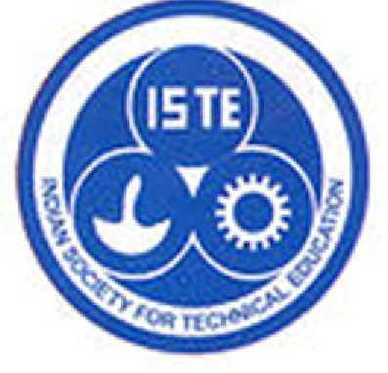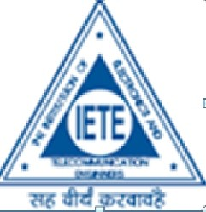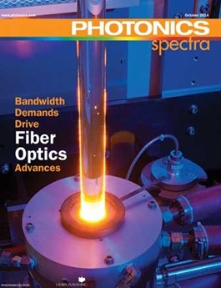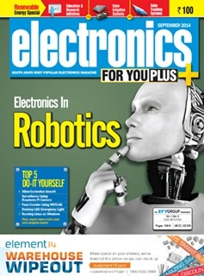VARIOUS CLUBS OF ECE DEPARTMENTS :
- IEEE:
- The world's largest professinal association for the advancement of technology. It enables programs to enhance technology access ,literacy and education. It supports the IEEE professional community and inspires donors generosity.

Highlights :
- IEEE-WIE chapter was inaugurated on 15th September. It is the largest professional organization dedicated to promote aspiring women Engineers and Scientists.
- EPICS in IEEE (Engineering Projects in Community Service in IEEE) : The EPICS is a form of service learning, a process of using experience as a means of teaching. This program mainly aims at selection and implementation of a project that is useful to the society. The selected project shall be executed with the help of high school students. Thus it provides the students with an opportunity to experience volunteerism as well as a preview to potential careers in STEM (science, technology, engineering and math).

- ISTE :The international society for technology in education. It is the premier non proﬁt organization serving educators and education leaders committed to empowering connected learners in a connected world. The vision of ISTE is a world where all the learners thrive, achieve and contribute.
- Highlights: The ISTE organized a special talk by Mr. Zane Cuxton on Personality Development. Many events like Second International Conference on Advanced Trends in VLSI and Signal Processing organized by ECE Department and National Conference on Innovation in Communication organized by TCE Department came in association with ISTE. ISTE also received the grant for conducting 17th State Level ISTE Faculty Convention in our Campus .
- IETE : The institute of Electronics and Telecommunication engineers is a leading professional society devoted to the advancement of Science and Technology of Electronics , telecommunication and IT. The basic aim is to promote general advancement of EC,TC,CS,IT and allied subjects and application of these and to exchange information and ideas on these subjects amongst the members.
- Highlights : The registration process for IETE membership is in progress.

National and International Magazines :
- PHOTONIC SPECTRA : This journal covers topics related to bandwidth demands to drive ﬁbre optics advances, applications expand for photon counting .

- ELECTRONICS FOR YOU PLUS+ : Over the last four decades the EFY group has become synonymous with information on cutting edge technology It is a magazine for electronics fraternity.

“ The diﬀerence between winning and losing is most often not quiting .”

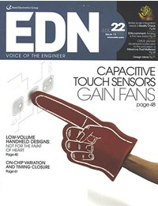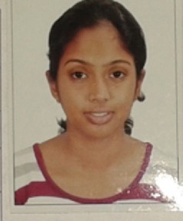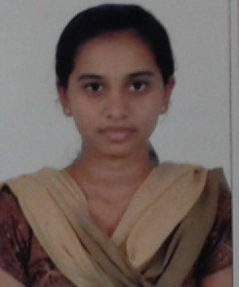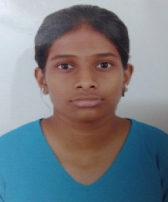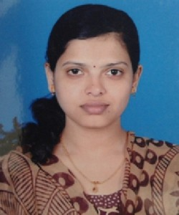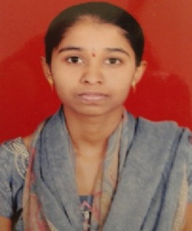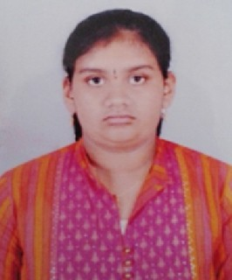• Electronic Products provides teardowns of some of the best selling consumer products in market. It has full details of all components as well link to data sheets. It provides innovative and novel solutions to constrained designs.
Sushma S N 1KS12EC090
81.56%

Sixth Semester :

Manasa M S 1KS11EC
80.66%

• EDN caters to the need of working electronic engineer and cover new technologies and electronic component products at engineering level. Columns here discuss about technical issues generally faced in the design of electronic components, systems and developing technologies.

Mamatha K 1KS11EC
78.66%

TOPPERS :
Fourth Semester :
Sanjana Sathish 1KS11EC
74.88%

Navya Sri 1KS12EC072
86.67%

Sumithra B 1KS12EC087
82.22%
Eighth Semester :

1) | Padmini R | 1KS10EC | 83%
2) | Abhijit . M . Rao | 1KS10E | 82.98%
3) | Sanjay Anand | 1KS10EC | 82.2%

“ What we fear to face today becomes our limits tomorrow .” 10

