Dr.P.N.Sudha PROF & HOD ECE DEPARMENT
•
The Department of Electronics and Communication Engineering was started in the year 1999 with an intake of 60 students and increased subsequently to 120 with an additional intake of 10% lateral entry diploma students. The ECE Department provides a holistic environment for the overall development of the student. It has a dedicated and experienced team of 26 faculty members who are highly accomplished with post graduations and doctoral degrees together to provide a conducive atmosphere to achieve excellence in education. It is also committed to achieve academic excellence in Electronics Engineering and promoting R & D activities. The mission of this Department is to produce Engineers with self-discipline, high integrity and good personality by providing excellent training. It also has several active forums where students learn to do projects, present technical papers and organize various technical events thereby receiving a broader perspective on the professional front and opportunities for teamwork, leadership and service. Apart from providing a conducive atmosphere for learning, it also constantly strives to improve the quality of Engineering through various Faculty Development Programs.

Latest Technology :

Biodegradable Electronics – A Step Closer towards Solving E-waste Disposal Problems :

- Good old wood. It's everywhere! And soon it may be in your computing devices as the newest, most cutting-edge semiconductor material. Today, on an average people replace their gadgets every 22 months junking about 50 million tons of electronic waste every year in the process. Disposal of all this e- waste is one of the biggest concerns for the safety of the environment. What if the electronic products we dispose ever so frequently were biodegradable? Sounds like a fantasy? Not anymore!!
- Researchers at the University of Wisconsin working in partnership with the US Department of Agriculture Forest Products Laboratory have come up with wooden semiconductors. In a typical semiconductor electronic chip, the active region comprises the top thin layer and is only a small portion of the chip, whereas the bottom substrate that holds the chip and its passive components consists of more than 99 percent of the semiconductor materials. The new proposed ICs are constructed from a substrate layer of Cellulose Nano Fibril (CNF). Cellulose is the critical structural component underpinning the cell walls of greenest plants and in its Nano sized form begins to take on properties almost resembling plastic. Paper is produced from wood as it's broken down further and further until it's a pulp of micron-scale ﬁbers. Essentially, cellulose Nano ﬁbril is just a continuation of the process until the resulting ﬁbers are at the scale of nanometers. The result is a super-strong, transparent paper made up of CNF that can be used as electronic substrate. It has a good proven resistance to water and other potential solvents. This could be the possible solution for the e-waste disposal issues.

EVENTS :

- Dr.M.J.Shantiprasad, Prof. organized a 2 day Workshop on Fiber Optics on 2nd and 3rd of April 2015 where Mr.Praveen from TPO technologies, Bangalore was invited as the resource person.
- Dr.Shantiprasad, Prof. and Mrs.Sahana Salagare, Asst.Prof organized a 2 day workshop on ARM Cortex on 10th to 11th April 2015 where Mr.Srinivas, Tinyship Solutions, Bangalore was invited as the resource person.
- Mr.Sudarshan.B, Asst.Prof, Mrs.Sahana Salagare, Asst.Prof and Mr.Christo Jain, Asst.Prof organized an Industrial visit to HAL on 6th October 2015.
- A ﬁve-day Faculty Development Program (FDP) on “VLSI Design Using Cadence tools” was organized by the Department of Electronics & Communication Engineering, K S Institute of Technology, Bengaluru from 29th June to 3rd July,2015. The Program provided an excellent plaVorm to enrich the knowledge of VLSI Design using Cadence tools. Research scholars, Faculty members and Post graduate students of Electronics & Communication branch from diﬀerent Engineering colleges attended the program. About 51 people attended the event. The Convener of the event was Dr. P N Sudha, Prof and Head. The chief coordinators were Dr. Shanthi Prasad M J, Prof and Mrs. Supriya V G, Assoc.Prof, the coordinators of the event were, Mr. Praveen A, Asst.Prof, Mrs. Anitha Senthil Kumar, Asst.Prof, Mrs. Sahana Salagare, Asst.Prof and Mrs. Lakshmi H R, Asst.Prof.

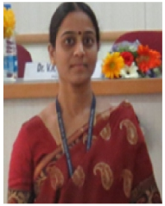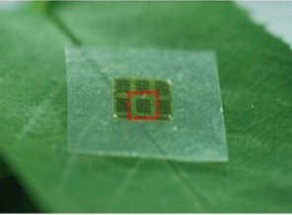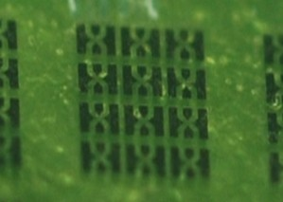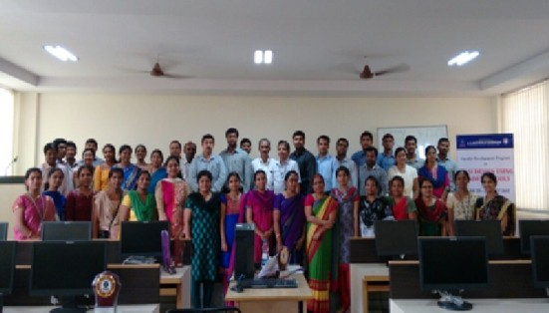
“ Dream becomes Reality through Determination .” 2

- An Industrial visit was also arranged for all the participants to "UTL technologies, Yeshvanthpur, Bengaluru on 2nd July, 2015. As per the feedback received from faculty, all the sessions were very informative and it helped them to enhance their knowledge in simulation, synthesis, layout and chip fabrication of both analog and digital signals using CADENCE tools.
- An "Entrepreneurship Awareness Program" through the Entrepreneurship Development Cell (EDC) of K S Institute of Technology, Bengaluru was organized on 28th July,2015 in the conference hall. The speaker was Mr. Anson Ben, CEO, Global Intelnet services, Koramangala, Bengaluru. The talk was on the future world, students of 3rd and 5th semester participated in this interactive session. The sessions were very informative. It also motivated the students to come up with new innovative ideas and apply their skills to develop new products.

- Dr.Shantiprasad, Asst.Prof organized a Entrepreneurship Program (AIEE) on 31st July 2015 where Mr.Vijaya,Joint Director of AIEE,Bangalore was invited as the resource person.
- Mrs.Rajasjwari Devi, Asst.Prof ,Mrs.Nityakumari, Asst.Prof and Mrs.Sangitha, Asst.Prof organized an Industrial visit to All India Radio on 10th August 2015.
- A guest lecture on "Embedded systems" was organized at K S Institute of Technology, Bengaluru on 3rd September,2015, with an aim to create interest in Embedded Systems for ﬁnal year students. The speaker was Dr. S B Bhanu Prashanth, Prof and Head, Dept of ECE, from BNM Institute of Technology. The event was convened by Mrs. Jayasudha B S K, Asst.Prof. The speaker highlighted the importance of embedded systems. He emphasized that exponentially increasing computing power (Moore's law), ubiquitous connectivity and convergence of technology have resulted in hardware/soGware systems being embedded within everyday products and places. Today 90% of computing devices are in Embedded Systems and not in PCs. Embedded systems design is a productive synergy between hardware and soGware design. Essentially, it's the art of choosing and designing the proper combination of hardware and soGware components to achieve design goals like speed and eﬃciency.

- Mrs.Supriya.V.G, Asst.Prof and Mr.Santhoshkumar.B.R, Asst.Prof organized a Project Exhibition on 9th May 2015 where Dr.R.Manjunath, HOD ECE, DSCE, Bangalore was invited as the resource person.
- A guest lecture on “Dr.Kalam, Rockets and Satellites” was organized on 15th October,2015 at K S Institute of Technology, Bengaluru on the occasion of 85th birth anniversary of our Ex-President, the Missile Man of India, Dr. A P J Abdul Kalam. The speaker was Mr.Nagaraj Ananth, scientist from ISRO, Bengaluru. The event was convened by Mrs. Supriya V G, Assoc.Prof. The speaker enlightened the audience about the Indian space program by providing very useful information about the satellite launch, design and development of launch vehicles and related technologies for providing access to space. He also spoke about the Missile man of India Dr. A P J Abdul Kalam, his early life, his career as a scientist, his presidency and achievements. This was a real inspiration to the young minds.

- Mrs.Sahana Salagare organized an event on Developing soG skills on 25th January 2016 where Mr.Vidyanag Moka, CEO of Vidyanag Training solutions, Bangalore was invited as the resource person.
- Dr.Surekha, Professor organized a 1 day Faculty Development Program on Writing Research Proposals on 2nd January 2016 where Dr.Nagraj,Prof JNTU Hyderabad was invited as the resource person.
- Mr.Sunilkumar.G, Asst.Prof, Mrs.Jayasudha.B.S.K, Asst.Prof a n d M r s . N i t y a k u m a r i , A s s t . P r o f and Mrs.Prathima.D.R, Asst.Prof organized an Industrial Visit to ELECTRAMA on 16th February 2016.
- Dr.P.N.Sudha conducted an Industrial trip to CDAC by IEEE students on 19th February.
- Mrs.Supriya.V.G, Asst.Prof conducted a technical seminar on embedded systems on 24th February where Mr.N.Avasti, CEO, APSIS solutions, Bangalore was invited as the Resource person.
- Dr.Surekha.B, Asst.Prof organized a Workshop on wireless embedded systems on 26th and 27th February 2016 where Tent Techtronics were invited as the resource people.
- Mr.Sunilkumar.G.R , Asst.Prof organized a workshop on Quadrature on 27th and 28th of February 2016.
- Mrs.Prathima.B.A, Asst.Prof and Mr.Sampath Kumar, Asst.Prof organized a Workshop on MSB 430 on 16th and 17th of March 2016 where Mr.Sanjayakumar, Jyothi Embedded Lab, Bangalore was invited as the resource person.
- KSIT, Bangalore organized the Faculty Development Program on Research Funds and IPR writing research proposal on 27th to 29th of March 2016 where Dr.Cyril Prasan from M S EC, B a n ga l o re , D r. K . N . S r i d h a ra, Principal of KSSEM, Bangalore, Dr.Srinivas.M.Jamakhandi, Director of IISC- MSME and PRof.V.Ramaprasad, IT consultant, Bangalore were invited as the Resource people.

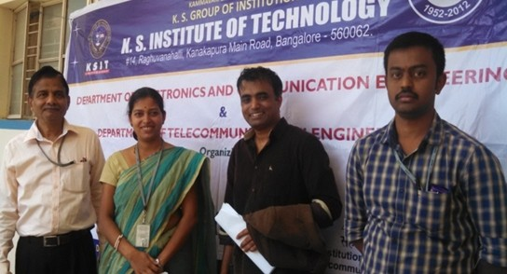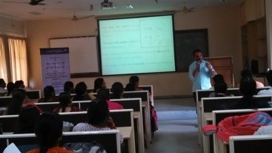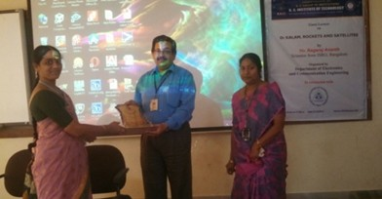
“ Nothing worth achieving comes easy.” 3

  - Dr.M.J.Shantiprasad, Asst.Prof organized a 2 day Workshop on Fiber Optics on 2nd and 3rd of April 2015 where Mr.Praveen from TPO technologies, Bangalore was invited as the resource person.

WORKSHOP/FDP ATTENDED BY STAFF :
  - Mrs.Lakshmi.H.R ,Asst.Prof , Dr.Shantiprasad,Asst.Prof and Mrs.Sahana Salagare,Asst.Prof attended the Workshop on Optical Fiber Technology conducted in KSIT, Bangalore held on 2nd and 3rd of April 2015.
  - Mrs Sahana Salagare ,Asst.Prof, Dr.Shantiprasad, Asst.Prof , Mrs.Jayasudha, Asst.Prof and Dr.Surekha.B,Prof attended the Workshop on ARM Cortex conducted in KSIT, Bangalore held on 10th and 11th of April 2015.
  - Mrs.D.V.Rajeshwari Devi, Asst.Prof attended the event, Research Methodology and latex conducted in BMSCE, Bangalore on 21st to 23rd May 2015.
  - A three-day workshop on "Embedded System Design Using ARM CORTEX M4"which was held at M S Ramaiah Institute of Technology, Bengaluru from the 25thof May to the 27th May of 2015. Mrs. Lakshmi H R, Asst.Prof and Mrs. Jayasudha B S K, Asst.Prof attended this workshop which aimed at giving information and project ideas about ARM Cortex M4. The resource persons were Mr. Narendra Babu and Mr. Arvind, Senior Application Engineers at Starcom Information Technology. The kits provided by them helped a lot for the hands - on session which gave an excellent idea about the IDE and Launch Pad. It also gave a wonderful insight about applications and current industrial advancements with respect to ARM.
  - A three-day Faculty Development Program on “Signal, Image and SDR using LABVIEW” held at JSS Academy of Technology, Bengaluru from 22nd June to 24 June,2015 was attended by Mr. Sampath Kumar S, Asst.Prof. The program aimed to provide opportunities to faculty, research scholars and post graduate students to enrich their teaching skill in the ﬁeld of Engineering and Signal & Image processing. The program also focused to develop the knowledge of participants for simulation with advanced soGware in the relevant ﬁeld for inculcating learning values in students and guiding and monitoring their progress. The discussed areas were of great beneﬁt to the participants as the topics matched with the current working domain. Participants were enlightened with the most widely used advance technologies in this domain.
  - A two-day workshop on "Intellectual Property Rights" at VTU Regional Oﬃce, Bengaluru was attended by Mrs. Prathima B A, Asst.Prof on the 10th and 11th of July,2015. The workshop gave an overview of IPR Spectrum and innovations, procedure for ﬁling an application in India and abroad, intellectual assets like patents, copyrights, trademarks etc. It also gave a hands on experience on prior art search. The workshop was very useful in enabling the participants to view their tasks in broader context.
  - One-week workshop “A Practical approach towards Embedded system Design” under TEQIP phase II held at M S Ramaiah Institute of Technology,Bengaluru from the 27thof July to the 1st of August,2015 which was attended by Mrs. Jayasudha B S K, Asst.Prof. The Emphasis of the workshop was on project based training to assist in setting up state of the art Embedded Systems Design Laboratory.
  - The workshop provided a comprehensive training on emerging embedded plaVorms such as ARM CORTEX M4,MSP430, RTOS, TI C6713-DSK, Zynq-7000 boards using
Vivado tools. The entire design and development of the product proto type model could be accomplished with the help of knowledge of these plaVorms. Project Based Hands on Session during the Workshop was on ARM Cortex-M4, Embedded system design application- Robotics, RTOS on Beagle Bone Board, DSP Application and FPGA Design.
  - A ﬁve-day workshop on "Embedded Processors and Application" was attended by Mr. Dinesh J, Instructor from the 13th to 17th of July,2015 at R V College of Engineering, Bengaluru. The workshop was very useful in understanding the embedded systems. The workshop also provided a hands on experience with respect to the usage of ARM and Keil IDE.
  - A one-day Industrial Certiﬁcate Training Program on "FEKO - Antenna Design and Simulation SoGware" at Altair India Pvt. Ltd was attended by Dr. P N Sudha, Prof and Head on 20th August,2015. The program gave an overview of FEKO. FEKO is a comprehensive electromagnetic simulation soGware tool for the electromagnetic ﬁeld analysis of 3D structures. It oﬀers multiple state-of-the-art numerical methods for the solution of Maxwell's equations, enabling its users to solve a wide range of electromagnetic problems encountered in various industries. Participants were enlightened with the most widely used advance technologies in this domain.
  - A one-day Faculty development program on "Intellectual Property Signiﬁcance for Academia in Business &Research" held at BNM Institute of Technology, Bengaluru on August
,2015 was attended by Mrs. Sahana Salagare, Asst.Prof, Mrs. Jayasudha B S K, Asst.Prof and Mr.Vikram Ramesh Lakkavalli, Asst.Prof. The program provided an opportunity to learn about the patenting processes, patents are critically important in protecting intellectual property and companies are investing fortunes in them to safeguard their inventions.
  - A two-day Conference on “Skill Development, Rural Entrepreneurship and Technology” organized by Skill Development Centre, was attended by Mr. Vikram Ramesh L a k k a v a l l i , A s s t . P r o f. o n t h e 4 t h a n d 5 t h o f September,2015.The speakers highlighted about the social issues and huge task facing the Nation in providing / improving / upgrading skills to youth from both organized and unorganized sectors. Further, it was reported in the meet that from 2016 Government Funding and Jobs would be given to aspirants only if they acquire an accredited certiﬁcate or license pertaining to a speciﬁc skills. VTU is also planning to undertake the responsibility of awarding accredited certiﬁcate or license to students.
  - A four-day Professional Development Program on “Formulation of Research and Development Initiatives for Scientists and Technologist” conducted from 7th to 10th September,2015 at Engineering Staﬀ College India (ESCI) Campus, GachiBowli, Hyderabad was attended by Dr. Surekha B,Professor and Mrs. Supriya V G, Assoc.Prof. The summary and outcome of the program were it identiﬁed the thrust areas of funding organizations, diﬀerent phases of project proposal, advantages of institutional collaboration with industries, importance of NBA accreditation to get the grants (DST, AICTE,BRNS, UGC etc) and it also encouraged to write project proposals through R & D activities in college.

“ If it is worth it, work for it.” 4

- A one-week "Faculty Orientation Workshop" conducted at VTU Regional Centre, Mysore from the 7th to the 13th of September,2015 was attended by Mrs. Divya K, Asst.Prof .The workshop dealt with principles of eﬀective teaching methods and planning that could be integrated with the campus culture. The workshop had short presentations with frequent activities and opportunities for networking with new colleagues, experienced researchers and teachers. It also explained how technology could be used to make learning more interesting and fun.
- A one-day Faculty Development Program on "Antenna design and analysis" was attended by Dr. Surekha B, Professor, Mr. S. Christo Jain, Asst.Prof. and Mrs. Pragathi P, Asst.Prof at T. John Institute of Technology, Bengaluru on the 15th of September,2015.The workshop gave an overview of antennas design using CEM tool. The session helped the faculty handling the theory & lab sessions of Field Theory and Antennas. The workshop brought the students, academicians, research scholars and industrialists to share their knowledge, views and ideas on the concepts of the foundations of antennas in the modern telecommunication world.
- Mrs.Supriya,V,G, Professor, Mrs. Sahana Salagare, Asst.Prof and Mrs.Nithya Kumari, Asst.Prof attended an event on Robominiance Workshop conducted in KSIT, Bangalore held on 2nd and 3rd of October 2015.
- Mr.Sangappa.B, Asst.Prof,Dr.Sudha.P.N, Professor and HOD of ECE attended a 2 day faculty convention conducted in PES university, Bangalore held on 6th and 7th of October 2015.
- A one-day event "Lockheed Martin India Innovation Growth Program" organized by FICCI in association with Department of Science and Technology (DST), Government of India, along with the partners, Lockheed Martin, Stanford Business School, IC2 institute, TiE and Indo US technology forum was attended by Mr. Vikram Ramesh Lakkavalli, Asst.Prof. on the 15th October,2015 at Hotel ITC gardenia, Bengaluru. Many products were exhibited by innovators from diﬀerent parts of the country which included a table-top dosa making machine, solar based irrigation facilities, electronic waste disposal systems, and a new technology to build house faster (27 days to construct a 6000 sqG house) and much more. DST-Lockheed Martin program encourages innovations in India and also helps in providing impetus to scale up production, market, investor contact support, and training.
- “User2User International Conference” held on November 6,2015 at Leela Palace, Bengaluru organized by Mentor Graphics was attended by Mrs. Lakshmi H R, Asst Prof. The conference gave a wonderful opportunity for EDA tool users to learn from each other and also understand the latest trends in the semiconductor ecosystem
- Dr.Shantiprasad, Asst.Prof and Mrs.Sahana Salagare, Asst.Prof attended 2 days workshop on Outcome Based Education conducted in KSSEM,Bangalore held on 5th December 2015.
- Mr. Sudarshan B, Asst.Prof has attended a one-week Workshop on "Bhuvan Panchayat Portal for Asset Mapping and Planning" held on 4th December,2015 at ISRO Headquarters, New BEL Road, Bengaluru.
- Dr.Surekha.B,Professor attended a 1 day Workshop Portal Mapping comdcuted in ISRO,Bangalore held on 4th December 2015.
- Mrs.Supriya.V.G, Asst.Prof and Dr.Sudha.P.N, HOD and Professor of ECE attended an event on ARM cortex held in BNMIT, Bangalore held on 8th to 14th January 2016.
- Mr.Sachin.D.J, Instructor attended a 3 day workshop on Advanced Communication and Servicing of Electronics Equipment conducted in SJBIT, Bangalore held on 20th and 21st January 2016.
- Mrs.Anitha Senthilkumar, Asst.Prof attended a 2 day Workshop on Analog VLSI Design conducted in C-DAC, Bangalore held on 22nd and 23rd of January 2016.
- Mrs.Sahana Salagare, Asst.Prof attended a 4 days Faculty Development Program on Latest Advances in WC and WSN conducted in Sir MVIT,Bangalore held on 27th to 30th January 2016.
- Mrs.Sangeetha.V, Asst.Prof Coordinated a Workshop on Wireless Embedded System by TENET Techtronic conducted in KSIT, Bangalore held on 26th to 27th February 2016.
- Mrs.Jayasudha.B.S.K, Asst.Prof attended 4 days workshop on Digital Signal Processing conducted in IIIT-B,Bangalore held on 1st and 3rd of March 2016.
- Mrs.Lakshmi.H.R, Asst.Prof and Mrs.Sahana Salagere, Asst.Prof attended 2 days Faculty Development Program on Industry 4.0 on Women Empowerment conducted in VTU regional centre, Bangalore held on 8th to 9th March 2016.
- Dr.P.N.Sudha, HOD and Professor of ECE, Mrs.Supriya.V.G, Asst.Prof, Mrs.Pragathi.P, Asst.Prof, Mr.Sampath Kumar.B, Asst.Prof, Mr.Sangappa, Asst.Prof, Mr.Saleem.T, Asst.Prof, Mrs.Sahana Salagare, Asst.Prof, Mrs.Prathima.B.A, Asst.Prof, Mrs.Rajeshwari Devi, Asst.Prof, Mrs.Lakshmi.H.R, Asst.Prof and Mrs.Jayasudha.B.S.K, Asst.Prof attended Faculty Development Program on Research Funding and IPR and writing Research Proposal conducted in KSIT, Bangalore held on 27th to 29th March 2016.

INDUSTRIAL VISIT :
- An Industrial visit to All India Radio, Bengaluru was organized for the 5thsemester students on the 8th of October,2015. Mrs. Sahana Salagare, Asst.Prof, Mrs. Sangeetha V, Asst.Prof, Mrs. Nithya Kumari, Asst.Prof Mr. Sudarshan B, Asst.Prof and Mr. Saleem S Tevaramani, Asst.Prof accompanied the students. This visit gave an insight to the students about the internal working of a radio station and how it actually functions. It also provided a practical perspective on the principles of communication and an exposure to the current work practices and technology used in radio broadcasting.

- An Industrial visit to The Hindustan Aeronautical Limited(HAL), Bengaluru was organized for the 3rdsemester students on the 6th of October, 2015, where 122 students under the guidance of Mrs. Sahana Salagare, Asst.Prof, Mr. S. Christo Jain, Asst.Prof , Mrs. Pragathi P, Asst.Prof and Mr. Sudarshan B, Asst.Prof visited the place.

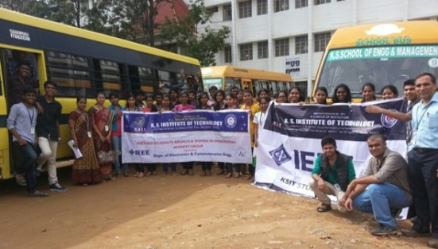“ In the middle of diﬃculty lies oppurtunity.” 5

- The students were taken to the HAL museum which displayed several aircraG models. They were given ﬁrst hand description about manufacturing, carriage capacities and design of the aircraG. A detailed explanation was also given regarding aircraG aviation namely the design of the aviation, tail colours corresponding to diﬀerent countries and its manufacturing processes. Industrial visit of such a nature will help the students bridge the gap between industry and the regular curriculum. The technical details provided by the company enlightened the students on various career opportunities and ultimately was very beneﬁcial.

ACHIEVEMENTS :

Faculty :
- Mrs. Supriya V G, Assoc.Prof published a paper titled "A Novel Irreversible Transformation Scheme for Biometric Template Protection" in the International Journal of Electrical and Electronics Engineering in volume 10, issue 5 in the month of October,2015.
- Dr. B Surekha, Prof ﬁled a patent on 26th October,2015 with the title "VISWAAS" in the area of image processing.
- Mrs.Rajeshwari Devi D V, Asst.Prof has presented a paper titled "An Improved Feature Extraction Method Based ON DWT and 2DSubXPCA Methods" at the International Conference on Computing and Network Communications (CoCoNet'15) organized by Indian Institute of Information Technology and Management -Kerala (IITM-K).
- Mrs. Prathima B A, Asst.Prof has published a paper titled as "Proposed Methodology for Auto Error Detection and Correction for Closed Loop Manufacturing using Embedded System" in the International Journal of Current Research in volume 07,issue 09, in the month of September,2015.
- Mr. Sangappa S B, Assoc. Prof was nominated as member of National ISTE Student Award Selection Committee of the 18th ISTE Student National convention held at Kings College of Engineering, Tamilnadu.
- He also was the guest of honor during the 12th Karnataka State ISTE Student Convention held on the 12th of September,2015 at SDMIT, Ujjire on the theme "Sustainable Developments through Innovative Technologies" for rural needs.
- Mrs. Lakshmi H R,Asst. Prof. has presented a paper titled “GSM Enabled Smart Incubator for Endangered Species” at the 2nd National Conference on "Emerging Trends in Science and Technology" organized by Sapthagiri College of Engineering, Bengaluru on 12th May,2015.
- Dr. B Surekha, Prof has presented a paper titled "AADHAR Integrated Biometric Vigilance System" at Indian International Science festival-Young Scientists Meet held at IIT, Delhi which was held from 4th to 8th December,2015.
- Dr. B Surekha, Prof and Mrs. Lakshmi H R, Asst. Prof. have presented a paper titled “Visual Cryptography based Lossless Water marking of Sensitive Images” in 6th International Conference on Swarm Evolutionary and Memetic Computing which was held on 18th and 19th December 2015.

Students :

- Zaiba, Vinaya Singh P, Varshitha G and Vaishnavi Devi of 7th semester underwent an internship program at Hindustan Aeronautical Limited, Bengaluru.
- Shreesha Raghavan, Siri T Bhat and Faizuddin of 7th semester underwent an internship program at Robert BOSCH, Bengaluru.
- Sushma S N and S Navya Sri of 7th semester underwent an internship program at Bharat Electronics Limited, Bengaluru.
- Suraksha S Aithal of 7th semester has undergone an In-plant training at Indian Space Research Organization, Bengaluru.

Sports :
- Aakash P S of the 3rd semester secured Gold medal in The National Martial Art Extravaganza held at Sree Kanteerava Indoor Stadium, Bengaluru on the 19th and 20th of July 2015.
- Jeevan D B of the 5th semester participated in the 5th Division Cricket Tournament held by Karnataka State Cricket Academy (KSCA).
- Leela Sandeep of the 7th semester secured the silver medal in the International Inﬁni Fest Event held at PESIT, Bengaluru.
- Bhavya P of the 5th semester has won the silver medal in VTU Women power LiGing event held at GAT Bengaluru.
- Bhavya P, Bhavani and Hema U of the 5th semester represented the college team which secured the Gold medal for Kabbadi event at MVIT Kalanjali Fest, Bengaluru.
- Goutham of the 3rd semester had the distinction of participating in the Dance Plus Reality Show which was aired on Star Plus Channel. He also bagged the ﬁrst place in V-Fest National level dance competition held in Goa, and is also an Assistant choreographer in Kannada ﬁlm industry.

DEPARTMENT WELCOMES :
- Mr. Vikram Ramesh Lakkavalli, Asst.Prof.M. Tech (Digital Electronics and Advanced Communication)
- Mrs. Divya K, Asst.Prof. M. Tech (VLSI Design and Embedded System)
- Mrs. Priyadarshini J Patil, Asst.Prof. M. Tech (Power Electronics).

VARIOUS CLUB DETAILS :
- IEEE :A two-day workshop on Robotics was organized by IEEE Student chapter and WIE aﬃnity group in association with Robominions on the 2nd and 3rd of October,2015 at K S Institute of Technology, Bengaluru. Students from various Engineering colleges participated in the workshop.

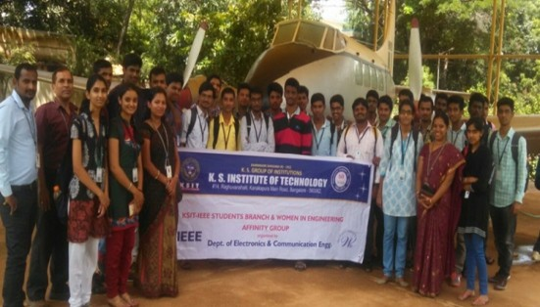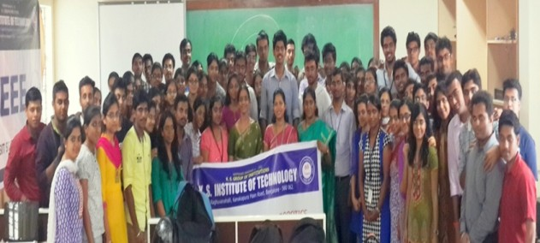

“ Individual talents always come second to team work” 6

- The workshop revised the basics of several electronic components and it's working. During the various sessions several autonomous robots like Line following robot, obstacle detector robot, joystick controlled robot, edge detector robots and many more were built. The workshop provided a wonderful learning experience. The phrase “Tell me I'll forget, show me I may remember, involve me and I'll understand", was very apt and proved that practical knowledge and hands on experience that was gained during the workshop will definitely help to have an edge over others.

FACULTY WHO HAVE ACHIEVED 100% RESULTS IN THEIR SUBJECTS :

Dr. P N Sudha

Mrs. Jayasudha B S K

Mr. Saleem S Tevaramani Mr. Sunil Kumar G R Mr. B Sudharshan
Mrs. B Surekha

Mr. B R Santhosh Kumar Mrs. Sangeetha V

Mr. Praveen A

Mr. Sangappa S B Mrs. Jayanthi M Mrs. P Supriya
Mrs. D V Rajeshwari Devi Mrs. Sahana Salagare

Mrs. Pragathi P
Control Systems
RF and Microwave Circuit Design

Applied Embedded System Design Advanced Embedded System

Image Processing Information Theory and Coding
Management and Entrepreneurship

Analog Communication Wireless Communication

Embedded System Design

Information Theory and Coding Wireless Communication

Fundamentals of CMOS VLSI Analog and Mixed Mode VLSI Design

Global System for Mobile Microwaves and Radars Wireless Communication Modern DSP
Optical Communication and Networking

Global System for Mobile

- EDN caters to the need of working electronic engineer and cover new technologies and electronic component products at engineering level.
- Columns here discuss about technical issues generally faced in the design of electronic components, systems and developing technologies.

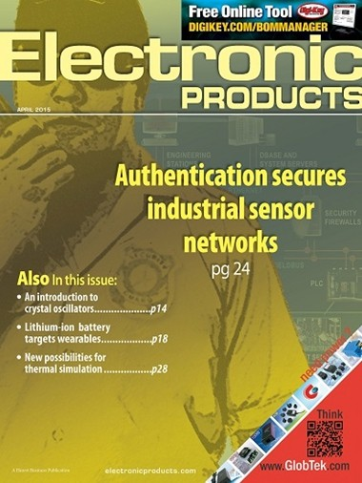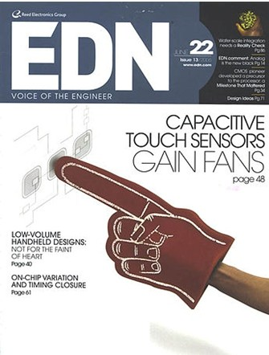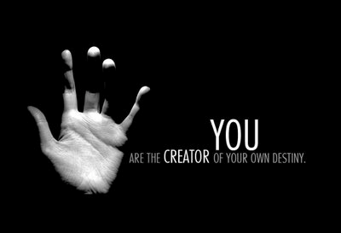

ELECTRONICS MAGAZINES :
- Electronic Products provides teardowns of some of the bestselling consumer products in market.
- It has full details of all components as well link to data sheets. It provides innovative and novel solutions to constrained designs.

“ Believe you can and you are half way there.” 7

