FACULTY PROFILE
Name | KIRAN KUMAR S R |  |  |  |  |  |  | 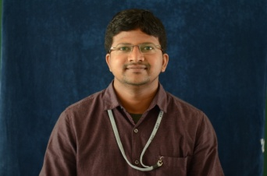
Designation | Assistant Professor
Date of Joining | 06 – 02 - 2012
Mobile No. | +91-8147673335
E-Mail ID | kirankumarbrp@gmail.com
Educational Qualifications |  | U.G | PG | PG |  | Ph.D.
 | Degree | B Sc | M Sc | - |  | Persuing
 | Specialisation | PCM | CHEMISTRY
 | Institution Name | Shyadri Science College  Shimoga | University Camus
 | University | Kuvempu University | Kuvempu University
 | Year of Passing
Experience |  | Teaching | No. of Yrs. |  | Industrial |  |  |  | No. of Yrs.
 | Institution Name | Shyadri Science College  Shimoga | 03
 |  | K S Institute of technology  Bangalore | 06
 | Total No. of Yrs. |  | 09
Area of Interest | Networking, Programming languages in Computer Science
Research Papers | Journals (in No.’s) | 15 | Conferences (in No.’s) |  |  |  | 25
Details of Papers | Anal. Bioanal.Electrochem., | “Electrochemical Studies of Dopamine Using Titaniumdioxide Nanoparticle Modified Carbon Paste Electrode”
 | Surface Engineering and Applied Electrochemistry | “Synthesis and Characterization of Copper Oxide Nanoparticles: To Study Voltammetric Response of Biomolecules.”
 | J. Chem. Bio. Phy. Sci. Sec. A | “Synthesis and characterization of ZnO-CuO nano-composites and its application in modified carbon paste electrode for electrochemical detection of Dopamine, Folic acid and Paracetomol”
 | Separation Science and Technology, | “Hydrothermal Synthesis of Hierarchical Copper Oxide Nanoparticles and its Potential Application as Adsorbent for Pb(II) with High Removal Capacity”
 | Indian Academy of Sciences | “Cost effective and shape controlled approach to synthesize hierarchically assembled NiO nanoflakes for the removal of toxic heavy metal ions in aqueous solution”.
 | MATERIALS Today Elsevier | “Synthesis and Characterization of Hierarchical Nickel Oxide (NiO) Nanoparticles and its application in Modified Carbon Paste Electrode for Electrochemical Detection of Biomolecules”

